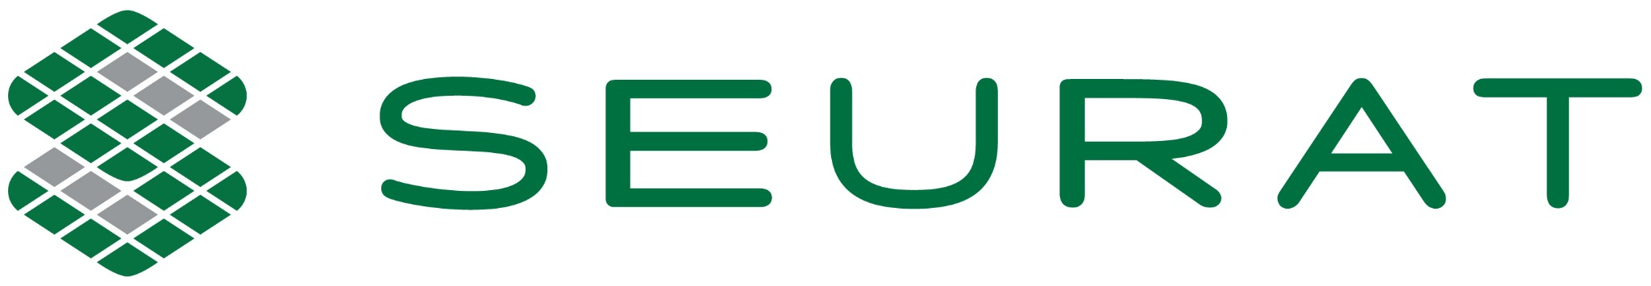 | PRESS RELEASE  FOR IMMEDIATE RELEASE

Seurat Technologies Selected for America Makes JAQS-SQ Award in Support of Defense Additive Manufacturing
Seurat named among 25 awardees under a $10.5 million Department of War–funded initiative to qualify suppliers and expand metal additive manufacturing capabilities across the defense industrial base
WILMINGTON, MASS. | July 28, 2026

Seurat Technologies, the developer of Area Printing® technology for industrial-scale metal additive manufacturing, today announced it has been selected as an awardee under the Joint Additive Qualification for Sustainment – Supplier Qualification (JAQS-SQ) Groups 2 and 3 project call, administered by America Makes and the National Center for Defense Manufacturing and Machining (NCDMM) and funded through the Office of the Under Secretary of War, Manufacturing Technology Office (OSW ManTech).
The JAQS-SQ initiative is designed to accelerate the integration of traditional and non-traditional additive manufacturing suppliers into the defense industrial base by training and supporting manufacturers to implement the process control documents, qualification principles and audit requirements needed for qualified AM production. The program addresses a critical gap in the AM supply chain: the lack of standardized training and audit frameworks aligned with government acquisition requirements. The Groups 2 and 3 project call selected 25 teams from across the AM industry, bringing the total JAQS supplier network to 31 — one of the largest coordinated efforts to qualify and expand additive manufacturing in support of national defense readiness. Total funding under the Groups 2 and 3 project call is $10.5 million.
“Defense readiness depends on a manufacturing base that can produce qualified metal parts not just reliably — but on demand, at scale. The ability to surge capacity when a program requires it, without retooling or rebuilding a supply chain, is what makes additive manufacturing strategically valuable to the DoD,” said James DeMuth, CEO of Seurat Technologies. “This award reflects our commitment to achieving and demonstrating the process rigor the government requires, and our confidence that Area Printing® can deliver the throughput and cost structure that turns that flexibility into a genuine national asset.”

Area Printing technology uses a proprietary patterned laser approach that enables high-throughput production of metal parts at costs that make additive manufacturing competitive with traditional production methods. Designed and built in the United States, Area Printing gives domestic manufacturers and their defense customers a uniquely American alternative to the fragmented, offshore-dependent supply chains that have long constrained military readiness. Seurat has been expanding its production capabilities and customer base across defense, energy, and industrial markets.
The JAQS-SQ program is administered by America Makes, the National Additive Manufacturing Innovation Institute, in partnership with NCDMM, with funding from OSW ManTech. The program will help Seurat strengthen the process controls, quality systems, and supplier readiness required to demonstrate a performance qualification and successfully complete the JAQS-SQ supplier audit, supporting its readiness for qualified additive manufacturing production within the defense industrial base. Project teams will report progress at the America Makes Technical Review and Exchange (TRX) and other industry events.
About Seurat Technologies
Seurat is reinventing metal manufacturing. The company’s proprietary Area Printing® technology enables the contract manufacturing of high-volume metal parts at speeds and costs that make additive manufacturing competitive with traditional methods for the first time. Built in America, for American industry and its allies, Seurat serves customers across defense, energy, and industrial markets — reducing time to market, securing domestic supply chains, and providing unmatched production flexibility. Seurat enables customers to reimagine what is possible at scale, unlocking future potential for their products and businesses. Ready to Scale Your Possible? Learn more at seurat.com.
About America Makes
America Makes is the nation’s leading public-private partnership for additive manufacturing (AM) technology and education. America Makes members from industry, academia, government, and workforce and economic development organizations work together to accelerate the adoption of AM and the nation’s global manufacturing competitiveness. Founded in 2012 as the Department of War’s National Manufacturing Innovation Institute for AM and the first of the Manufacturing USA network, America Makes is based in Youngstown, Ohio, and managed by the not-for-profit National Center for Defense Manufacturing and Machining (NCDMM). Learn more at americamakes.us.
Media Contact
Craig Colman  Director of Marketing  Seurat Technologies | ccolman@seurat.com

