HEAVENLY PLACES BOOK SERIES SELL SHEET

Genre: Christian Fantasy • Epic Fantasy • Fantasy
Tagline: “With the fate of two worlds in the balance, God didn’t send an army, He sent a family…”

SERIES OVERVIEW
Redemption was only the beginning. After God restores their broken family through acts of obedience, Jonah, Willa, and their adopted daughter, Wren, are thrust through a mysterious portal into Aeramor, a world of ancient kingdoms, sword and sorcery, and spiritual warfare unlike anything they have ever known. Called by Adonai to proclaim His truth, they discover a land experiencing a version of the Old Testament of the Bible. Miracles confront dark magic, prophets challenge the powers of darkness, and every soul stands at the crossroads of faith and fear.
As war spreads across the nations of Aeramor, their mission grows beyond survival. They must recover sacred relics, expose hidden betrayal, protect the innocent, and care for the widows and orphans left behind by the Enemy's relentless campaign. Along the way, unlikely allies emerge, ancient mysteries are revealed, and the fate of two worlds becomes intertwined.
From the first step of faith to the final battle between light and darkness, the Heavenly Places series is an epic Christian fantasy story of redemption, found family, spiritual warfare, and unwavering hope. Perfect for readers who love portal fantasy, sweeping adventures, and stories where faith in God is the greatest weapon of all.

Perfect For Readers Who Enjoy
- Ted Dekker, C.S. Lewis, Margaret Weis and Tracy Hickman
- Epic worldbuilding, Character-driven fantasy, Spiritual themes, Adventure and mystery

HEAVENLY PLACES SERIES AT A GLANCE
Book | Status | Publication Date
Book 1: Coram Deo | Available | 9/9/2023
Book 2: Solus Deus | Available | 9/9/2024
Book 3: Gracia Dei | Available | 9/9/2025
Book 4: Diaspora  Book 5: Babylon  Book 6: Holy City | Coming Soon  Coming in ‘27  Coming in ‘28 | 9/9/2026  9/9/2027  9/9/2028

INDIVIDUAL BOOKS

BOOK ONE – Coram Deo
One-Sentence Hook
An ordinary family. An extraordinary calling. Eternal stakes.

Synopsis
A family called by God. Forged in battle. Asked to stand Coram Deo, before the face of God. In Aeramor, faith is the sharpest weapon, and prayer is more potent than magic. When God opens a portal, the war for two worlds begins.
Formats
Format | ISBN | Price
Paperback | 9798330317721 | $14.99
Hardcover | 9798330317523 | $27.99
eBook | 9798869282521 | $4.99

BOOK TWO – Solus Deus
One-Sentence Hook
A portal. An ancient world. A divine mission. The greatest battle has always been for the least of these.
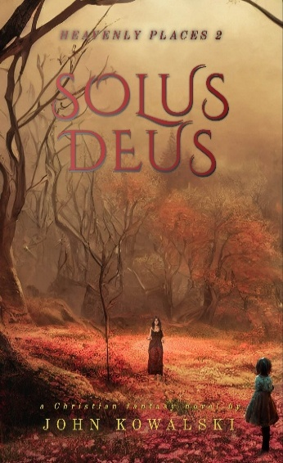
Synopsis
As war spreads across Aeramor, Jonah, Willa, and Wren continue Adonai's mission to proclaim His truth while searching for sacred relics that could save two worlds. Torn between completing their divine calling and caring for the widows and orphans left behind by the conflict, they must uncover a hidden traitor and trust that only God can lead them through the darkness.
Formats
Format | ISBN / ASIN | Price
Paperback | 9798330317639 | $14.99
Hardcover | 9798330299225 | $29.99
eBook | B0CHWQ1X9W | $7.99

BOOK THREE – Gracia Dei
One-Sentence Hook
Obedience began the journey. Faith opened the portal. Grace will decide the ending.
Synopsis
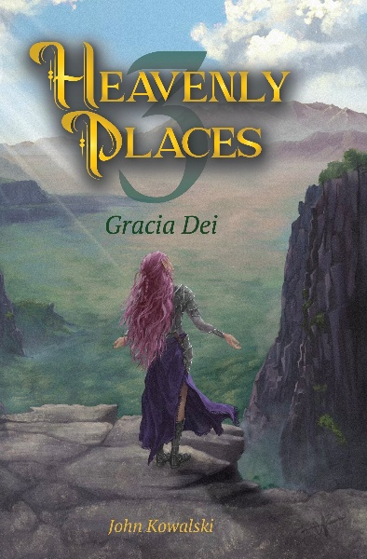
As the battle to save two worlds reaches its climax, Jonah, Willa, and Wren must split their focus. Can they recover the final divine relics before the Enemy unleashes his ultimate plan? Will their refusal to let the innocent victims of war be forgotten cause them to fail in their mission? With ancient secrets revealed, unlikely allies rising, and the fate of two worlds hanging in the balance, they discover that victory will come not through strength alone, but through the grace of God.
Formats
Format | ISBN / ASIN | Price
Paperback | 9798869169358 | $16.99
Hardcover | 9798330231614 | $29.99
eBook | B0FF7G2FMC | $8.99

BOOK FOUR – Diaspora (Launches on 9/9/26)
One-Sentence Hook
In Diaspora, the greatest enemies are not monsters or men; they are fear, rebellion and the slow erosion of hope…
Synopsis
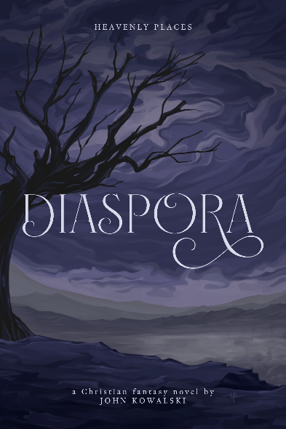
Seven years after the miracles at Mount Carmel, Claire is called back to Aeramor to lead the exiled people of Judah through a dangerous wilderness toward their promised destiny in Babylon. Facing enemies, rebellion, and a nation in exile struggling with fear and doubt, Claire and the new members of Coram Deo must rediscover what it means to live before the face of God.
Formats
Format | ISBN / ASIN | Price
Paperback | 9798256185749 | $18.99
Hardcover | 9798256186005 | $29.99
eBook | B0HDSV2SSW | $8.99
* Preorders 8/15/26
**Launches 9/9/26

Reviews:
Coram Deo:
John has done an amazing job of encapsulating an entire world in this first installment of Heavenly Places, a world that is both fascinating in its uniqueness, yet comforting with its deep ties to Biblical truths and lands. This book is Christian fiction at its finest, unapologetic about its foundational truths, yet full of grace. Can't wait for part two, Solus Deus!
- M.T.
Solus Deus:
I cannot believe I simply stumbled onto this series and now I have to go back and read book one and then book two again. This book is a fantastic mix of religion and to me D&D. The story draws you in and just puts a new twist on what has become the old genre. Could not recommend it more, the world building, the people and the story draws you in like nothing has for me in a long time.
- Jackie F.

Gracia Dei (Editorial):
"John Kowalski’s Heavenly Places 3: Gracia Dei is a landmark in faith-based fiction, bridging the gap between high-fantasy worldbuilding and profound Christian theology. This book lies in its unique "Coram Deo" perspective—challenging characters to live "before the face of God" in a world where magic and spiritual warfare are tangible realities. Born from the creative fire of a thirteen-player tabletop roleplaying game, the narrative possesses a rare authenticity, treating every battle and every prayer as a pivotal moment of character formation. It literalizes the struggle for the soul, using the quest for the Full Armor of God and the mysterious Codex of Light to explore how faith survives under the ultimate pressure.
This is a book that will be loved by "kindred spirits" who follow Jesus but love the wonder of fantasy, as well as those outside the church who desire a window into a faith that isn't afraid of imagination, questions, or complexity. It is an essential read for families looking for immersive stories that teach Biblical values through critical thinking and problem-solving.
In an age where fantasy often leans toward the cynical, Gracia Dei stands as a breathtaking epic of hope and high-stakes adventure. Readers join the heroes of Coram Deo on a heart-wrenching journey across a transformed Israel, from the smoke-filled halls of the Deepforge stronghold to the divine heights of Mount Carmel. Kowalski masterfully weaves pulse-pounding action—such as the desperate defense of Haven and battles against the lich Xhex’zogol—with raw, emotional moments of personal redemption and family sacrifice. Whether it is the Tabaxi girl Wren’s ultimate bravery or the paladin Jonah’s struggle to trust God’s plan, every page pulses with a sense of profound purpose. This volume is a transformative experience, reminding us that while the enemy is relentless, the light of Adonai is invincible. It is more than a novel; it is a powerful testimony to the grace that carries us through the darkest valleys and leads us, finally, home.
This book is an experience of the ultimate clash between light and darkness in a world where magic is real, faith is a weapon, and the grace of God is the only way home."

— Authors Reading – Dustin B.

