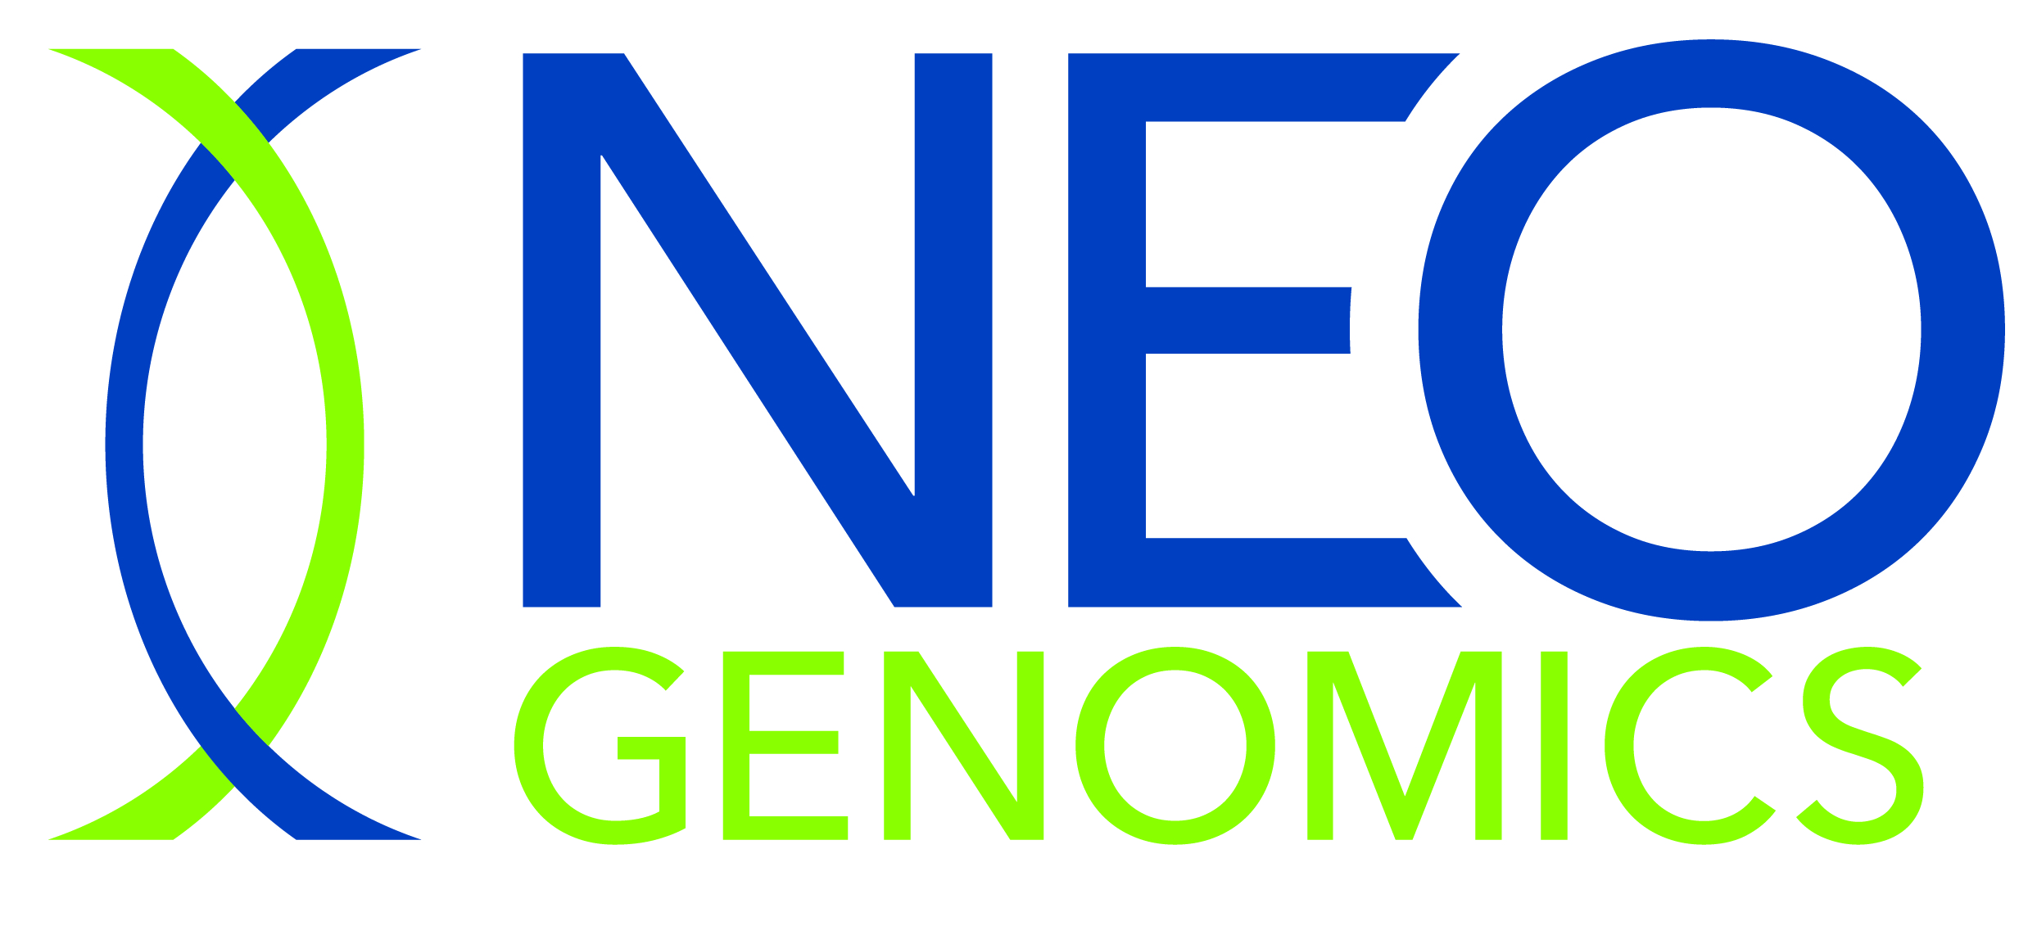

NeoGenomics To Virtually Participate In Fireside Chat At The 18th Annual Morgan Stanley Global Healthcare Conference

Ft. Myers, Florida – September 10, 2020 - NeoGenomics, Inc. (NASDAQ: NEO), a leading provider of cancer-focused genetic testing services, today announced that Doug VanOort, Chairman and Chief Executive Officer, Kathryn McKenzie, Chief Financial Officer and Doug Brown, Chief Strategy and Corporate Development Officer, will be participating in a virtual fireside chat at the 18th Annual Morgan Stanley Global Healthcare Conference on Monday, September 14, 2020 at 9:45am ET.

The presentation will be webcast live and accessible online via the investors section of the Company’s website, www.neogenomics.com. A replay of the webcast will be archived for 90 days following the presentation.

About NeoGenomics, Inc.
NeoGenomics, Inc. specializes in cancer genetics testing and information services. The Company provides one of the most comprehensive oncology-focused testing menus in the world for physicians to help them diagnose and treat cancer. The Company's Pharma Services Division serves pharmaceutical clients in clinical trials and drug development.
Headquartered in Fort Myers, FL, NeoGenomics operates CAP accredited and CLIA certified laboratories in Fort Myers and Tampa, Florida; Aliso Viejo, Carlsbad, Fresno and San Diego, California; Houston, Texas; Atlanta, Georgia; Nashville, Tennessee; and CAP accredited laboratories in Rolle, Switzerland, and Singapore. NeoGenomics serves the needs of pathologists, oncologists, academic centers, hospital systems, pharmaceutical firms, integrated service delivery networks, and managed care organizations throughout the United States, and pharmaceutical firms in Europe and Asia. For additional information about NeoGenomics, visit http://www.neogenomics.com/.

Forward Looking Statements
Certain information contained in this press release constitutes forward-looking statements for purposes of the safe harbor provisions of The Private Securities Litigation Reform Act of 1995. These forward looking statements involve a number of risks and uncertainties that could cause actual future results to differ materially from those anticipated in the forward-looking statements as the result of the Company's ability to continue gaining new customers, respond to the effects of the COVID-19 outbreak, offer new types of tests, integrate its acquisitions and otherwise implement its business plan, as well as additional factors discussed under the heading "Risk Factors" and elsewhere in the Company's Annual Report on Form 10-K filed with the SEC on February 28, 2020. As a result, this press release should be read in conjunction with the Company's periodic filings with the SEC. In addition, it is the Company's practice to make information about the Company available by posting copies of its Company Overview Presentation from time to time on the Investor Relations section of its website at http://ir.neogenomics.com/.
Forward-looking statements represent the Company's estimates only as of the date such statements are made (unless another date is indicated) and should not be relied upon as representing the Company's estimates as of any subsequent date. While the Company may elect to update forward-looking statements at some point in the future, it specifically disclaims any obligation to do so, even if its estimates change.

For further information, please contact:
NeoGenomics, Inc.
Doug Brown
Chief Strategy and Corporate Development Officer
T: 239.768.0600 x2539
M: 704.236.2064
doug.brown@neogenomics.com

Charlie Eidson
Manager of Investor Relations and Manager of Strategy and Corporate Development
T: 239.768.0600 x2726
M: 952.221.8816
charlie.eidson@neogenomics.com

