Monterey Minerals Provides Corporate and Exploration Update at Alicia Project in the Philippines
TORONTO, ON – September 16, 2020 - Monterey Minerals Inc. (the “Company” or “Monterey”) (CSE: MREY and FSE :2DK) is pleased provide a corporate and exploration update on activities at its wholly owned Alicia high-grade gold and base metals project in Alicia Municipality, Philippines (“Alicia Project”).
The Company mobilized its Technical Team to the project after the closing of the oversubscribed private placement (See press release dated July 28, 2020).
Highlights:
- Acquisition of 100% of Greater Arc Pty Ltd (100% subsidiary of Greater Arc Resources Ltd, “Greater Arc”) by Monterey (See Press Release dated August 13, 2020)
  - Monterey issued 54 million Common Shares @ 8 cents (Canadian) for a total consideration of C$4.32 million (approximately A$4.10 million).
  - The Monterey Shares will be held in escrow until February 9, 2021 and then distributed in specie to the 140 Greater Arc shareholders, following shareholder approval at a Greater Arc General Meeting of shareholders.
- Contract with Philippine-based drilling company, IndoDrill, has been executed for initial 3,000 metre drilling program. Personnel have been mobilized on site.
- Drilling to target high-grade gold and polymetallic veins over 10 kilometres combined strike length identified over the last five or so years of exploration at Alicia.
- Philippine-based geologist, Max Tuesley, has been appointed as country Manager for the Philippines and is due on site in late September. Max has over 25 years multi-commodity experience including over 9 years in the Philippines.
- The Alicia Municipality and local barangays continue to be supportive of the project and have supplied labour for exploration to date.

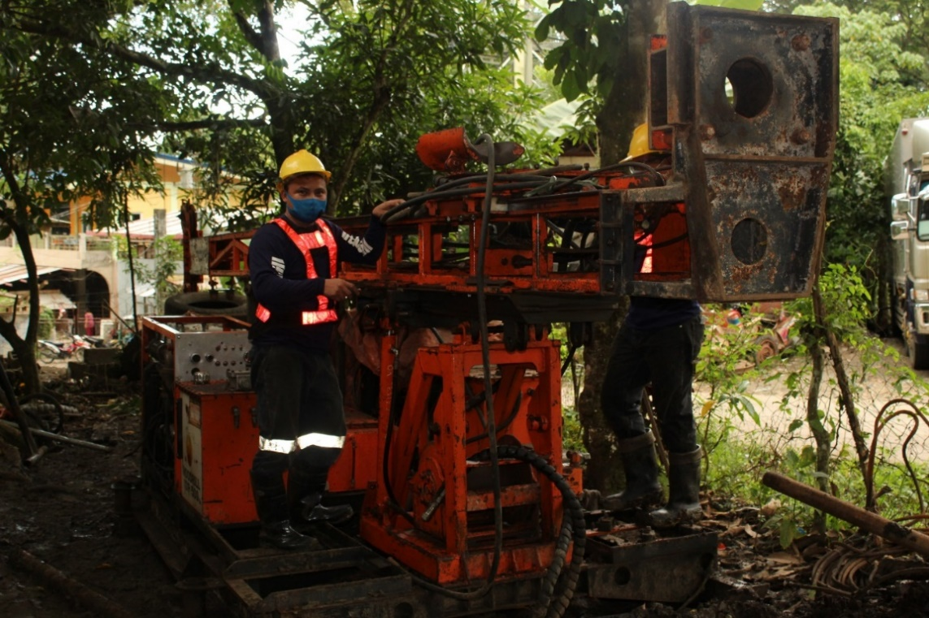
Figure 1 - Indodrill drill rig currently being assembled on site.

Drilling
IndoDrill, a Philippines based drilling company, has been awarded the initial 3,000 metre drilling contract. Personnel have been mobilized on site and the drill rig is currently being assembled, see Figure 1. It is anticipated that drilling will commence before the end of September.

Strong Addition to our Technical Team
The Company appointed Max Tuesley as the Country Manager (See Press Release dated August 26, 2020).
Mr. Tuesley will oversee exploration activities at the Alicia Project. Max is a highly experienced project manager and has spent over 25 years in grassroots, advanced mineral exploration and mine production, predominantly in gold, copper and base metals. He has been working in the Philippines for nine years, including senior management positions at the Masbate Gold Project for B2Gold Corp. and the Runruno Gold Mine for Metals Exploration Plc.

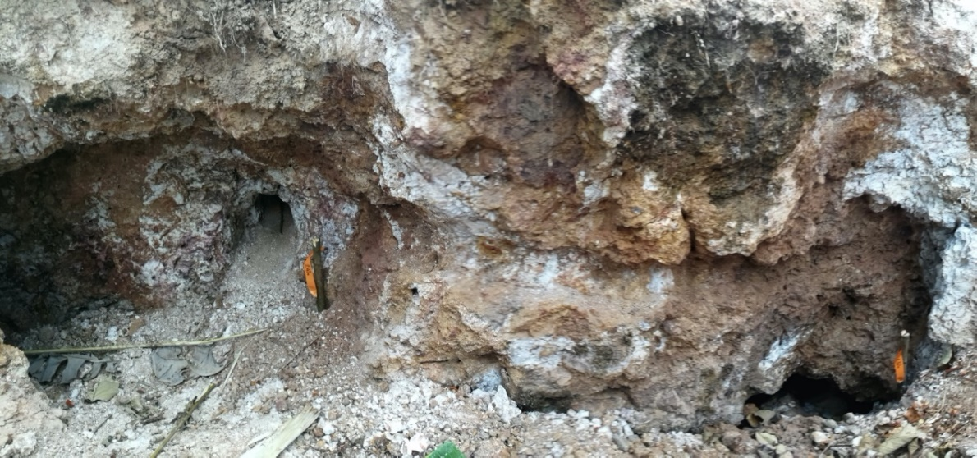
Max has also managed start up gold projects in Central Asia and porphyry copper exploration in both Mongolia and Sudan. Mr. Tuesley holds an Honour’s degree in Economic Geology from James Cook University in Australia and is a member of the Australian Institute of Mining and Metallurgy.

Figure 2 - Recent sampling of the Baloy Vein

2020 Exploration Program
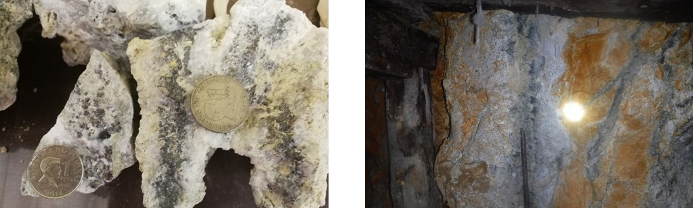
Trenching activity has continued, with focus on the Pamaraw, Baloy, Sandi and Quintilla veins. Priority samples are now being prepared for dispatch to the Intertek laboratory in Manila. Results are expected before the end of the October. Further field work, including sampling will be ongoing in advance of the initiation of drilling.
Figure 3 - Additional sampling of the Baloy Vein.
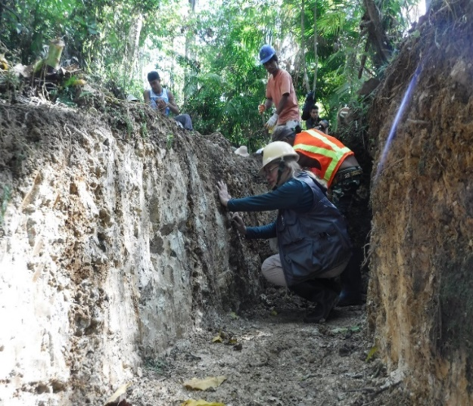
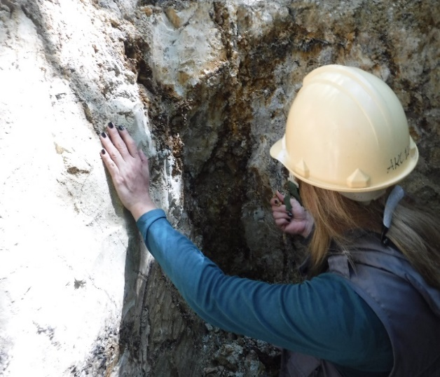
The Company is also pleased to announce that Emma Jadoc is remaining as Exploration Manager at Alicia.

Figure 4 - Exploration Manager Emma Jadoc, undertaking trench mapping.

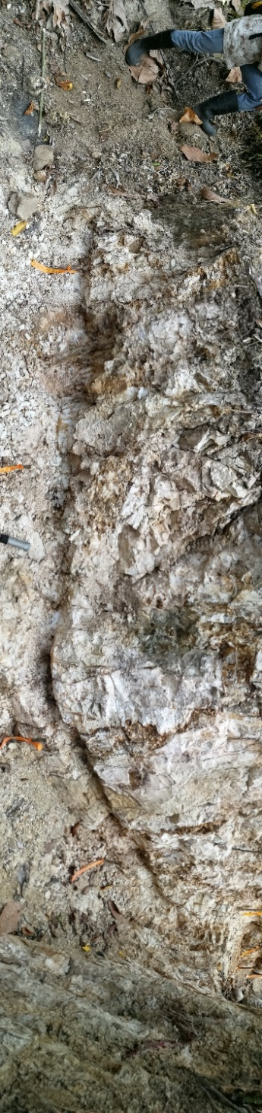
Figure 5 - Pamaraw Vein trench.

“With the addition of Max, we are able to explore the potential of how large the area of mineralization is at the Alicia Project. We would also like to thank our team members Emma Jadoc and Liza Neido for working tirelessly for the Alicia Project despite the COVID-related restrictions that are in place”, stated James Macintosh, President and CEO.

Qualified Person
The technical information in this press release has been reviewed and approved by Martin Dormer, a consultant to the Company, who is a Qualified Person as defined by NI 43-101. Martin is a member of the Australian Institute of Mining and Metallurgy (AusIMM), the Australian Institute of Geoscientists (AIG). He is a West Australian geologist with over 22 years’ experience and sufficient experience of relevance to the styles of mineralization and types of deposits under consideration to qualify as a Competent Person as defined by the 2012 Edition of the Joint Ore Reserves Committee (JORC) Australian Code for Reporting of Exploration Results, Mineral Resources, and Ore Reserves.

About Monterey Minerals Inc.
The Company owns 100% of the Alicia Project in the Alicia Municipality of the Philippines. The Alicia Project is a system of multiple, high-grade gold and silver veins with base metals over a strike length of greater than ten kilometres. The Company also owns the Cobalt Mountain Property (the “Property”) in the Omineca Mining Division of British Columbia near the town of Smithers. The Company’s NI 43-101 technical report, available on SEDAR, notes historic sampling on the Property that returned mineralized showings of gold, silver, copper, zinc and cobalt. The Company also owns 877 sq. km. of prospective Pilbara Basin tenements on the eastern flank of the Pilbara Basin in Western Australia, including a property that abuts Pacton Gold’s tenement where gold-bearing conglomerates were identified.
For more information, contact investor relations at info@montereyminerals.com
On Behalf of the Board of Directors,
James Macintosh,
President and CEO
Neither the Canadian Securities Exchange nor its regulation services provider has reviewed or accepted responsibility for the adequacy or accuracy of this press release
This press release may include forward-looking information within the meaning of Canadian securities legislation, concerning the business of the Company. Forward-looking information is based on certain key expectations and assumptions made by the management of the Company. Although the Company believes that the expectations and assumptions on which such forward-looking information is based on are reasonable, undue reliance should not be placed on the forward-looking information because the Company can give no assurance that they will prove to be correct. Forward-looking statements contained in this press release are made as of the date of this press release. The Company disclaims any intent or obligation to update publicly any forward-looking information, whether as a result of new information, future events or results or otherwise, other than as required by applicable securities laws.

