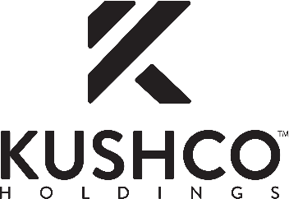

KushCo Holdings Sets September and October 2020 Financial Conference Schedule

CYPRESS, Calif., — September 22, 2020 — KushCo Holdings, Inc. (OTCQX: KSHB) (''KushCo'' or the ''Company''), the premier provider of ancillary products and services to the legal cannabis and CBD industries, is scheduled to participate at the following financial conferences during September and October 2020:

AGP Consumer Cannabis Virtual Conference 2020
Date: Tuesday, September 29, 2020
Type: 1x1 meetings
Location: Virtual
Executives: Nick Kovacevich, Co-founder, Chairman, and Chief Executive Officer and Stephen Christoffersen, Chief Financial Officer

Jefferies Virtual Cannabis Summit
Date: Wednesday, October 7, 2020
Time: Panel at 1:00 p.m. ET
Type: Panels and 1x1 meetings
Location: Virtual
Executives: Nick Kovacevich and Stephen Christoffersen

Benzinga Cannabis Capital Conference
Date: Thursday, October 15, 2020
Time: Presentation at 12:15 p.m. ET
Type: Presentations and 1x1 meetings
Location: Virtual
Executive: Nick Kovacevich

To schedule a one-on-one meeting, request a conference invitation or receive additional information, please contact KushCo’s investor relations at ir@kushco.com or 714-539-7653. To be added to the Company’s email distribution list, please email ir@kushco.com with "KushCo" in the subject line.

About KushCo Holdings

KushCo Holdings, Inc. (OTCQX: KSHB) (www.kushco.com) is the premier provider of ancillary products and services to the legal cannabis and CBD industries. KushCo Holdings' subsidiaries and brands provide product quality, exceptional customer service, compliance knowledge and a local presence in serving its diverse customer base.

Founded in 2010, KushCo Holdings has now sold more than 1 billion units to growers, processors and producers across North America, South America, and Europe. The Company has been featured in media nationwide, including CNBC, Fox News, Yahoo Finance, Cheddar, Los Angeles Times, TheStreet.com, and Entrepreneur, Inc Magazine.

For more information, visit www.kushco.com or call (888) 920-5874.

KushCo Holdings Contact

Investor Contact:

Najim Mostamand, CFA

Director of Investor Relations

714-539-7653

ir@kushco.com

