Monterey Minerals Sells its Southern Pilbara Tenements and Options its Northern Pilbara Tenements
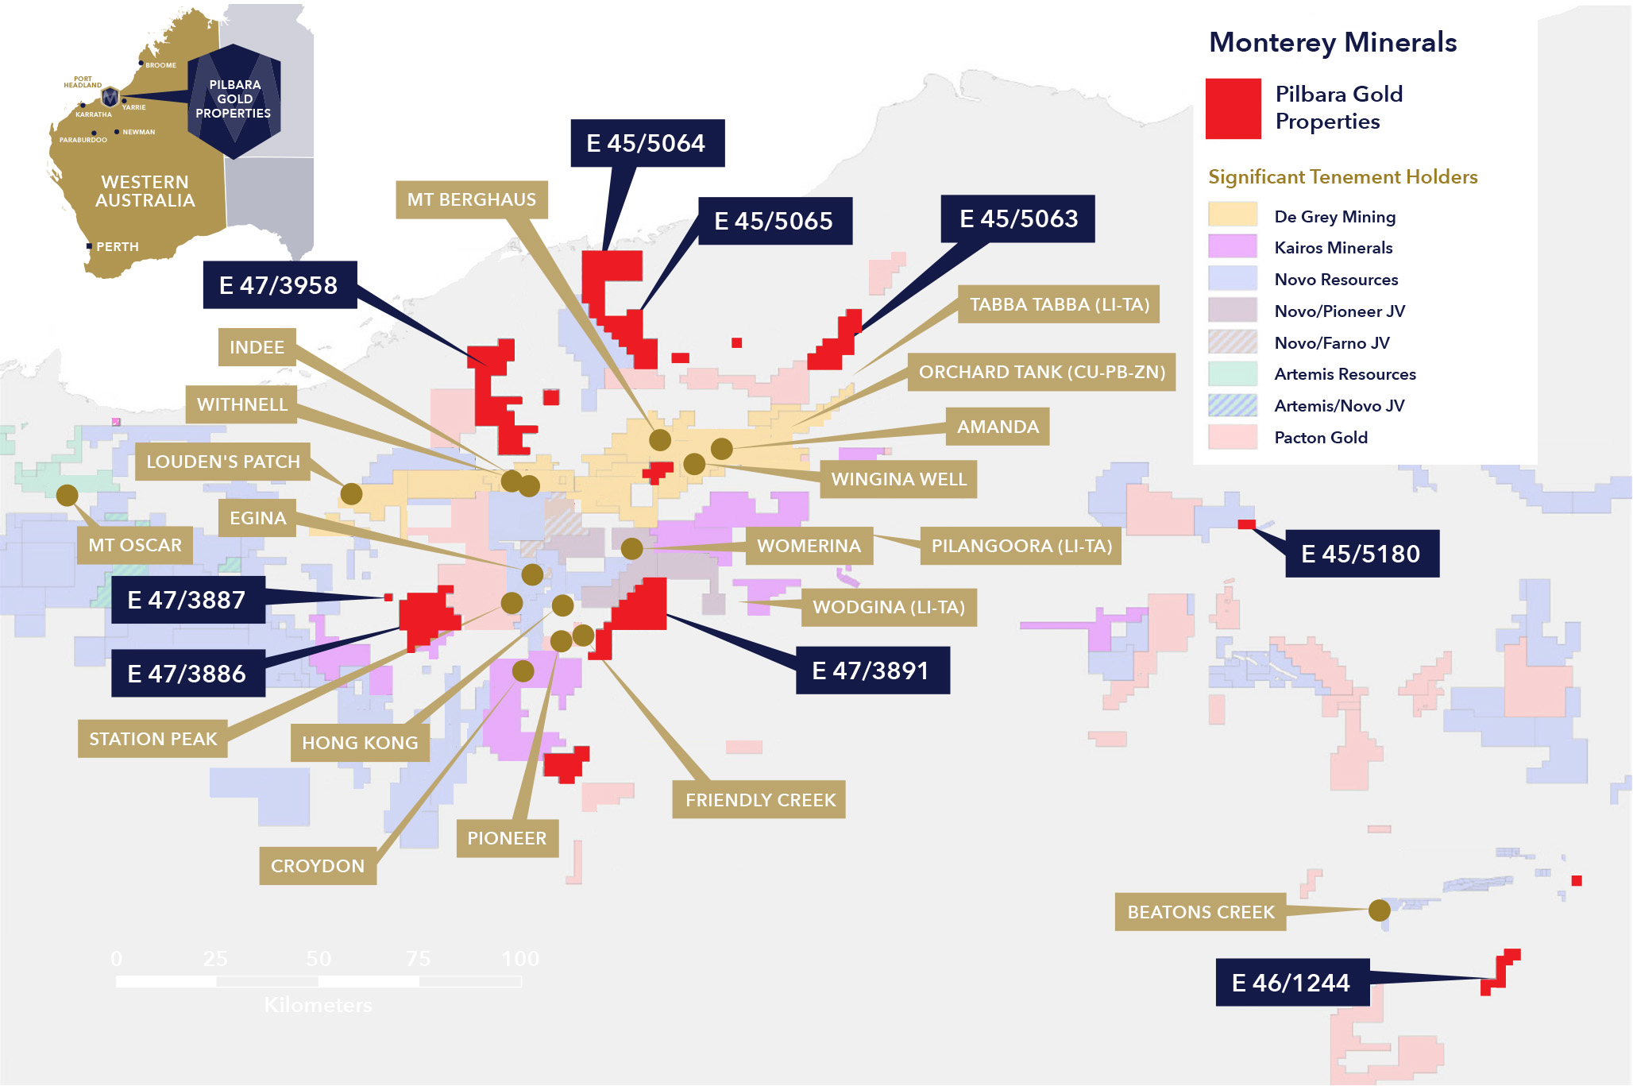
TORONTO, ON - September 29, 2020 - Monterey Minerals Inc. (the “Company” or “Monterey”) (CSE: MREY and FSE :2DK) is pleased announced that it has signed a purchase and sale agreement to sell four of its southern tenements (the “Tenements”) within the Company’s portfolio of Pilbara gold properties. New Age Exploration Limited (ASX: NAE) (“New Age”) will acquire the Tenements for 25 million shares of New Age. The divested Tenements are E47/3886, E47/3887, E47/3891 and E45/5180 and represent 307 square kilometres (“sq. km.”).

In addition, New Age has entered into an option and asset sale agreement to acquire a further four tenements comprising 538 sq.km. from Monterey for total consideration of 75 million NAE shares and 37.5 million unlisted NAE options with an exercise price of $0.02, expiring 28 September 2023. NAE will have an exclusive right to exercise the option to acquire the four tenements (E47/3958, E45/5063, E45/5064 and E45/5065) on or before completion of a 45 day due diligence period. NAE was required to pay an option fee of $25,000.
“The Pilbara tenements are located in proximity to some exciting results. Given that our main focus is on our current and future plans for the Alicia Project in the Philippines, it made sense to divest to a group who is able to put a primary focus on exploring these tenements. As shareholders of New Age, we look forward to sharing in their success”, stated James Macintosh, President and CEO.

Qualified Person
The technical information in this press release has been reviewed and approved by Martin Dormer, a consultant to the Company, who is a Qualified Person as defined by NI 43-101. Martin is a member of the Australian Institute of Mining and Metallurgy (AusIMM), the Australian Institute of Geoscientists (AIG). He is a West Australian geologist with over 22 years’ experience and sufficient experience of relevance to the styles of mineralization and types of deposits under consideration to qualify as a Competent Person as defined by the 2012 Edition of the Joint Ore Reserves Committee (JORC) Australian Code for Reporting of Exploration Results, Mineral Resources, and Ore Reserves.
About Monterey Minerals Inc.
The Company owns 100% of the Alicia Project in the Alicia Municipality of the Philippines. The Alicia Project is a system of multiple, high-grade gold and silver veins with base metals over a strike length of greater than ten kilometres. The Company also owns the Cobalt Mountain Property (the “Property”) in the Omineca Mining Division of British Columbia near the town of Smithers. The Company’s NI 43-101 technical report, available on SEDAR, notes historic sampling on the Property that returned mineralized showings of gold, silver, copper, zinc and cobalt. The Company also owns 877 sq. km. of prospective Pilbara Basin tenements on the eastern flank of the Pilbara Basin in Western Australia.
For more information, contact investor relations at info@montereyminerals.com
On Behalf of the Board of Directors,
James Macintosh,
President and CEO
Neither the Canadian Securities Exchange nor its regulation services provider has reviewed or accepted responsibility for the adequacy or accuracy of this press release
This press release may include forward-looking information within the meaning of Canadian securities legislation, concerning the business of the Company. Forward-looking information is based on certain key expectations and assumptions made by the management of the Company. Although the Company believes that the expectations and assumptions on which such forward-looking information is based on are reasonable, undue reliance should not be placed on the forward-looking information because the Company can give no assurance that they will prove to be correct. Forward-looking statements contained in this press release are made as of the date of this press release. The Company disclaims any intent or obligation to update publicly any forward-looking information, whether as a result of new information, future events or results or otherwise, other than as required by applicable securities laws.

