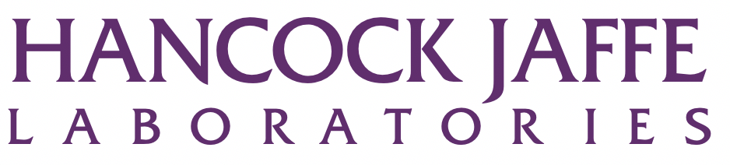

Hancock Jaffe Laboratories, Inc. Announces Pricing of $5.1 Million Registered Direct Offering Priced at the Market

IRVINE, California, October 7, 2020 – Hancock Jaffe Laboratories, Inc. (Nasdaq: HJLI), a developer of medical devices that restore cardiac and vascular health, today announced the pricing of a registered direct offering of $5.1 million of its common stock and warrants to purchase shares of common stock in a concurrent private placement. The combined purchase price for one share of common stock and one warrant to purchase one share of common stock will be $0.535 which is priced at-the-market under Nasdaq rules.

Ladenburg Thalmann & Co. Inc. is acting as exclusive placement agent in connection with the offering.

The gross proceeds to the Company from the registered direct offering and concurrent private placement are expected to be approximately $5.1 million before deducting the placement agents’ fees and other estimated offering expenses. The Company intends to use the net proceeds for the offering for the continued development of the Company’s two lead products, VenoValve and the CoreoGraft, and for general corporate purposes, including working capital.

The warrants to purchase up to 9,532,709 shares of common stock have an exercise price of $0.41 per share, will be exercisable from the date of issuance, and will expire seven years from the date of issuance. The Company has agreed to file a registration statement registering the shares of common stock issuable upon exercise of the warrants within thirty days of the closing of the private placement.

The closing of the offering is expected to take place on or about October 9, 2020, subject to the satisfaction or waiver of customary closing conditions.

The shares of common stock described above (but not the warrants or the shares of common stock underlying the warrants) are being offered pursuant to a "shelf" registration statement on Form S-3 (File No. 333-237592) that was filed by the Company with the Securities and Exchange Commission (SEC) and was declared effective on April 16, 2020. The Company will file a prospectus supplement with the SEC relating to such shares of common stock. Copies of the prospectus supplement and the accompanying prospectus relating to and describing the terms of the offering may be obtained, when available, from Ladenburg Thalmann & Co. Inc., 277 Park Avenue, 26th Floor, New York, NY 10172, or by email at prospectus@ladenburg.com.

The warrants described above were offered in a private placement under Section 4(a)(2) of the Securities Act of 1933, as amended (the Act), and Regulation D promulgated thereunder and, along with the shares of common stock underlying the warrants, have not been registered under the Act, or applicable state securities laws. Accordingly, the warrants and underlying shares of common stock may not be offered or sold in the United States except pursuant to an effective registration statement or an applicable exemption from the registration requirements of the Act and such applicable state securities laws.

About Hancock Jaffe Laboratories, Inc.

HJLI specializes in developing and manufacturing bioprosthetic (tissue based) medical devices to establish improved standards of care for treating cardiac and vascular diseases. HJLI currently has two lead product candidates: the VenoValve®, a porcine based valve which is intended to be surgically implanted in the deep venous system of the leg to treat reflux associated with Chronic Venous Insufficiency; and the CoreoGraft®, a bovine tissue based off the shelf conduit intended to be used for coronary artery bypass surgery. For more information, please visit HancockJaffe.com.

Cautionary Note on Forward-Looking Statements

This press release and any statements of stockholders, directors, employees, representatives and partners of Hancock Jaffe Laboratories, Inc. (the “Company”) related thereto contain, or may contain, among other things, certain "forward-looking statements" within the meaning of the Private Securities Litigation Reform Act of 1995. Such forward-looking statements involve significant risks and uncertainties. Such statements may include, without limitation, statements identified by words such as "projects," "may," "will," "could," "would," "should," "believes," "expects," "anticipates," "estimates," "intends," "plans," "potential" or similar expressions. These statements are based upon the current beliefs and expectations of the Company’s management and are subject to significant risks and uncertainties, including those detailed in the Company’s filings with the Securities and Exchange Commission. Actual results (including, without limitation, the closing of the offering described in this release) may differ significantly from those set forth or implied in the forward-looking statements. These forward-looking statements involve certain risks and uncertainties that are subject to change based on various factors (many of which are beyond the Company’s control). The Company undertakes no obligation to publicly update any forward-looking statements, whether as a result of new information, future presentations or otherwise, except as required by applicable law.

###

