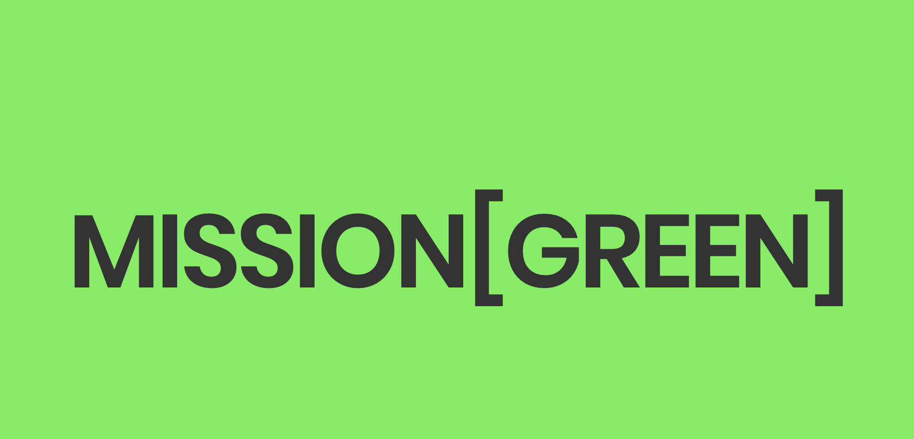
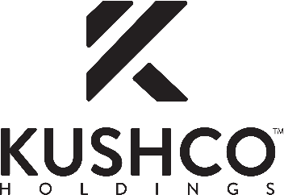

KushCo Holdings Partners with The Weldon Project’s “Project Mission Green” to Fight Social Injustice and Provide Relief for Victims of The War on Drugs

Company to Support Donations to Project Mission Green Through Co-Marketing and Discounts on Select Products for Participating Brands

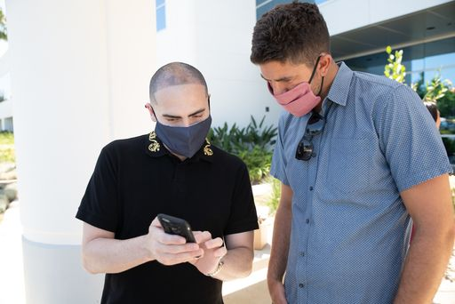
Project Mission Green founder Weldon Angelos and
KushCo Holdings co-founder and CEO Nick Kovacevich

CYPRESS and LOS ANGELES, Calif., — October 7, 2020 — KushCo Holdings, Inc. (OTCQX: KSHB) (''KushCo'' or the ''Company''), the premier provider of ancillary products and services to the legal cannabis and CBD industries, is proud to announce that it has partnered with Project Mission Green (“Mission Green”), an initiative of The Weldon Project that advocates on behalf of currently or formerly incarcerated cannabis offenders who were sentenced to prison for nonviolent cannabis offenses.

Mission Green works to address the injustices and the collateral consequences of cannabis arrests and convictions. The organization redresses these injustices and disparities through legislative advocacy and programs designed to both secure the release of nonviolent cannabis offenders from incarceration and to assist those coming out of prison in rebuilding their lives through re-entry programs.

Under the terms of the partnership, both parties will work together to raise awareness of—and to support— Mission Green’s social justice and social equity initiatives. This includes co-marketing efforts as well as a commitment by KushCo to donate to Mission Green up to 50% of the proceeds from the sale of select KushCo products.

The partnership represents KushCo’s latest efforts to create meaningful and lasting positive change against social injustice, following the Company’s previously announced paid time off award to its employees on “Election Day,” November 3, 2020. KushCo reaffirms its longstanding commitment to supporting the industry and affected communities against the decades-long “War on Drugs” and the deep-rooted racial profiling it has engendered. The Company is proud to be one of the founding sponsors of Mission Green and a long-time advocate of promoting social equity in the legal cannabis industry.

Leading up to the formation of the partnership, KushCo was instrumental in helping support REEForm Cannabis, a social equity-focused cannabis company founded by The Weldon Project’s President Weldon Angelos. In 2019, KushCo provided REEForm Cannabis with preferred pricing and credit terms to purchase high-quality packaging, papers, and supplies, which helped accelerate the brand’s growth. REEForm Cannabis pledges to provide monthly payments directly to commissary accounts of those needlessly suffering in prison for nonviolent cannabis possession. The brand has been financially supporting men and woman incarcerated for nonviolent cannabis-related offenses, while working tirelessly to ensure their personal freedom.

“We have always made it a priority to support our community, industry, and people, knowing full well that that there is a tremendous amount of work that still needs to be done to rectify the social injustices that have destroyed the lives of many,” said Nick Kovacevich, KushCo’s Co-founder, Chief Executive Officer and Chairman. “We immediately were drawn and hurt by Weldon’s tragic story of serving 13 years in prison for a low-level, first-time cannabis-related offense. But more than that, we knew that we could make a meaningful and lasting difference to right these wrongs, starting by supporting Mission Green’s unique purpose and team, which is made up of people who have been personally impacted by the justice system and have lived through the issues that came with it. We will not stop in this endeavor until we can ensure the safe release of many more vulnerable, at-risk incarcerated individuals from prison, and we are proud to have Mission Green as our partner in this essential cause.”

Angelos added: “While cannabis legalization has provided an opportunity for many to enrich themselves, those reaping the profits from the legal industry cannot forget those who have paid the ultimate price and whose suffering enabled them to be successful. KushCo is one of the few companies in our industry that truly understands that, and has never hesitated to support the cause, starting from the industry’s early days up until now. Given their stellar reputation for quality, breadth of products, and a deep and loyal customer network, we realized early on that KushCo is the ideal partner for Mission Green. More importantly, it has been obvious to us during this entire process, starting with KushCo’s first involvement with REEForm, that the people there, from the leadership on down, are truly committed to working towards clemency and criminal justice reform. It's personal to them in the same way it's personal to us, and we are thrilled to join forces, especially at this critical time where more new states are legalizing medical and/or adult recreational use cannabis, leaving many victims of the War on Drugs severely disadvantaged.”

About KushCo Holdings

KushCo Holdings, Inc. (OTCQX: KSHB) (www.kushco.com) is the premier provider of ancillary products and services to the legal cannabis and CBD industries. KushCo Holdings' subsidiaries and brands provide product quality, exceptional customer service, compliance knowledge and a local presence in serving its diverse customer base.

Founded in 2010, KushCo Holdings has now sold more than 1 billion units to growers, processors and producers across North America, South America, and Europe. The Company has been featured in media nationwide, including CNBC, Fox News, Yahoo Finance, Cheddar, Los Angeles Times, TheStreet.com, and Entrepreneur, Inc Magazine.

For more information, visit www.kushco.com or call (888) 920-5874.

About Project Mission Green

Project Mission Green (“Mission Green”) is an initiative of The Weldon Project (“TWP”) that brings together individuals impacted by the criminal justice system and unlikely allies from all sides of the political spectrum to push for criminal justice solutions. The organization works directly with lawmakers, celebrities, advocacy groups, incarcerated individuals, and the White House on a broad range of criminal justice issues. Notably, TWP helped pass the historic, bipartisan criminal justice reform legislation called the First Step Act which was signed into law in December 2018. TWP launched the Mission Green initiative (“Project Mission Green”) to focus exclusively on individuals incarcerated for cannabis-related offenses in the criminal justice system. The Mission Green campaign is led by people who have been directly impacted by prohibition and have lived through the issues that advocacy organizations are working to address. The people most affected by the current justice system are in a unique position to bring about transformative change.

For more information, visit www.theweldonproject.org/missiongreen.

KushCo Holdings Contact

Investor Contact:

Najim Mostamand, CFA

Director of Investor Relations

714-539-7653

ir@kushco.com

Project Mission Green Contact

Weldon Angelos
President, The Weldon Project
weldon@theweldonproject.org

