

NEUTRISCI PROVIDES UPDATE ON PRODUCT LAUNCH IN JAPAN

Vancouver, British Columbia – October 28, 2020 – NeutriSci International Inc. (“NeutriSci” or the “Company”) (TSX-V: NU, OTCQB: NRXCF, FRANKFURT: 1N9), an innovative technology company developing products for the nutraceutical industry, in conjunction with its partner, Tabletz LLC, is very pleased to update details regarding the launch of the TABLETZ brand in Japan.

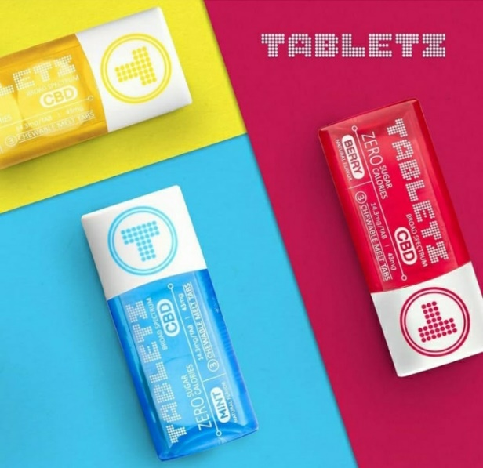
Tabletz LLC is holding an official launch of its brand on Nov 4th and 5th at the Trunk Hotel in Tokyo. The invite-only event will be attended by 200 industry VIPs, including corporate leaders, buying agents and executives from the largest retail houses in Japan.

The previously held ‘soft-launch’ event on October 8th and 9th was attended by approximately 3,000 people. The Tabletz brand received stellar reviews from all that were in attendance – “Great Taste!”, “Fantastic Packaging!”, “Portability!”, “Perfect Price Point!”, “Wow! There is nothing like this on the market!” were among the consistent high mark reviews.

The entire TABLETZ product line will be sold and distributed throughout Japan; a country with more than 126 million people. Distribution into 46,000 stores will include renowned retailers such as 7-Eleven, K.K. Lawson and Biople.

NeutriSci continues preparation for the upcoming ramp up in sales. The Company has been working hard behind the scenes to complete stick packaging, procure necessary ingredients for production while mobilizing its logistical network for distribution. The Company continues to receive the various required machinery and tools as it prepares for immediate production.

As previously stated, both NeutriSci and Tabletz LLC are planning to include the new bulk bottle. This new SKU will contain (35) 14 mg Tabletz and will be included with the previously announced Tabletz sticks. Final approval of the packaging for this product line, including pricing, will be completed in the coming days.

Glen Rehman, CEO of NeutriSci, stated: “After a fantastic ‘soft-launch’ in October, Tabletz LLC has taken the next necessary steps towards putting the product on the shelf. Many groups are being aligned to implement a long-term growth strategy. The support and feedback from retailers, celebrities, media, and influencers on the ground in Japan has been nothing but positive; Japan needs a product like Tabletz. These methodical and calculated steps are the efforts being put forth by Tabletz LLC. We could not agree more with their plan; a plan that is based on, solid long-term growth. We are looking forward to a successful and rewarding partnership for both companies!”

About NeutriSci International Inc.

NeutriSci specializes in the innovation, production, and formulation of nutraceutical products. Established in 2009, NeutriSci’s is building sustainable sales models with Convenience, Chain Drug, and Mass Market and Supermarket retailers for neuenergy®, the Company’s natural energy and focus supplement that has at its core, the beneficial effects of blueberries. For more information, please visit: www.neutrisci.com.

On Behalf of the Board of Directors of
NEUTRISCI INTERNATIONAL INC.
Glen Rehman
CEO
Tel: (403) 264-6320
For investor inquiries, please contact investors@neutrisci.com

Neither the TSX Venture Exchange nor its Regulation Services Provider (as that term is defined in policies of the TSX Venture Exchange) accept responsibility for the adequacy or accuracy of this release.

This news release may include forward-looking statements that are subject to risks and uncertainties. All statements within, other than statements of historical fact, are to be considered forward-looking. Although the Company believes the expectations expressed in such forward-looking statements are based on reasonable assumptions, such statements are not guarantees of future performance and actual results or developments may differ materially from those in forward-looking statements. Factors that could cause actual results to differ materially from those in forward-looking statements include market prices, continued availability of capital and financing, and general economic, market or business conditions. There can be no assurances that such statements will prove accurate and, therefore, readers are advised to rely on their own evaluation of such uncertainties. We do not assume any obligation to update any forward-looking statements except as required under the applicable laws.

Statements in this press release have not been evaluated by the Food and Drug Administration. Products or ingredients are not intended to diagnose, treat, cure, or prevent any disease.

