FOR IMMEDIATE RELEASE

NORAM SUCCESSFULLY PERMITTED FOR 5 ADDITIONAL HOLES TO DEPTHS OF 500 FT (152 M): DRILLS CVZ-64 TO A DEPTH OF 422 FT (129 M)
Vancouver, British Columbia – December 17, 2020 – Noram Ventures Inc. (“Noram” or the “Company”) (TSX - Venture: NRM / Frankfurt: N7R / OTCQB: NRVTF) is pleased to announce that the Company has received approval from the Bureau of Land Management (“BLM”) to complete an additional 5 holes up to depths of 500 ft as part of the Phase V Drill Program. As a result of successfully drilling the longest intersections to date during this campaign, the permitting depth was increased from 400 ft (122 m) to 500 ft (152 m).
Figure 1. Zeus Property map showing a) location of current Indicated and Inferred resources at >900ppm Li cut-off; b) location of drill sites completed or in progress (seen in green) to date for the Phase V 2020 program. Proposed drill sites not yet explored indicated in white.
CVZ-64 was completed at a depth of 422 ft (129 m) and potentially mineralized claystone was apparent near surface at 22 ft (7 m). It contained approximately 240 ft (73 m) of promising claystones of olive, black and blue colors. These type clays have contained high lithium values in drill holes from past Zeus Project drilling campaigns. CVZ-64 had olive clays from 22 – 109ft (7 – 33m), black and blue claystones from 109 – 212 ft (33 – 65 m) and blue claystones from 212 – 268 ft (65 – 82 m). Below this, the core hole intersected variably colored claystones that were gray, brown, blue and olive in color. This hole is out in an area that has not been tested by drilling to these depths, so it is unknown whether the lower units (below 268 ft) will contain the higher lithium grades anticipated for the upper part of this drill hole.
“Holes CVZ-63 and CVZ-64 were both drilled near the northeastern extent of the Zeus property. It is encouraging to note that both drill holes contain substantial thicknesses of the same claystones that were used to define the previously reported indicated and inferred lithium resource tonnages. Since the claystones are blanket-like lakebed sediments, these two drill holes establish that the claystones are present from the southwest to the northeast corners of the Zeus property, a distance of approximately 4 kilometers” commented Brad Peek, consulting geologist and Qualified Person for this and all 4 of the previous drilling phases of Noram’s Zeus lithium property.
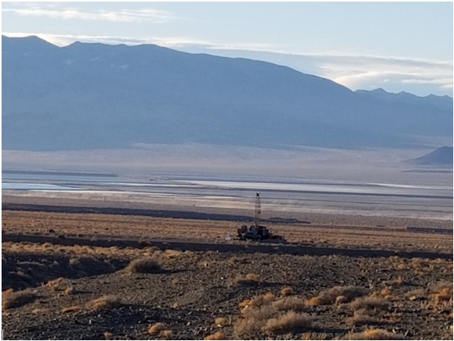
Figure 2 – Noram drill rig operating at Site A (CVZ-63) on the northeastern extent of the Zeus Property. Albemarle’s Silver Peak lithium brine evaporation ponds visible in the background.

Samples from CVZ-62 and CVZ-63 have been sent on a rush basis for analysis by ALS Global Laboratories, Vancouver, B.C. using the ME-MS61 method, which includes a four-acid digestion.

The technical information contained in this news release has been reviewed and approved by Brad Peek., M.Sc., CPG, who is a Qualified Person with respect to Noram’s Clayton Valley Lithium Project as defined under National Instrument 43-101.

About Noram Ventures Inc.
Noram Ventures Inc. (TSX - Venture: NRM / Frankfurt: N7R / OTCQB: NRVTF) is a Canadian based junior exploration company, with a goal of developing lithium deposits and becoming a low - cost supplier. The Company’s primary business is the Zeus Lithium Project (“Zeus”) in Clayton Valley, Nevada. The Zeus Project has a current resource estimate of 124 million tonnes at 1136 ppm lithium as Indicated Resources, and 77 million tonnes lithium at 1045 ppm lithium as Inferred Resources (900 ppm Li cut-off: 1.18 million tonnes lithium carbonate equivalent – “LCE”.
Noram’s long term strategy is to build a multi-national lithium minerals company to produce and sell lithium into the markets of Europe, North America and Asia.
Please visit our web site for further information: www.noramventures.com

ON BEHALF OF THE BOARD OF DIRECTORS
/s/ “Anita Algie.”
Director and CFO
Office: (604) 553-2279
Neither the TSX Venture Exchange nor its Regulation Services Provider (as that term is defined in the policies of the TSX Venture Exchange) accepts responsibility for the adequacy or accuracy of this release. This news release may contain forward-looking information which is not comprised of historical facts. Forward-looking information involves risks, uncertainties and other factors that could cause actual events, results, performance, prospects and opportunities to differ materially from those expressed or implied by such forward-looking information. Forward-looking information in this news release includes statements regarding, among other things, the completion transactions completed in the Agreement. Factors that could cause actual results to differ materially from such forward-looking information include, but are not limited to, regulatory approval processes. Although Noram believes that the assumptions used in preparing the forward-looking information in this news release are reasonable, including that all necessary regulatory approvals will be obtained in a timely manner, undue reliance should not be placed on such information, which only applies as of the date of this news release, and no assurance can be given that such events will occur in the disclosed time frames or at all. Noram disclaims any intention or obligation to update or revise any forward-looking information, whether as a result of new information, future events or otherwise, other than as required by applicable securities laws.

