FOR IMMEDIATE RELEASE
NORAM PROVIDES SUCCESSFUL UPDATE ON CHLORIDE-BASED LEACHING
FOR LITHIUM CLAY EXTRACTION: 95% LI INTO SOLUTION
Vancouver, British Columbia – January 26, 2021 – Noram Ventures Inc. (“Noram” or the “Company”) (TSX - Venture: NRM / Frankfurt: N7R / OTCQB: NRVTF) is pleased to provide a follow-up on the announcement made on January 14, 2021 pertaining to leaching studies. Noram is actively conducting a series of chloride-based leaching tests to extract lithium from Zeus claystone material. Noram has contracted Activation Laboratories, Inc. (“ALS”), of Ancaster, Ontario for this series of tests.

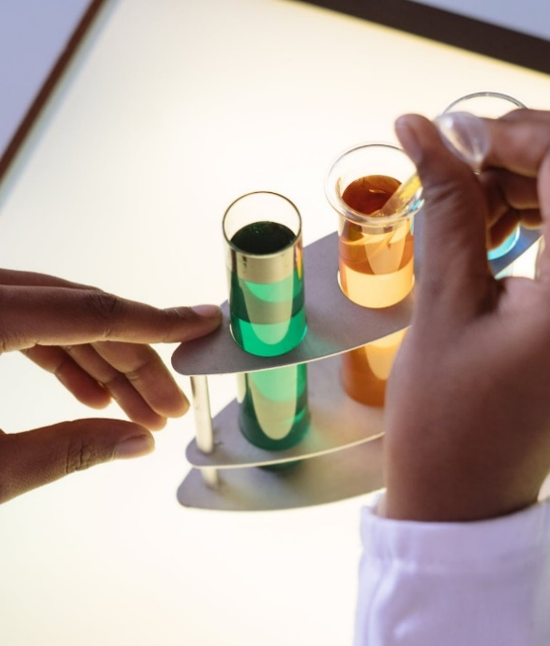

A second round of experiments has yielded up to 1230 ppm lithium into solution using moderate HCl and halide concentrations and moderate temperatures, for up to two hours. As the original sample has 1290 ppm lithium, this means that up to 95% of the lithium goes into solution. These values are significantly higher than those of the sulfate-based experiments conducted by Noram in 2018.

Noram and Actlabs will continue to optimize the leaching process with further carefully controlled and documented experiments through Q1 2021. These will provide guidance for detailed chemical engineering studies to be incorporated in a Preliminary Economic Assessment (PEA), with a goal of completing the PEA in 2021.

President and CEO C. Tucker Barrie discusses these results: “These chloride-based leaching tests are proving to be very significant for Noram. It appears that nearly all of the lithium in the claystone material can be put into solution with reasonable reagent concentrations. Chloride-based solutions are easier to manage than sulfate-based solutions, as there is a much lower chance for scaling or undesirable mineral precipitation during treatment. In addition, this may allow us to forego a building a sulfuric acid plant on site, which is a very significant part of the Capex of other lithium claystone projects in Nevada. Thus, we may save significantly on both the Capex and Opex for the Zeus project. We are enthused by these early results, and we look forward to refining and optimizing this process ahead of our PEA.”

About Noram Ventures Inc.
Noram Ventures Inc. (TSX - Venture: NRM / Frankfurt: N7R / OTCQB: NRVTF) is a Canadian based junior exploration company, with a goal of developing lithium deposits and becoming a low - cost supplier. The Company’s primary business is the Zeus Lithium Project (“Zeus”) in Clayton Valley, Nevada. The Zeus Project has a current resource estimate of 124 million tonnes at 1136 ppm lithium as Indicated Resources, and 77 million tonnes lithium at 1045 ppm lithium as Inferred Resources (900 ppm Li cut-off: 1.18 million tonnes lithium carbonate equivalent – “LCE”.

Noram’s long term strategy is to build a multi-national lithium minerals company to produce and sell lithium into the markets of Europe, North America and Asia.

Please visit our web site for further information: www.noramventures.com

ON BEHALF OF THE COMPANY
/s/ “Tucker Barrie”
President and CEO
Office: (604) 553-2279
Neither the TSX Venture Exchange nor its Regulation Services Provider (as that term is defined in the policies of the TSX Venture Exchange) accepts responsibility for the adequacy or accuracy of this release. This news release may contain forward-looking information which is not comprised of historical facts. Forward-looking information involves risks, uncertainties and other factors that could cause actual events, results, performance, prospects and opportunities to differ materially from those expressed or implied by such forward-looking information. Forward-looking information in this news release includes statements regarding, among other things, the completion transactions completed in the Agreement. Factors that could cause actual results to differ materially from such forward-looking information include, but are not limited to, regulatory approval processes. Although Noram believes that the assumptions used in preparing the forward-looking information in this news release are reasonable, including that all necessary regulatory approvals will be obtained in a timely manner, undue reliance should not be placed on such information, which only applies as of the date of this news release, and no assurance can be given that such events will occur in the disclosed time frames or at all. Noram disclaims any intention or obligation to update or revise any forward-looking information, whether as a result of new information, future events or otherwise, other than as required by applicable securities laws.

