Kisses From Italy Announces an Exclusive North American co-Branding Agreement with Manufacturer, Mastro Vinci

MIAMI, FL / ACCESSWIRE / January 26, 2021 / Kisses from Italy Inc. (OTCQB: KITL), a U.S.-based restaurant chain operator, Franchisor, and product distributor (the "Company"), is pleased to announce that an exclusive co-branding agreement has been entered into with Gluten-Free specialist and food manufacturer Mastro Vinci, based in Mississauga, Ontario. The new agreement is now in effect and covers the entire North American market. The exclusive agreement will immediately include Mastro Vinci’s Organic and Gluten-Free Gnocchi as well as the Gluten-Free Dry Pasta. Both parties have agreed to leave room in the exclusive agreement for the list of products to grow in the future.

Michele Di Turi, President, co-CEO and co-founder of Kisses from Italy stated, “having worked with Mastro Vinci, in a short period of time, both organizations have realized that the aligning of our interests was the best course of action to take immediately. We are impressed with Mastro Vinci’s vision of the market, their products and production process. We felt that it was important to attach our brand to Mastro Vinci’s Organic and Gluten-Free Gnocchi as well as the Gluten-Free Dry-Pasta and we expect the list of products included in the co-branding agreement to grow in the future. Di Turi added,” from the first time we tried Mastro Vinci’s Organic and Gluten-Free Gnocchi and Gluten-Free Dry Pasta we became instant fans. We were certain that we had fallen upon one of the more superior products when compared to other Gluten-Free pasta products available in the market.”
Olesya Krivobok, President of Mastro Vinci, commented” we are pleased to enter into this
agreement with Kisses from Italy sharing the same vision to offer superior products to an
increasingly demanding segment of the population. Furthermore, we feel that we are a good
alternative with a locally produced gluten free line of products. We are proudly Canadian made
with an Italian flair and possess the capabilities to meet larger demand with our affiliate manufacturing and production plants in California.”

Claudio Ferri, co-CEO, CIO and co-founder of Kisses from Italy commented, “Kisses From Italy/ Mastro Vinci Organic, Gluten-Free Gnocchi and Gluten-Free Dry-Pasta have been in stores since the beginning of December and we have been humbled by the high demand for these products, therefore we needed to solidify this agreement with the team at Mastro Vinci. When the Company began its project to have Kisses From Italy branded products in retail stores in Canada, at the end of November 2020, we expected to have our products in approximately 2 or 3 retail stores by the end of 2020. Having underestimated the demand and the unexpected overwhelming welcome from the consumers we ended 2020 by being in 9 retail stores, in Canada. Presently, the number of stores carrying Kisses From Italy products has grown to 15 and we strongly believe that it will only continue to climb higher from here”. Ferri further stated,” we have been able to penetrate 15 stores, in the Montreal and Toronto area, at a minimal expense and we believe that we have barely scratched the surface of what is possible in Canada, let alone the enormous North American market and the overall demand for healthy gluten-free products.”

Kisses From Italy's focus remains on the main business lines of being a restaurant chain operator, Franchisor, and product distributor and continues to move forward in growing the brand and streamlining its efficiencies which includes its current retail stores in South Florida, Bari (Italy) and soon to be open the Company's first franchise in the State of California which has been unexpectedly delayed due to the onset of COVID. Despite the severe challenges we faced in 2020 we have emerged as a stronger and better positioned Company going into 2021.

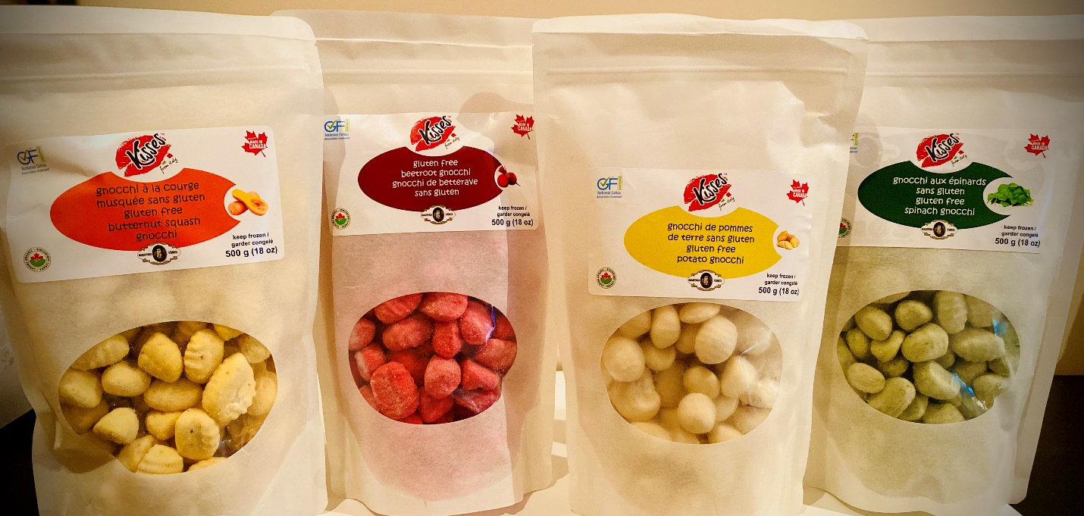
Kisses From Italy / Mastro Vinci Organic and Gluten Free Gnocchi
(Potato, Beet Root, Butternut Squash, Spinach)
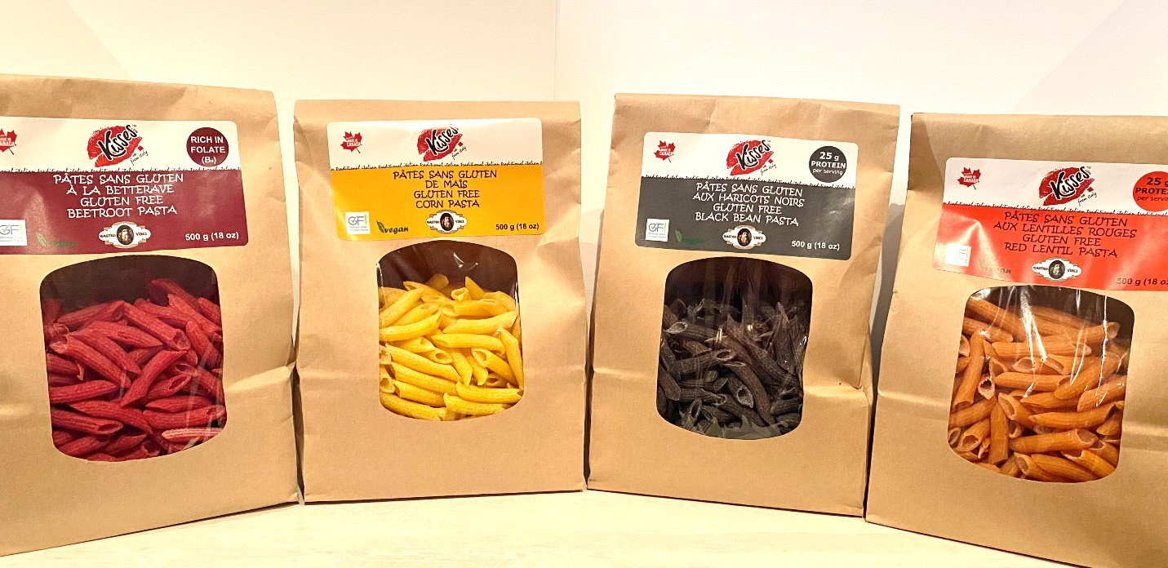
Kisses From Italy / Mastro Vinci Gluten-Free Pasta
(Black Bean, Yellow Corn, Beet Root and Red-Lentil)

About Kisses from Italy Inc.
Kisses from Italy Inc. is a U.S.-based restaurant chain operator, franchisor and product distributor with locations in North America and Europe. The Company offers a quick-service menu and a unique take on traditional Italian delicacies with an All-American flair. Kisses from Italy offerings include sandwiches, salads, Italian roasted coffee, coffee-related beverage and an array of other products. The Company currently operates four corporate-owned stores. It successfully commenced operations in May 2015 with the opening of its flagship location in Ft. Lauderdale at 3146 NE 9th St. This was followed by three additional sites across the greater Ft. Lauderdale/Pompano Beach area. The Company recently opened its inaugural European location in Ceglie del Campo, Bari, Italy in October of 2019. In September of 2019, Kisses from Italy Inc. was given the approval by FINRA to trade its common stock and was approved for up-listing by the OTC Markets Group to the OTCQB in mid-October 2019 under the ticker symbol KITL.

About Mastro Vinci
Mastro Vinci, founded in 2017, is a Canadian based manufacturer, producer and distributor of high-quality products. Mastro Vinci’s high standards allow them to be at the forefront of manufacturing products such as kosher, gluten free, peanut free, soy free, non-GMO healthy foods. Mastro Vinci also provides a large selection of European and locally grown corn flour, legume pulses, specialty flour, pasta, pizza, canned products and a growing list of natural products. Mastro Vinci’s production capabilities extend into the U.S. with affiliate production plants in California.

Forward-Looking Statements
This press release may contain forward-looking statements, which are based on current expectations, forecasts, and assumptions that involve risks and uncertainties that could cause actual outcomes and results to differ materially from those anticipated or expected, including statements related to the amount and timing of expected revenues and any payment of dividends on our common and preferred stock, statements related to our financial performance, expected income, distributions, and future growth for upcoming quarterly and annual periods. These risks and uncertainties are further defined in filings and reports by the Company with the Securities and Exchange Commission (SEC). Actual results and the timing of certain events could differ materially from those projected in or contemplated by the forward-looking statements due to a number of factors detailed from time to time in our filings with the SEC. Among other matters, the Company may not be able to sustain growth or achieve profitability based upon many factors including, but not limited to, general stock market conditions. Reference is hereby made to cautionary statements set forth in the Company's most recent SEC filings. We have incurred and will continue to incur significant expenses in our expansion of our existing and new service lines, noting there is no assurance that we will generate enough revenues to offset those costs in both the near and long term. Additional service offerings may expose us to additional legal and regulatory costs and unknown exposure(s) based upon the various geopolitical locations where we will be providing services, the impact of which cannot be predicted at this time. Additionally, the ultimate impact of the Covid-19 pandemic on our company's operations continues to evolve, is highly uncertain and subject to change.
For more information, please visit www.kissesfromitaly.com
Contact Information:
Kisses from Italy Inc.
305-423-7129
info@kissesfromitaly.com
SOURCE: Kisses from Italy Inc.

