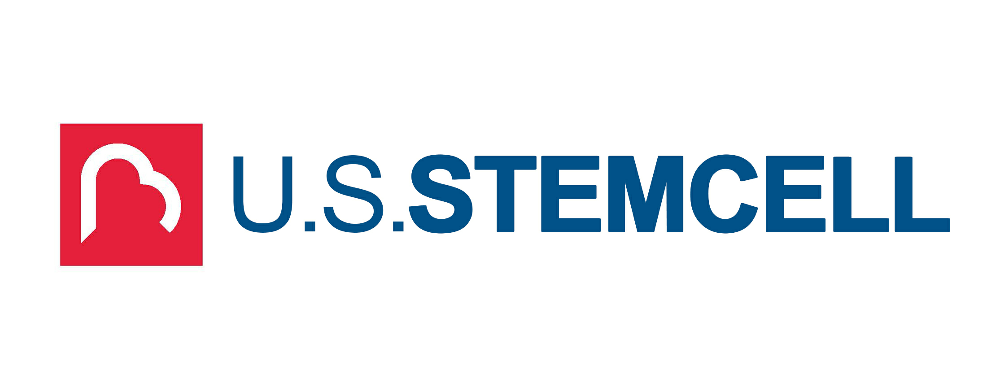

Media Contact: U.S. Stem Cell, Inc.
1560 Sawgrass Corporate Parkway, 4th Fl.
Sunrise, FL 33323
Phone: 954.835.1500
Email: usstemcell@us-stemcell.com
For Immediate Release

Northstar Biotech and USRM BOD Members Reinvest in the Company
___________________________________________

SUNRISE, FL – XX. XX, 2021 – U.S. Stem Cell, Inc. (OTC: USRM), a leader in the development of proprietary, physician-based, and novel regenerative medicine solutions, is pleased to announce the efforts of NorthStar Biotech Group and USRM Board Members to reinvest in U.S. Stem Cell, Inc.

On May 9, 2018, the U.S. Department of Justice, at the request of the U.S. Food and Drug Administration (FDA), filed suit against U.S. Stem Cell, Inc. and others to enjoin defendants from utilizing the SVF Surgical Procedure, in which “stromal vascular fraction” (SVF) cells are removed from a patient’s fat tissue and reimplanted in the patient during the same surgical procedure. The Company has maintained that such cellular therapies are surgical procedures regulated by state law, and that the SVF surgical procedure is excepted from regulation under the Federal Food, Drug, and Cosmetic Act (FDCA). On June 25, 2019, the federal court for the Southern District of Florida ruled in favor of the government, enjoining the Company and the other defendants from certain product sales and processes. The Company filed an appeal on August 23, 2019 and attended oral argument on January 13th, 2021. The Court of Appeal has not yet ruled on the Company’s appeal that the injunction should not have been entered.

“While there can be no assurances for a positive outcome of the case, we believe and fully support the mission of U.S. Stem Cell” said Gregory Knutson, Managing Partner of NorthStar Biotech Group and U.S. Stem Cell board director. Further commenting “We believe in the technology and the potential of the Company and now is the time to help support it towards the next goal.”

“The support of our NorthStar Biotech partners and our board of directors is timely, crucial and testament to our company’s potential.” States Mike Tomas, President and CEO of U.S. Stem Cell Inc.

U.S. Stem Cell, Inc. is an emerging leader in the regenerative medicine and cellular therapy industry specializing in physician training and certification, as well as veterinary applications, and management of cellular therapy clinics. To management’s knowledge, the Company historically has completed more clinical treatments than any other cellular therapy company in the world in the past 20 years, and has certified more than 700 physicians and veterinarians in autologous cell therapies worldwide.

Forward-Looking Statements: Except for historical matters contained herein, statements made in this press release are forward-looking statements. Without limiting the generality of the foregoing, words such as “may”, “will”, “to”, “plan”, “expect”, “believe”, “anticipate”, “intend”, “could”, “would”, “estimate”, or “continue”, or the negative other variations thereof or comparable terminology are intended to identify forward-looking statements. Forward-looking statements involve known and unknown risks, uncertainties and other factors, which may cause our actual results, performance or achievements to be materially different from any future results, performance or achievements expressed or implied by the forward-looking statements and represent our management’s beliefs and assumptions only as of the date hereof. Except as required by law, we assume no obligation to update these forward-looking statements, even if new information becomes available in the future. The Company’s business and the risks and uncertainties of the business are described in its past filings with the Securities and Exchange Commission which can be found at sec.gov.

# # #

