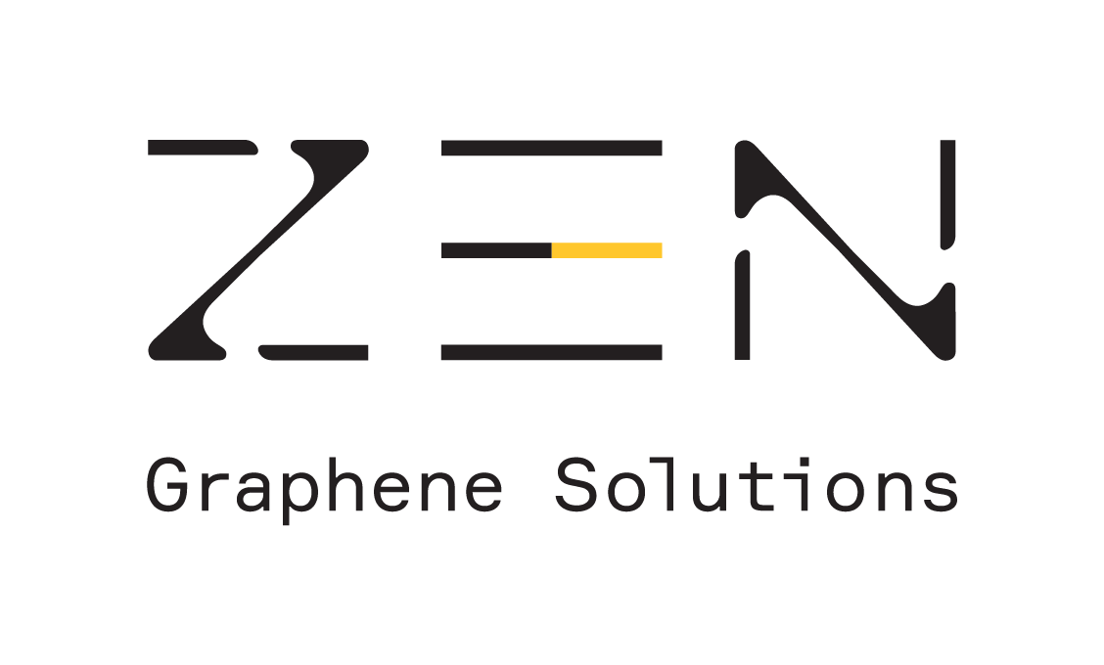
ZEN Graphene Solutions Announces Successful
Phase 2 Cytotoxicity Testing Results

Guelph, ON – March 2, 2021, ZEN Graphene Solutions Ltd. (“ZEN” or the “Company”) (TSX-V:ZEN and OTC:ZENYF), a next-gen nanomaterials technology company, is pleased to announce successful phase 2 results from cytotoxicity testing of its graphene-based compound. Nucro-Technics recorded no adverse effects after seven days of repeated dosing with concentrations many thousands of times higher than those found to be 99.9% effective against viruses, bacteria, and fungi.
Dr. Francis Dubé, Executive Chairman, commented: “This is an exciting next step as we continue to demonstrate the safety of our antibiotic, antiviral, and antifungal compound that could be a potential medical breakthrough treatment for human-contracted pathogens. ZEN’s technology could play a key role in infectious disease management, an area where several billions of dollars are allocated each year and, more specifically, in antimicrobial resistance. The World Health Organization considers this to be one of the top 10 global public health threats facing humanity. Our compound is being tested against several multi-drug resistant organisms that are a part of that global public health threat, and we expect to receive results from that study soon.”
Repeated Dose Toxicity Study
Testing was conducted by Nucro-Technics – a fully accredited Pharmaceutical Contract Research Organization that is a partner to pharmaceutical companies located worldwide. Nucro-Technics is inspected by and in compliance with the US Food and Drug Administration and Health Canada.
Results Overview:
- No significant abnormal clinical observations were noted during the 7-day repeated dose study
- No findings in blood clinical pathology that could be attributed to the dosing
- No significant or clinically relevant alterations in absolute organ weights, organ/body weight, or organ/brain weight ratios
- No abnormal findings from histopathology attributed to the dosing
- Analysis of all generated data indicated that ZEN’s compound was well tolerated following a 7-day repeated oral dose administration
Based on these encouraging results, ZEN will now initiate a 14-day repeated dose toxicity safety preclinical study that will be conducted by Nucro-Technics in accordance with Good Laboratory Practice regulations to support Phase 1 human clinical trials.
Disclaimer
The company is not making any express or implied claims that its product has the ability to eliminate, cure or contain COVID-19 at this time
The company must receive Health Canada or Food and Drug Administration approvals for any of the products or solutions discussed.
About ZEN Graphene Solutions Ltd.
ZEN is a next-gen nanomaterials technology company developing graphene-based technologies that help protect people and the environment, as well as making existing products better. ZEN is currently focused on commercializing a patent pending graphene-based coating with 99% biocidal activity, including against COVID-19, and the potential to use similar graphene compounds as pharmaceutical products against infectious diseases. The company has a significant R&D pipeline with an interest in monomers, polymers, metal alloys, corrosion coatings, biosensors along with the production of graphene oxide and graphene quantum dots. Additionally, the company owns the unique Albany Graphite Project which provides the company with a potential competitive advantage in the graphene market. Labs in Japan, UK, Israel, USA, and Canada have independently demonstrated that ZEN’s Albany PureTM Graphite is an ideal precursor material that easily converts (exfoliates) to graphene, using a variety of mechanical, chemical, and electrochemical methods.
For further information:
Dr. Francis Dubé, Executive Chairman
Tel: +1 (289) 821-2820
Email: drfdube@zengraphene.com
To find out more about ZEN Graphene Solutions Ltd., please visit our website at www.ZENGraphene.com. A copy of this news release and all material documents in respect of the Company may be obtained on ZEN’s SEDAR profile at www.sedar.ca.
Forward-Looking Statements
This news release contains forward-looking statements. Since forward-looking statements address future events and conditions, by their very nature they involve inherent risks and uncertainties. Although ZEN believes that the assumptions and factors used in preparing the forward-looking information in this news release are reasonable, undue reliance should not be placed on such information, which only applies as of the date of this news release, and no assurance can be given that such events will occur in the disclosed time frames or at all. ZEN disclaims any intention or obligation to update or revise any forward-looking information, whether as a result of new information, future events or otherwise, other than as required by law. Neither the TSX Venture Exchange nor its Regulation Services Provider (as that term is defined in the policies of the TSX Venture Exchange) accepts responsibility for the adequacy or accuracy of this release.

