NEWS RELEASE

Roscan Gold Continues to Expand and Upgrade the Kandiole North Discovery with a 2,000m Strike Length and 92m Depth that Remains Open.

Intersects 4.13gpt over 10m and 5.43gpt over 7m.

Toronto, Ontario. – March 11, 2021 – Roscan Gold Corporation (“Roscan” or the “Company”) (TSX-V: ROS; FSE:2OJ; OTC:RCGCF) is pleased to announce the positive drill results at the Kandiole North discovery where the mineralized zone is expanding in size. (Figure 1 and Figure 2). We continue to increase depth extension and strike length at Kandiole North with high grade intercepts and the mineralized zones remain open. We have extended gold mineralization down to 92m depth at Kandiole North (Figure 3 and Figure 4).

The Kandiole North (KN1) gold mineralization trend appears to extend for 8km to Moussala (MO1) (Figure 1 & 2) and Kandiole North (KN2) gold mineralization trend appears to extend for 6km to Kabaya (Figure 1 & 2). Drilling at Kabaya is ongoing with the aim to connect these targets and expand its current dimensions. Both Kabaya, Kandiole North and Moussala remains open along strike and depth.

The mineralized corridor trends N020 with steep easterly dips but within the corridor, there are E-W domains with steep north dipping quartz veins that carry the best gold grades (Figure 6). On the section (Figure 3), the mineralization appears to dip 45° NE but if these intersections correspond to E-W domains (Figure 7), then true widths are in the order of 20m and 10m for the two zones interpreted and dips are about 65°N.

Drilling Highlights:

KANDIOLE NORTH - DD AND RC Holes
- 6.67 gpt gold over 4m from drill hole RCKAN21-010 from 116m (End of hole)
    - Including 21.9 gpt gold over 1m from 117m
- 5.43 gpt gold over 7m from drill hole RCKAN21-003 from 69m
    - Including 21.9 gpt gold over 1m from 73m
- 4.13 gpt gold over 10m from drill hole RCKAN21-002 from 90m
    - Including 25.8 gpt gold over 1m from 92m
  - And 3.13 gpt gold over 7m from drill hole RCKAN21-002 from 50m
    - Including 12.0 gpt gold over 1m from 52 m
- 2.60 gpt gold over 9m from drill hole RCKAN21-011 from 27m
  - And 1.91 gpt gold over 11m from drill hole RCKAN21-011 from 65m
    - Including 10.0 gpt gold over 1m from 72m

KANDIOLE NORTH (KN1) AC
- 9.30 gpt gold over 4m from drill hole ACKAN20-1223 from 14m
    - Including 18.0 gpt gold over 2m from 16m
- 4.28 gpt gold over 6m from drill hole ACKAN20-1233 from 8m
- 3.37 gpt gold over 8m from drill hole ACKAN20-842 from 30m
    - Including 15.7 gpt gold over 1m from 31m

KANDIOLE NORTH (KN4) - AC Holes
- 4.91 gpt gold over 4m from drill hole ACKAN20-1380 from 10m (End of hole)

KANDIOLE NORTH (Regional)
- 9.79 gpt gold over 2m from drill hole ACKAN20-1105 from 10m

Notes: 1: True width yet to be determined, 2: Table 1 – Assay Highlights, 3: 0.5gpt used as cut-off with 2m internal dilution, 4: No top-cut.

Nana Sangmuah, President and CEO, stated, " Kandiole North has been returning some great results and shaping up to be a key deposit for resource definition with 2km strike length and 92m depth and remains open for further expansion along strike and at depth. Numerous holes ended in mineralization clearly showing the potential at depth. We are confident that this resource will play a crucial role in adding significant value to our company building on top of our flagship discoveries of Mankouke South and Kabaya.

The continued drilling success on our numerous regional targets is proving the potential to add ounces from multiple targets on our large land package. We are also seeing encouraging results from our other regional discoveries made in late 2020 including Walia and Moussala North and we look forward to providing updates on those in the near future as more assays become available.

The potential for numerous mineralized corridors on the property over long strike lengths is being further validated by our recent regional exploration success and step out drilling outside of Mankouke South with hole 89 released earlier this week, we are looking forward to sharing the full results of our extensive geophysics survey in the coming weeks which will further show the clear regional potential for a multi million oz mining camp at Kandiole.

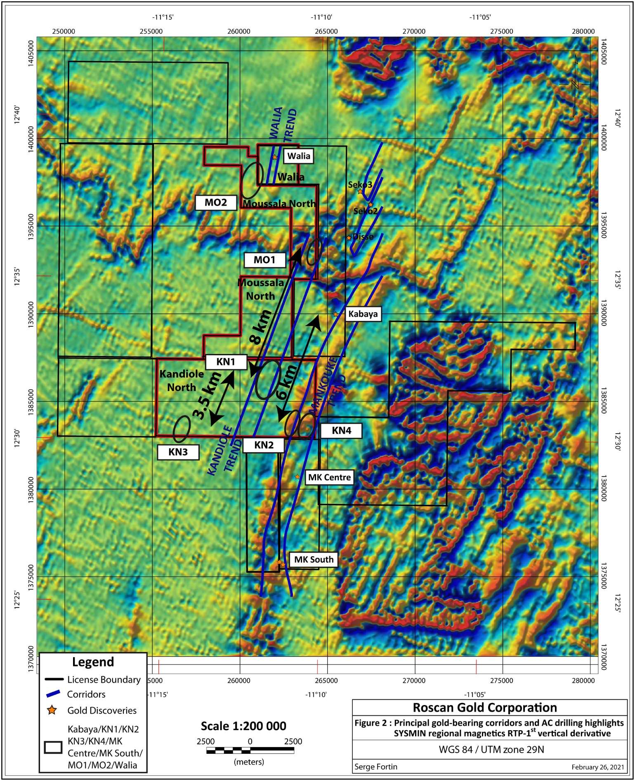
Figure 1: Plan View of the Regional Targets

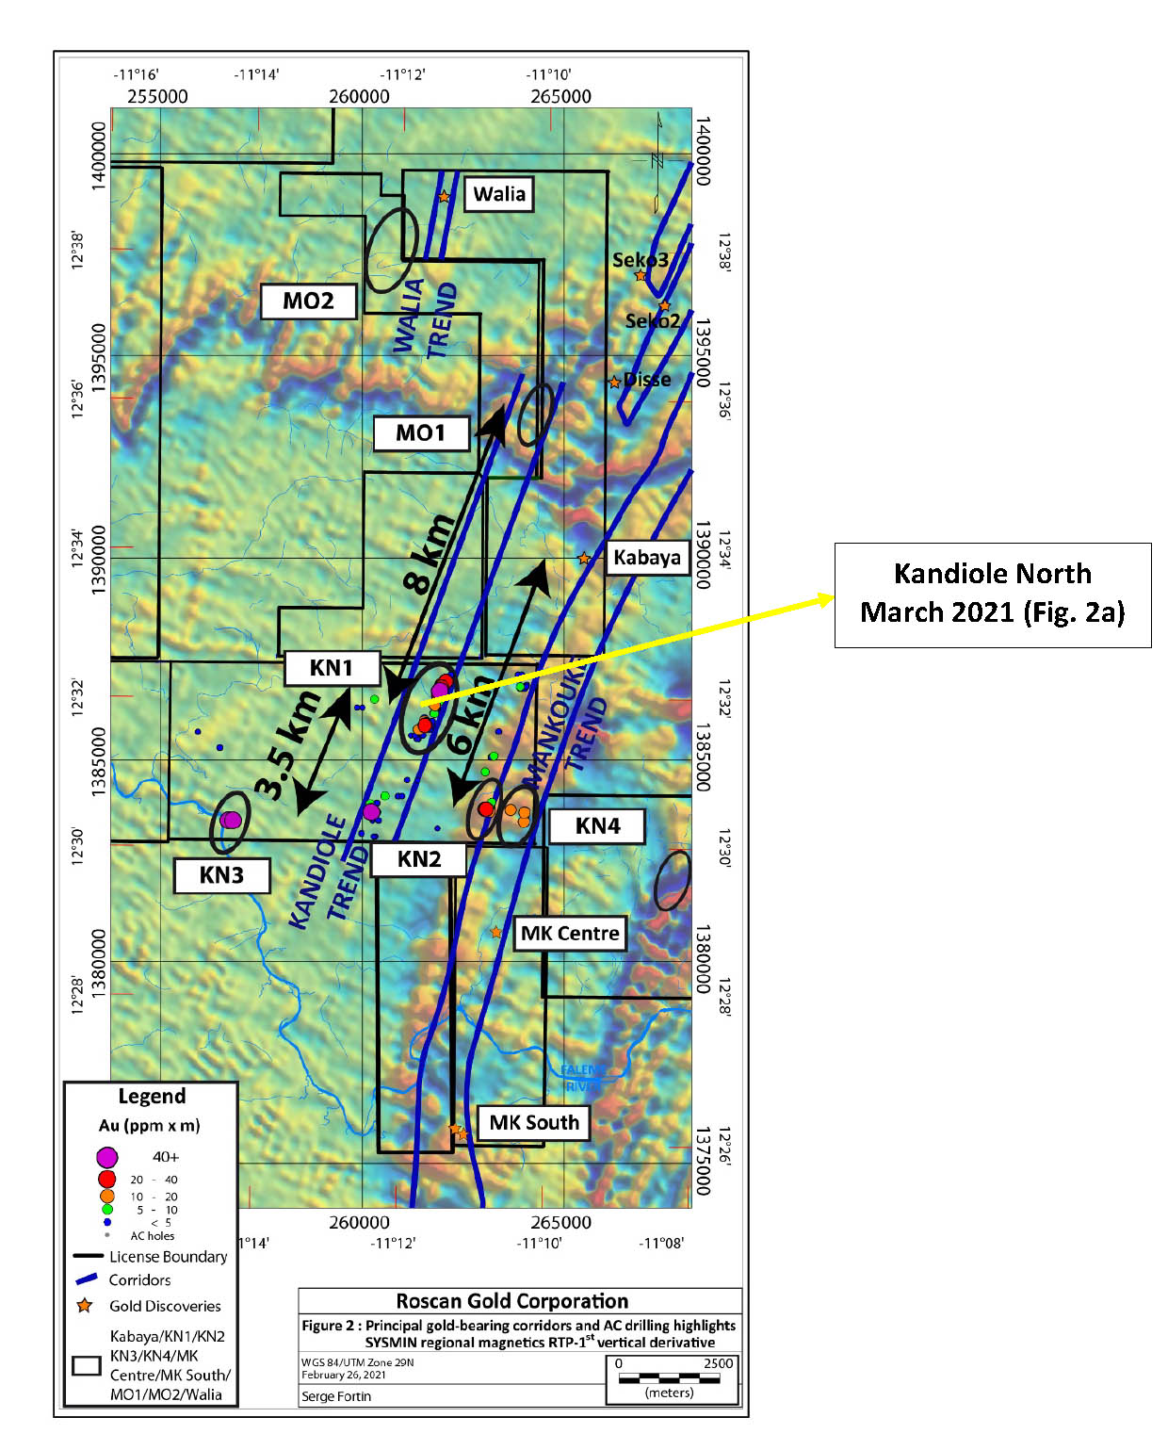

Figure 2: Plan View of the Major Trends on our Regional Targets

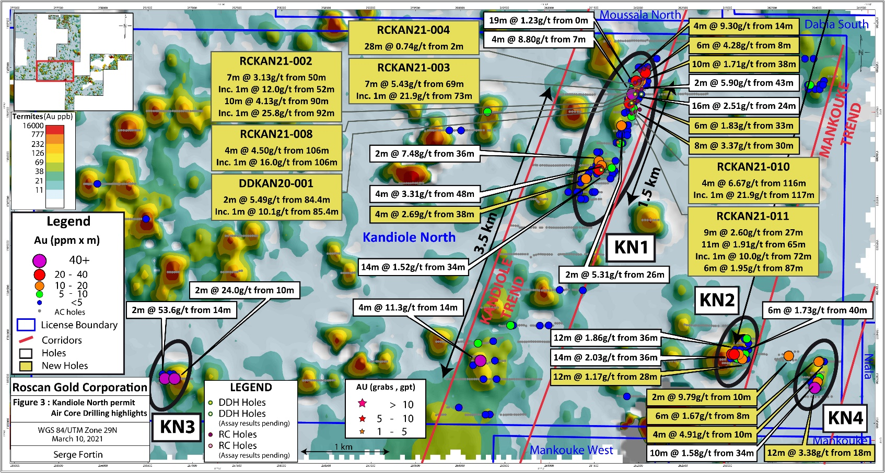
Figure 2a: Plan View showing high grades at Kandiole North with Strike Length 2km

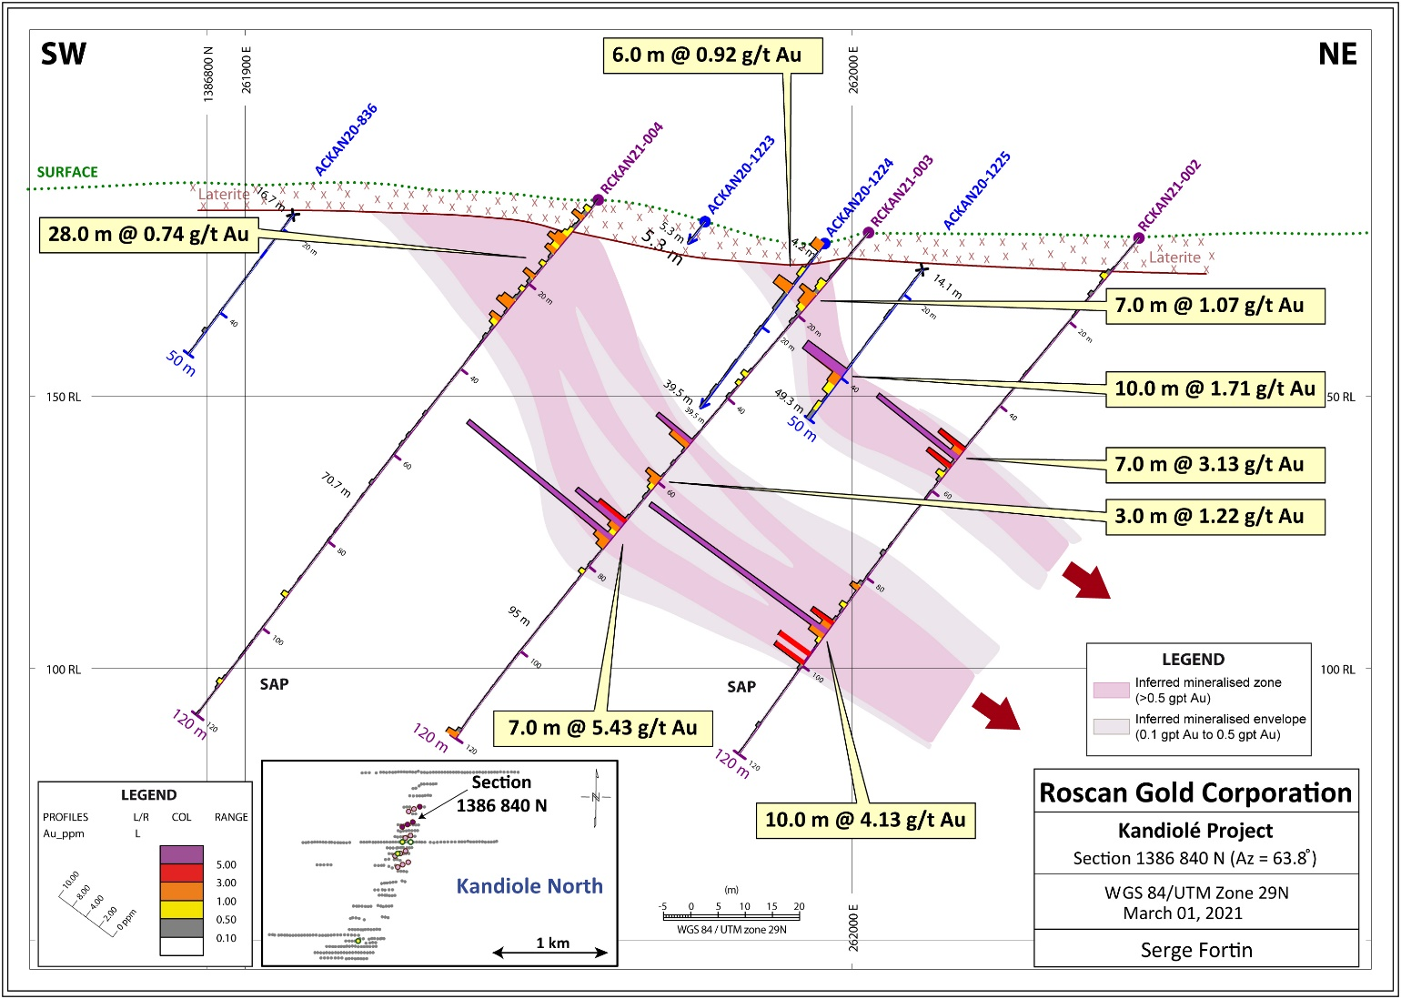
Figure 3: Cross Section at Kandiole North Depicting the Depth Potential
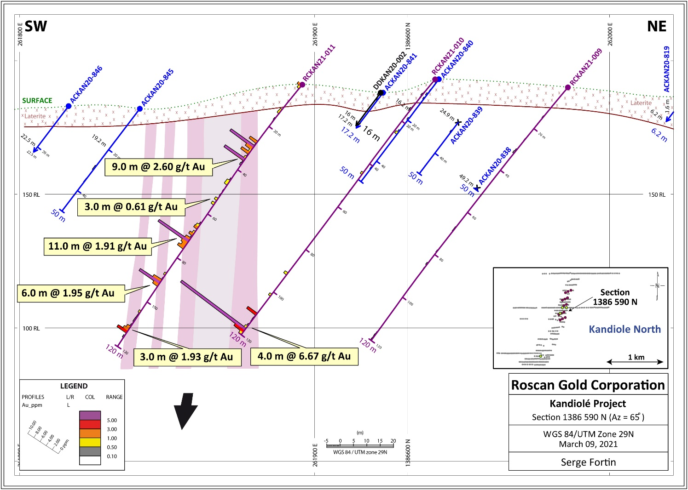
Figure 4: Cross Section at Kandiole North Depicting the Depth Potential
- At Kandiole North we continue to hit very good grades and increase the dimensions of the targets. Hole RCKAN21-002 when coupled with previously high-grade drill holes, shows the persistent nature of the resource and in fresh rock. Figures 3 and 4 clearly shows the mineralized zone remains open at depth.

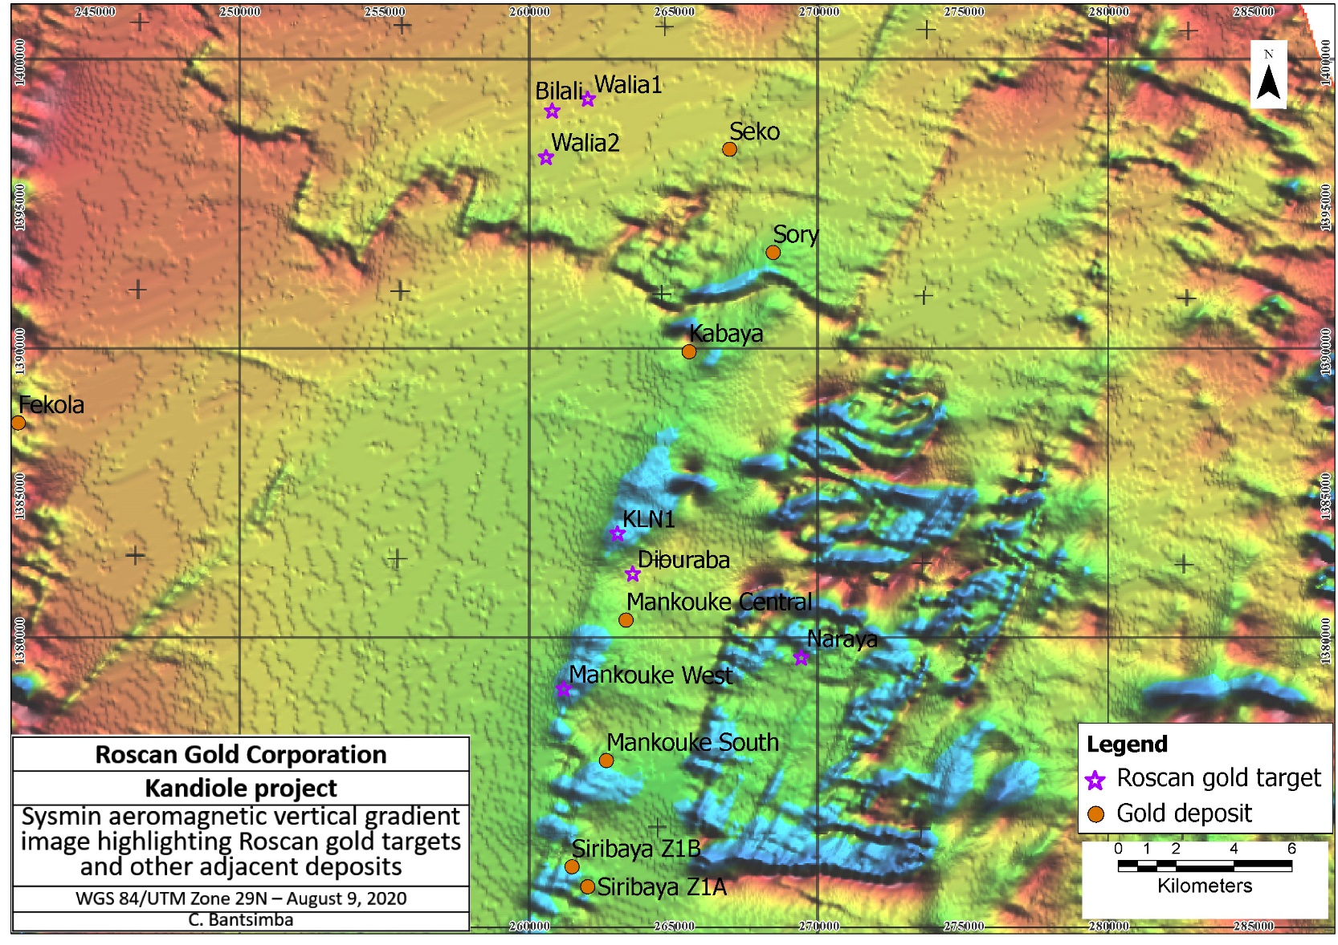
Figure 5: Geophysics data showing the major structure on Kandiole Project

- We are continuing to drill our flagship projects namely Mankouke South and Kabaya, and drilling is also continuing on regional targets which are giving us some excellent results. – it is anticipated we will follow up on expanding and growing key targets.

Geology

The gold mineralization at Kandiole Project is located approximately 25km east of the Fekola mine (B2Gold Corp.). Gold mineralization in Kandiole Project occurs within hydrothermally altered and sheared metasediments of the Kofi formation which include greywacke, limestone and diamictite.

KANDIOLE KN1
Kandiole North has been upgraded from target status to a confirmed zone of mineralization where continuity both along strike and to depth exists. We will continue to drill to build on this mineralization from the initial round of drilling. KN1 alteration in the mineralized saprolite suggests a disseminated pyrite + quartz vein deposit (Figure 5).

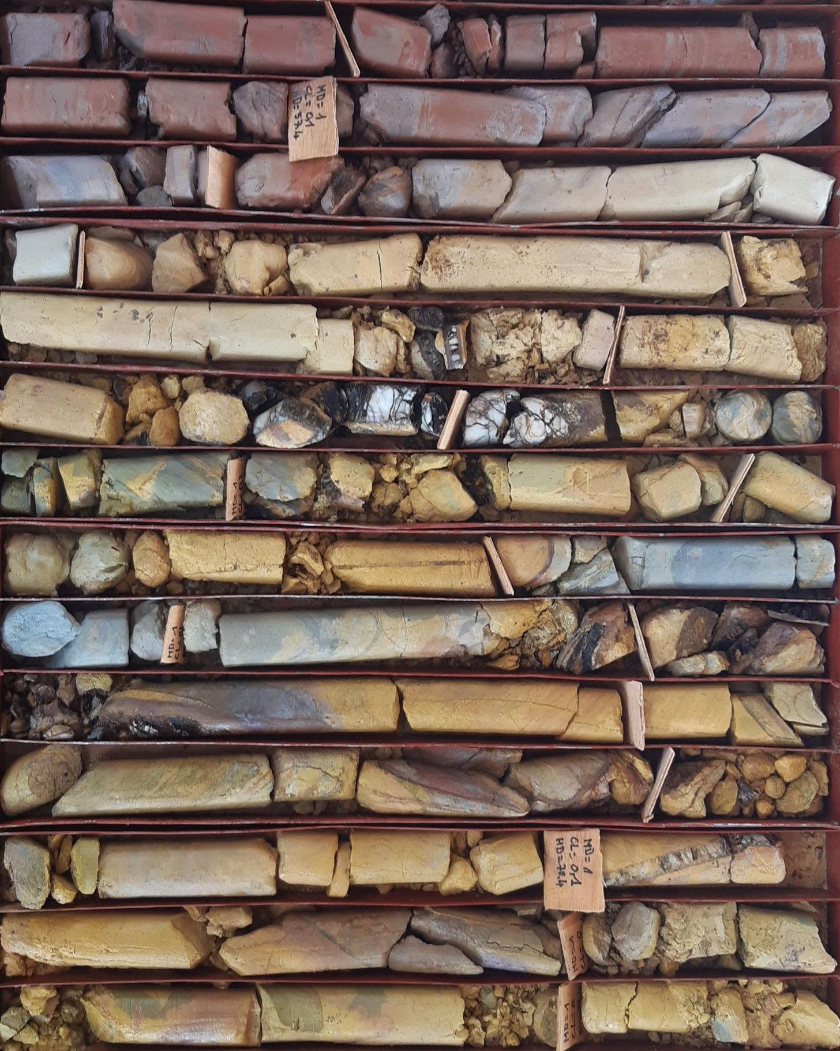
Figure 6: Drill Core Photo at Kandiole North Showing High Grades (DDKAN20-001)

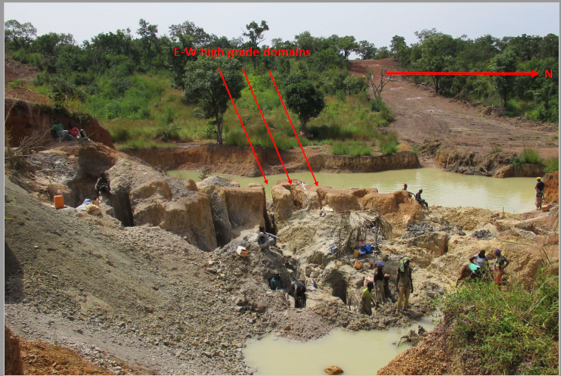
Figure 7: Small Scale Miners at Kandiole North

Drilling Contract and Analytical Protocol

The drilling contracts were awarded to Target Drilling SARL and Geodrill, who both employ multi-purpose (AC/RC/DD) rig and AC rigs, at the Kandiole Project. The AC drilling is mainly focused on drilling exploration targets. Roscan applied industry-standard QA/QC procedures to the program. Certified reference materials, blanks and field duplicates are inserted at appropriate intervals.

The samples are sent for preparation to Bureau Veritas Mineral Laboratories in Bamako, Mali and assayed at their analytical facilities in Bamako and in Abidjan, Ivory Coast with fire assay with atomic absorption finish and by gravimetric finish for grades above 10gpt Au.

Table 1: Drillhole Highlights of Kandiole North (March 11, 2021)
Hole ID | From (m) | To (m) | Interval (m) | gpt Au | Comment
KANDIOLE NORTH DD AND RC - KN1 |  |  |  |  | Saprolite unless otherwise noted
DDKAN20-001 | 60.4 | 67.4 | 7 | 1.31
 | 74.4 | 75.4 | 1 | 6.84
 | 78.4 | 79.4 | 1 | 0.97
 | 84.4 | 86.4 | 2 | 5.49
including | 85.4 | 86.4 | 1 | 10.1
 | 89.4 | 91.4 | 2 | 2.81
 | 94.4 | 95.4 | 1 | 0.51
 | 104.4 | 105.4 | 1 | 0.63
DDKAN20-002 | 32.5 | 33.5 | 1 | 0.64
 | 54.5 | 59.5 | 5 | 1.21
 | 66.5 | 67.5 | 1 | 1.24
 | 70.5 | 71.5 | 1 | 0.90
 | 74.5 | 77.5 | 3 | 1.33
 | 80.5 | 81.5 | 1 | 0.50
 | 109.5 | 110.5 | 1 | 0.52
 | 127.5 | 128.5 | 1 | 0.55
DDKAN20-003 |  |  |  |  | NSR
DDKAN21-004 | 9.0 | 10.0 | 1 | 5.55
 | 19.0 | 20.0 | 1 | 1.28 | Assays pending from 22m
 | 38.0 | 39.0 | 1 | 0.57
RCDDKAN21-05 | 188.4 | 189.4 | 1 | 0.88 | FRESH
 |  |  |  |  | Assays pending starting 291m to EOH at 320m
RCKAN21-001 | 50.0 | 51.0 | 1 | 4.73
 | 73.0 | 74.0 | 1 | 1.64
RCKAN21-002 | 9.0 | 10.0 | 1 | 0.72
 | 50.0 | 57.0 | 7 | 3.13
including | 52.0 | 53.0 | 1 | 12.0
 | 82.0 | 83.0 | 1 | 1.09
 | 86.0 | 87.0 | 1 | 0.72
 | 90.0 | 100.0 | 10 | 4.13
including | 92.0 | 93.0 | 1 | 25.8
RCKAN21-003 | 12.0 | 19.0 | 7 | 1.07
 | 34.0 | 35.0 | 1 | 0.77
 | 36.0 | 37.0 | 1 | 0.54
 | 50.0 | 52.0 | 2 | 3.89
 | 59.0 | 62.0 | 3 | 1.22
 | 69.0 | 76.0 | 7 | 5.43
including | 73.0 | 74.0 | 1 | 21.9
 | 81.0 | 82.0 | 1 | 0.60
 | 119.0 | 120.0 | 1 | 1.40 | END OF THE HOLE
RCKAN21-004 | 2.0 | 30.0 | 28 | 0.74
 | 92.0 | 93.0 | 1 | 0.66
 | 111.0 | 112.0 | 1 | 0.56
RCKAN21-005 | 119 | 120 | 1 | 1.26 | END OF THE HOLE
RCKAN21-006 | 1.0 | 2.0 | 1 | 0.85 | LAT
 | 64.0 | 65.0 | 1 | 0.98
RCKAN21-007 | 38.0 | 39.0 | 1 | 0.57
RCKAN21-008 | 98.0 | 100.0 | 2 | 1.37
 | 106.0 | 110.0 | 4 | 4.50
including | 106.0 | 107.0 | 1 | 16.0
RCKAN21-010 | 44.0 | 45.0 | 1 | 0.57
 | 91.0 | 92.0 | 1 | 0.99
 | 101.0 | 102.0 | 1 | 0.67
 | 110.0 | 111.0 | 1 | 3.17
 | 116.0 | 120.0 | 4 | 6.67 | END OF THE HOLE
including | 117.0 | 118.0 | 1 | 21.9
RCKAN21-011 | 0.0 | 2.0 | 2 | 1.04
 | 12.0 | 14.0 | 2 | 0.62
 | 27.0 | 36.0 | 9 | 2.60
 | 45.0 | 47.0 | 2 | 0.97
 | 53.0 | 56.0 | 3 | 0.61
 | 65.0 | 76.0 | 11 | 1.91
including | 72.0 | 73.0 | 1 | 10.0
 | 87.0 | 93.0 | 6 | 1.95
 | 104.0 | 105.0 | 1 | 0.55
 | 111.0 | 114.0 | 3 | 1.93
RCKAN21-012 | 74.0 | 75.0 | 1 | 0.50
 | 76.0 | 77.0 | 1 | 0.60
RCKAN21-013 | 15.0 | 16.0 | 1 | 3.56
 | 68.0 | 69.0 | 1 | 0.70
 | 93.0 | 94.0 | 1 | 2.18
 | 105.0 | 106.0 | 1 | 1.10
 | 108.0 | 109.0 | 1 | 0.59
RCKAN21-014 | 13.0 | 14.0 | 1 | 2.13
 | 117.0 | 118.0 | 2 | 1.05
KANDIOLE NORTH AC RESULTS - KN1
ACKAN20-814 | 1.0 | 3.0 | 2 | 1.4 | LAT
 | 8.0 | 10.0 | 2 | 0.72 | LAT
 | 29.0 | 30.0 | 1 | 0.81
 | 33.0 | 39.0 | 6 | 1.83
ACKAN20-840 | 26.0 | 27.0 | 1 | 0.79
ACKAN20-841 | 19.0 | 20.0 | 1 | 0.78
 | 47.0 | 48.0 | 1 | 0.82
ACKAN20-842 | 1.0 | 2.0 | 1 | 2.48 | LAT
 | 12.0 | 13.0 | 1 | 0.58
 | 30.0 | 38.0 | 8 | 3.37
including | 31.0 | 32.0 | 1 | 15.7
 | 41.0 | 42.0 | 1 | 1.21
ACKAN20-843 | 11.0 | 15.0 | 4 | 0.54
 | 40.0 | 41.0 | 1 | 0.57
ACKAN20-929 | 8.0 | 10.0 | 2 | 1.03
ACKAN20-930 | 16.0 | 18.0 | 2 | 0.63
ACKAN20-937 | 40.0 | 42.0 | 2 | 0.64
ACKAN20-938 | 16.0 | 18.0 | 2 | 3.86
ACKAN20-939 | 6.0 | 8.0 | 2 | 0.77
 | 16.0 | 18.0 | 2 | 0.64
ACKAN20-940 | 28.0 | 30.0 | 2 | 0.86
ACKAN20-1000 | 18.0 | 20.0 | 2 | 0.54
ACKAN20-1212 | 10.0 | 12.0 | 2 | 0.68
ACKAN20-1221 | 0.0 | 6.0 | 6 | 0.64 | LAT
ACKAN20-1223 | 14.0 | 18.0 | 4 | 9.30
including | 16.0 | 18.0 | 2 | 18.0
 | 22.0 | 24.0 | 2 | 1.11
 | 30.0 | 32.0 | 2 | 0.68
ACKAN20-1224 | 6.0 | 12.0 | 6 | 0.92
 | 44.0 | 48.0 | 4 | 2.36
ACKAN20-1225 | 6.0 | 14.0 | 8 | 1.26
 | 38.0 | 48.0 | 10 | 1.71
including | 38.0 | 40.0 | 2 | 5.74
ACKAN20-1226 | 40.0 | 46.0 | 6 | 1.00
ACKAN20-1227 | 8.0 | 12.0 | 4 | 1.49
 | 16.0 | 20.0 | 4 | 0.59
ACKAN20-1228 | 40.0 | 42.0 | 2 | 1.73
ACKAN20-1230 | 28.0 | 30.0 | 2 | 0.64
ACKAN20-1231 | 48.0 | 50.0 | 2 | 0.95 | END OF THE HOLE
ACKAN20-1233 | 8.0 | 14.0 | 6 | 4.28
 | 18.0 | 20.0 | 2 | 1.36
 | 32.0 | 34.0 | 2 | 0.73
 | 42.0 | 44.0 | 2 | 4.01
ACKAN20-1234 | 0.0 | 2.0 | 2 | 2.03 | LAT
 | 12.0 | 14.0 | 2 | 0.79
ACKAN20-1244 | 0.0 | 2.0 | 2 | 1.57 | LAT
ACKAN20-1246 | 18.0 | 20.0 | 2 | 1.28
 | 26.0 | 28.0 | 2 | 0.51
 | 46.0 | 48.0 | 2 | 1.72
ACKAN20-1250 | 14.0 | 16.0 | 2 | 1.12
ACKAN20-1257 | 48.0 | 50.0 | 2 | 0.54 | END OF THE HOLE
ACKAN20-1262 | 14.0 | 16.0 | 2 | 0.51
 | 28.0 | 30.0 | 2 | 3.96
ACKAN20-1301 | 26.0 | 28.0 | 2 | 0.61
ACKAN20-1307 | 36.0 | 38.0 | 2 | 0.95
ACKAN20-1308 | 16.0 | 18.0 | 2 | 0.62
ACKAN20-1316 | 26.0 | 28.0 | 2 | 0.55
ACKAN20-1318 | 20.0 | 22.0 | 2 | 1.14
 | 34.0 | 36.0 | 2 | 0.89
ACKAN20-1333 | 26.0 | 28.0 | 2 | 1.01
ACKAN20-1334 | 6.0 | 8.0 | 2 | 0.51
 | 38.0 | 42.0 | 4 | 2.69
ACKAN20-1335 | 32.0 | 34.0 | 2 | 0.84
ACKAN20-1336 | 8.0 | 10.0 | 2 | 1.38
KANDIOLE NORTH AC RESULTS - KN2
ACKAN20-1121 | 26.0 | 28.0 | 2 | 0.87
ACKAN20-1123 | 12.0 | 14.0 | 2 | 0.94
 | 28.0 | 40.0 | 12 | 1.17
ACKAN20-1124 | 0.0 | 2.0 | 2 | 1.29 | LAT
 | 22.0 | 26.0 | 4 | 0.82
 | 36.0 | 46.0 | 10 | 0.69
ACKAN20-1125 | 6.0 | 8.0 | 2 | 0.96 | LAT
 | 44.0 | 50.0 | 6 | 1.05 | END OF THE HOLE
ACKAN20-1126 | 4.0 | 6.0 | 2 | 0.50 | LAT
 | 22.0 | 24.0 | 2 | 0.93
ACKAN20-1178 | 42.0 | 44.0 | 2 | 0.61
ACKAN20-1179 | 42.0 | 44.0 | 2 | 0.55
 | 48.0 | 50.0 | 2 | 2.89 | END OF THE HOLE
ACKAN20-1180 | 32.0 | 34.0 | 2 | 0.63
 | 46.0 | 48.0 | 2 | 0.69
ACKAN20-1183 | 20.0 | 22.0 | 2 | 1.79
ACKAN20-1184 | 14.0 | 16.0 | 2 | 0.85
 | 36.0 | 38.0 | 2 | 0.94
 | 42.0 | 44.0 | 2 | 0.65
ACKAN20-1186 | 28.0 | 30.0 | 2 | 0.67
 | 40.0 | 42.0 | 2 | 1.91
ACKAN20-1218 | 16.0 | 18.0 | 2 | 0.59
ACKAN20-1219 | 10.0 | 22.0 | 12 | 0.72
KANDIOLE NORTH AC RESULTS - KN4
ACKAN20-1375 | 20.0 | 22.0 | 2 | 0.97
ACKAN20-1380 | 10.0 | 14.0 | 4 | 4.91 | END OF THE HOLE
ACKAN20-1381 | 8.0 | 14.0 | 6 | 1.67 | END OF THE HOLE
KNR (REGIONAL)
ACKAN20-800 | 22.0 | 24.0 | 2 | 0.76
ACKAN20-874 | 6.0 | 8.0 | 2 | 0.93
ACKAN20-880 | 34.0 | 36.0 | 2 | 0.79
ACKAN20-884 | 20.0 | 24.0 | 4 | 1.03
 | 48.0 | 50.0 | 2 | 0.75 | END OF THE HOLE
ACKAN20-917 | 22.0 | 24.0 | 2 | 2.74
ACKAN20-968 | 18.0 | 20.0 | 2 | 0.81
ACKAN20-974 | 2.0 | 4.0 | 2 | 0.78 | LAT
ACKAN20-1063 | 8.0 | 10.0 | 2 | 1.52
ACKAN20-1105 | 10.0 | 12.0 | 2 | 9.79
ACKAN20-1128 | 20.0 | 22.0 | 2 | 0.53
ACKAN20-1133 | 42.0 | 44.0 | 2 | 1.00
ACKAN20-1152 | 28.0 | 30.0 | 2 | 0.65
ACKAN20-1167 | 42.0 | 44.0 | 2 | 1.94
ACKAN20-1265 | 22.0 | 26.0 | 4 | 1.70
ACKAN20-1266 | 30.0 | 32.0 | 2 | 0.94
ACKAN20-1269 | 14.0 | 16.0 | 2 | 0.51
ACKAN20-1270 | 14.0 | 22.0 | 8 | 0.60
ACKAN20-1312 | 16.0 | 18.0 | 2 | 0.74
ACKAN20-1355 | 30.0 | 32.0 | 2 | 0.55
ACKAN20-1356 | 12.0 | 16.0 | 4 | 1.42

Table 2: Drillhole ID of Kandiole North (March 11, 2021)
Hole ID | X Collar | Y Collar | Z Collar | Section | AZM | DIP
KANDIOLE NORTH DD AND RC RESULTS - KN1
DDKAN20-001 | 261960 | 1386701 | 189 | 1386700 | 270 | -50
DDKAN20-002 | 261920 | 1386601 | 188 | 1386600 | 270 | -50
DDKAN20-003 | 261580 | 1385850 | 199 | 1385850 | 300 | -50
DDKAN21-004 | 262031 | 1386700 | 191 | 1386700 | 270 | -50
RCDDKAN21-005 | 262029 | 1386700 | 191 | 1386700 | 270 | -50
RCKAN21-001 | 262109 | 1387004 | 173 |  | 245 | -50
RCKAN21-002 | 262049 | 1386872 | 179 |  | 245 | -50
RCKAN21-003 | 262004 | 1386851 | 180 |  | 245 | -50
RCKAN21-004 | 261959 | 1386830 | 186 |  | 245 | -50
RCKAN21-005 | 262059 | 1386984 | 164 |  | 245 | -50
RCKAN21-006 | 262014 | 1386963 | 183 |  | 245 | -50
RCKAN21-007 | 262030 | 1386756 | 183 |  | 245 | -50
RCKAN21-008 | 261985 | 1386735 | 190 |  | 245 | -50
RCKAN21-010 | 261942 | 1386602 | 193 |  | 245 | -50
RCKAN21-011 | 261897 | 1386581 | 191 |  | 245 | -50
RCKAN21-012 | 262010 | 1386527 | 167 |  | 245 | -50
RCKAN21-013 | 261962 | 1386506 | 203 |  | 245 | -50
RCKAN21-014 | 261920 | 1386485 | 209 |  | 245 | -50
KANDIOLE NORTH AC RESULTS - KN1
ACKAN20-814 | 261910 | 1386649 | 189 | 1386650 | 270 | -50
ACKAN20-840 | 261944 | 1386601 | 197 | 1386600 | 270 | -50
ACKAN20-841 | 261921 | 1386601 | 188 | 1386600 | 270 | -50
ACKAN20-842 | 261896 | 1386598 | 186 | 1386600 | 270 | -50
ACKAN20-843 | 261871 | 1386599 | 189 | 1386600 | 270 | -50
ACKAN20-929 | 261560 | 1386048 | 211 | 1386050 | 270 | -50
ACKAN20-930 | 261532 | 1386049 | 213 | 1386050 | 270 | -50
ACKAN20-937 | 261820 | 1386149 | 185 | 1386150 | 270 | -50
ACKAN20-938 | 261795 | 1386145 | 184 | 1386150 | 270 | -50
ACKAN20-939 | 261775 | 1386150 | 183 | 1386150 | 270 | -50
ACKAN20-940 | 261750 | 1386155 | 178 | 1386150 | 270 | -50
ACKAN20-1000 | 261508 | 1385600 | 201 | 1385600 | 270 | -50
ACKAN20-1212 | 261708 | 1385803 | 208 | 1385800 | 270 | -50
ACKAN20-1221 | 261922 | 1386849 | 177 | 1386850 | 270 | -50
ACKAN20-1223 | 261972 | 1386848 | 182 | 1386850 | 270 | -50
ACKAN20-1224 | 261996 | 1386849 | 178 | 1386850 | 270 | -50
ACKAN20-1225 | 262025 | 1386849 | 184 | 1386850 | 270 | -50
ACKAN20-1226 | 262053 | 1386848 | 185 | 1386850 | 270 | -50
ACKAN20-1227 | 262076 | 1386847 | 189 | 1386850 | 270 | -50
ACKAN20-1228 | 262099 | 1386847 | 188 | 1386850 | 270 | -50
ACKAN20-1230 | 261998 | 1387002 | 179 | 1387000 | 270 | -50
ACKAN20-1231 | 262023 | 1387002 | 178 | 1387000 | 270 | -50
ACKAN20-1233 | 262074 | 1386942 | 179 | 1386950 | 270 | -50
ACKAN20-1234 | 262098 | 1387007 | 170 | 1387000 | 270 | -50
ACKAN20-1244 | 262202 | 1387100 | 164 | 1387100 | 270 | -50
ACKAN20-1246 | 261530 | 1385806 | 198 | 1385800 | 270 | -50
ACKAN20-1250 | 261435 | 1385803 | 199 | 1385800 | 270 | -50
ACKAN20-1257 | 261872 | 1386239 | 178 | 1386250 | 270 | -50
ACKAN20-1262 | 261921 | 1386450 | 197 | 1386450 | 270 | -50
ACKAN20-1301 | 261483 | 1385600 | 202 | 1385600 | 270 | -50
ACKAN20-1307 | 261334 | 1385600 | 196 | 1385600 | 270 | -50
ACKAN20-1308 | 261309 | 1385600 | 204 | 1385600 | 270 | -50
ACKAN20-1316 | 261683 | 1385750 | 207 | 1385750 | 270 | -50
ACKAN20-1318 | 261740 | 1385951 | 195 | 1385950 | 270 | -50
ACKAN20-1333 | 261433 | 1385750 | 205 | 1385750 | 270 | -50
ACKAN20-1334 | 261408 | 1385749 | 197 | 1385750 | 270 | -50
ACKAN20-1335 | 261385 | 1385750 | 197 | 1385750 | 270 | -50
ACKAN20-1336 | 261358 | 1385749 | 198 | 1385750 | 270 | -50
KANDIOLE NORTH AC RESULTS - KN2
ACKAN20-1121 | 263211 | 1383723 | 185 | 1383725 | 270 | -50
ACKAN20-1123 | 263161 | 1383722 | 187 | 1383725 | 270 | -50
ACKAN20-1124 | 263126 | 1383726 | 177 | 1383725 | 270 | -50
ACKAN20-1125 | 263106 | 1383726 | 181 | 1383725 | 270 | -50
ACKAN20-1126 | 263083 | 1383727 | 183 | 1383725 | 270 | -50
ACKAN20-1178 | 263187 | 1383948 | 175 | 1383950 | 270 | -50
ACKAN20-1179 | 263212 | 1383951 | 179 | 1383950 | 270 | -50
ACKAN20-1180 | 263229 | 1383826 | 181 | 1383825 | 270 | -50
ACKAN20-1183 | 263161 | 1383826 | 183 | 1383825 | 270 | -50
ACKAN20-1184 | 263135 | 1383826 | 188 | 1383825 | 270 | -50
ACKAN20-1186 | 263081 | 1383828 | 183 | 1383825 | 270 | -50
ACKAN20-1218 | 263167 | 1383777 | 182 | 1383780 | 270 | -50
ACKAN20-1219 | 263192 | 1383779 | 186 | 1383780 | 270 | -50
KANDIOLE NORTH AC RESULTS - KN4
ACKAN20-1375 | 264078 | 1383693 | 172 | 1383695 | 270 | -50
ACKAN20-1380 | 264026 | 1383696 | 167 | 1383695 | 270 | -50
ACKAN20-1381 | 264017 | 1383693 | 167 | 1383695 | 270 | -50
KNR (REGIONAL)
ACKAN20-800 | 260143 | 1383653 | 147 | 1383650 | 270 | -50
ACKAN20-874 | 261114 | 1384500 | 194 | 1384500 | 270 | -50
ACKAN20-880 | 260990 | 1384101 | 192 | 1384100 | 270 | -50
ACKAN20-884 | 260891 | 1384098 | 194 | 1384100 | 270 | -50
ACKAN20-917 | 263048 | 1384700 | 200 | 1384700 | 270 | -50
ACKAN20-968 | 260406 | 1383497 | 151 | 1383500 | 270 | -50
ACKAN20-974 | 260259 | 1383497 | 155 | 1383500 | 270 | -50
ACKAN20-1063 | 261373 | 1384495 | 194 | 1384500 | 270 | -50
ACKAN20-1105 | 263681 | 1383758 | 162 | 1383750 | 270 | -50
ACKAN20-1128 | 263929 | 1383464 | 191 | 1383465 | 270 | -50
ACKAN20-1133 | 260282 | 1383097 | 195 | 1383100 | 270 | -50
ACKAN20-1152 | 259983 | 1383177 | 156 | 1383175 | 270 | -50
ACKAN20-1167 | 260330 | 1383099 | 134 | 1383100 | 270 | -50
ACKAN20-1265 | 263920 | 1386804 | 201 | 1386800 | 270 | -50
ACKAN20-1266 | 263896 | 1386804 | 198 | 1386800 | 270 | -50
ACKAN20-1269 | 263903 | 1386757 | 193 | 1386750 | 270 | -50
ACKAN20-1270 | 263979 | 1386756 | 202 | 1386750 | 270 | -50
ACKAN20-1312 | 261209 | 1385600 | 196 | 1385600 | 270 | -50
ACKAN20-1355 | 260592 | 1384101 | 182 | 1384100 | 270 | -50
ACKAN20-1356 | 260563 | 1384101 | 182 | 1384100 | 270 | -50

Table 3: Grab Sample Results (March 11, 2021)
Sample ID | X Collar | Y Collar | Lithocode | Au gpt | Strike | Dip
KANDIOLE NORTH KN1 GRAB SAMPLING RESULTS
KNR-189173 | 261766 | 1386160 | VQZ | 1.519 | 290 | 80
KNR-189174 | 261771 | 1386165 | VQZ | 0.767 | 300 | 80
KNR-189175 | 261755 | 1386127 |  | 0.115
KNR-189176 | 261754 | 1386126 | VQZ | 0.467 | 295 | 80
KNR-189177 | 261993 | 1399406 | VQZ | 0.03 | 320 | 60

Qualified Person (QP) and NI43-101 Disclosure
Greg Isenor, P. Geo., Executive Vice-Chairman for the Company, is the designated Qualified Person for this news release within the meaning of National Instrument 43-101 (“NI 43-101”) and has reviewed and verified that the technical information contained herein is accurate and approves of the written disclosure of same.

About Roscan

Roscan Gold Corporation is a Canadian gold exploration company focused on the exploration and acquisition of gold properties in West Africa. The Company has assembled a significant land position of 100%-owned permits in an area of producing gold mines (including B2 Gold’s Fekola Mine which lies in a contiguous property to the west of Kandiole), and major gold deposits, located both north and south of its Kandiole Project in West Mali.

For further information, please contact:

Dr. Andrew J. Ramcharan, P.Eng
Executive Vice President – Corporate Development & Investor Relations
Tel: (416) 572-2295
Email: aramcharan@Roscan.ca

Greg Isenor, P.Geo
Executive Vice-Chairman
Tel: (902) 221-2329
Email: gpisenor@Roscan.ca

Forward Looking Statements
This news release contains forward-looking information which is not comprised of historical facts. Forward-looking information is characterized by words such as “plan”, “expect”, “project”, “intend”, “believe”, “anticipate”, “estimate” and other similar words, or statements that certain events or conditions “may” or “will” occur. Forward-looking information involves risks, uncertainties and other factors that could cause actual events, results, and opportunities to differ materially from those expressed or implied by such forward-looking information. Factors that could cause actual results to differ materially from such forward-looking information include, but are not limited to, changes in the state of equity and debt markets, fluctuations in commodity prices, delays in obtaining required regulatory or governmental approvals, and other risks involved in the mineral exploration and development industry, including those risks set out in the Company’s management’s discussion and analysis as filed under the Company’s profile at www.sedar.com. Forward-looking information in this news release is based on the opinions and assumptions of management considered reasonable as of the date hereof, including that all necessary governmental and regulatory approvals will be received as and when expected. Although the Company believes that the assumptions and factors used in preparing the forward-looking information in this news release are reasonable, undue reliance should not be placed on such information. The Company disclaims any intention or obligation to update or revise any forward-looking information, other than as required by applicable securities laws.

Neither the TSX Venture Exchange nor its Regulation Services Provider (as that term is defined in the policies of the TSX Venture Exchange) accepts responsibility for the adequacy or accuracy of this release.

