FOR IMMEDIATE RELEASE

AmeraMex International Receives Orders Totaling $1 Million

Fiscal Y-T-D Sales Total $6.3 Million

CHICO, CA March 16, 2021 –AmeraMex International, Inc. (OTCQB: AMMX), a provider of heavy equipment for logistics companies, infrastructure construction and forestry conservation, announced that it has received $1,004,000 in equipment orders driving year-to-date sales over $6.3 million.

The first order is for a 2019 Taylor XLC975 Loaded Container Handler shipping by the end of the first quarter to a port located in Southern California. This is the second Taylor XLC975 the customer has ordered this month.

The second order is for a Taylor XLC975 Loaded Container Handler sold to a customer in Savana, Georgia, and shipping to a facility in Oklahoma City.

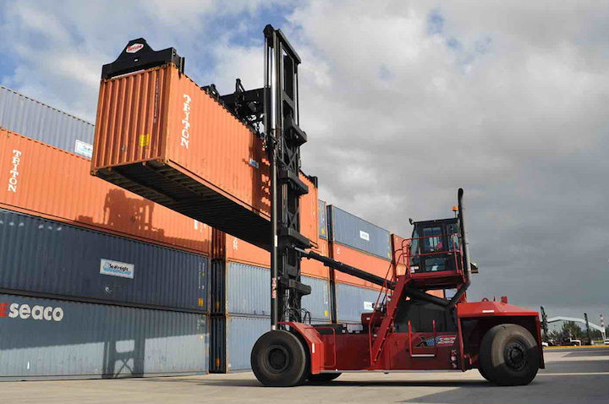 Taylor XLC975

Taylor Loaded Container Handlers are designed to handle Loaded Containers stacked up to 6 high. Common applications include, but not limited to, Port Operations, Stevedoring & Container Yards, Intermodal. Taylor has been designing and manufacturing Container Handlers since 1966.

The third order is for a Hyster H80 Forklift shipping to a countertop manufacturer in Northern California.

About AmeraMex International
AmeraMex International sells, leases, and rents heavy equipment to companies within multiple industries including construction, logistics, mining, and lumber. AmeraMex, with a US and international customer base, has over 30 years of experience in heavy equipment sales and service. Follow AmeraMex on Twitter @ammx_intl and visit the AmeraMex website, www.AMMX.net or www.hamreequipment.com for additional corporate information, online heavy equipment inventory/ pricing and videos.

Forward-Looking Statements
This press release contains forward-looking statements. All statements other than statements of historical facts included in this press release are forward-looking statements. In some cases, forward-looking statements can be identified by words such as "believe," "expect," "anticipate," "plan," "potential," "continue" or similar expressions. Such forward-looking statements include risks and uncertainties, and there are important factors that could cause actual results to differ materially from those expressed or implied by such forward-looking statements. Investors are encouraged to review the Company’s filings with the Securities and Exchange Commission. Investors should not place any undue reliance on forward-looking statements since they involve known and unknown, uncertainties and other factors which are, in some cases, beyond the Company’s control which could, and likely will, materially affect actual results, levels of activity, performance or achievements. Any forward-looking statement reflects the Company’s current views with respect to future events and is subject to these and other risks, uncertainties and assumptions relating to operations, results of operations, growth strategy and liquidity. The Company assumes no obligation to publicly update or revise these forward-looking statements for any reason, or to update the reasons actual results could differ materially from those anticipated in these forward-looking statements, even if new information becomes available in the future.

Investor and Media Relations
McCloud Communications, LLC
Marty Tullio, Managing Member
Office: 949.632.1900 or Marty@McCloudCommunications.com

