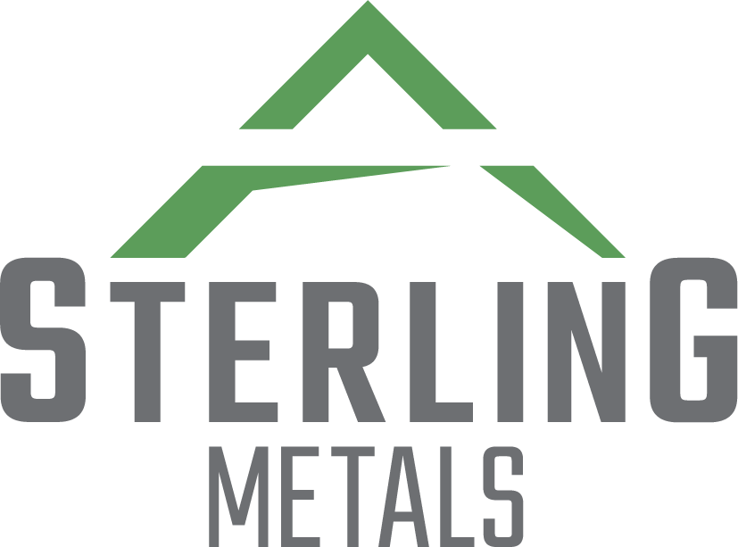
NOT FOR DISTRIBUTION TO UNITED STATES NEWS WIRE SERVICES OR FOR DISSEMINATION IN THE UNITED STATES

STERLING METALS ANNOUNCES CLOSING OF PRIVATE PLACEMENT OF UNITS
AND FLOW-THROUGH UNITS
April 1, 2021 – Toronto, Ontario – Sterling Metals Corp. (TSXV: SAG) (the “Company”) is pleased to announce that, further to its press releases of March 15, 2021 and March 17, 2021, the Company has closed a non-brokered private placement through the issuance of 2,981,925 units (each, a “Unit”) at a price of $0.52 per Unit and 2,542,805 flow-through units (each, a “FT Unit”) at a price of $0.57 per FT for aggregate gross proceeds of $3,000,000 (the “Offering”).
Each Unit is comprised of one common share (each, a “Common Share”) in the capital of the Company and one Common Share purchase warrant (each, a “Warrant”) of the Company. Each Warrant entitles the holder thereof to acquire one Common Share at a price of $0.78 per Common Share for a period of two (2) years from the closing date of the Offering (the “Closing Date”). Each FT Unit is comprised of one Common Share (each, a “FT Share”), issued on a flow-through basis, and one Warrant, issued on a non-flow-through basis, having the same terms as Warrants partially comprising the Units. The FT Shares will qualify as “flow-through shares” within the meaning of subsection 66(15) of the Income Tax Act (Canada).
Mathew Wilson, CEO, states: “We are fortunate to have excellent current and new shareholders who share our level of excitement for this potential high-grade district scale silver and base metal asset. With now over $6,000,000 in the bank and the potential for an additional nearly $10,000,000 in cash from future warrant exercises, the company is well positioned to drill out our numerous priority targets. The company has signed drill contractors and project geologists and is set to begin drilling as the weather warms. We are thankful for the support and look forward to continuing down the path of discovering Canada’s next high grade silver district.”
The net proceeds of the Offering from the sale of the Units will be used by the Company for general working capital purposes. The gross proceeds from the sale of the FT Units will be used by the Company to incur eligible “Canadian exploration expenses” that will qualify as “flow-through expenditures” as such terms are defined in the Income Tax Act (Canada).
In connection with the Offering, the Company paid certain eligible persons (the “Finders”) a cash commission of $38,155.23, equal to 7% of the gross proceeds of the Offering delivered by the Finders and issued 60,525 broker warrants (“Broker Warrants”), equal to 7% of the number of Units and FT Units delivered by the Finders pursuant to the Offering. Each Broker Warrant entitles the holder thereof to acquire one Common Share at a price of $0.65 per Common Share for a period of two (2) years from the Closing Date.
The Company engaged Canaccord Genuity Corp. (“Canaccord Genuity”) to act as financial advisor for the Offering. The Company paid Canaccord Genuity: (i) an advisory fee of $65,000 satisfied through the issuance of 125,000 Units; (ii) a cash commission of $142,117.45; and (iii) issued 208,320 Broker Warrants.
All securities issued pursuant to the Offering will be subject to a hold period of four months plus a day from the date of issuance and the resale rules of applicable securities legislation. The closing of the Offering is subject to certain conditions including, but not limited to, the receipt of all necessary regulatory and other approvals, including final approval of the TSX Venture Exchange.
The Offering constituted a related party transaction within the meaning of TSX Venture Exchange Policy 5.9 and Multilateral Instrument 61-101 – Protection of Minority Security Holders in Special Transactions (“MI 61-101”) as an insider of the Company subscribed for 70,175 FT Units pursuant to the Offering. The Company is relying on the exemptions from the valuation and minority shareholder approval requirements of MI 61-101 contained in sections 5.5(b) and 5.7(1)(a) of MI 61-101, as the Company is not listed on a specified market and the fair market value of the participation in the Offering by the insider does not exceed 25% of the market capitalization of the Company in accordance with MI 61-101. The Company did not file a material change report in respect of the related party transaction at least 21 days before the closing of the of the Offering, which the Company deems reasonable in the circumstances in order to complete the Offering in an expeditious manner.
For more information, please contact:
Sterling Metals Corp.
Mathew Wilson, President & CEO
Tel: (416) 643-3887
Email: info@sterlingmetals.ca
Website: www.sterlingmetals.ca

Neither the TSX Venture Exchange nor its Regulation Services Provider (as that term is defined in the policies of the TSX Venture Exchange) accepts responsibility for the adequacy or accuracy of this release.

This news release contains certain “forward-looking information” within the meaning of applicable securities laws. Forward looking information is frequently characterized by words such as “plan”, “expect”, “project”, “intend”, “believe”, “anticipate”, “estimate”, “may”, “will”, “would”, “potential”, “proposed” and other similar words, or statements that certain events or conditions “may” or “will” occur. These statements are only predictions. Forward-looking information is based on the opinions and estimates of management at the date the information is provided, and is subject to a variety of risks and uncertainties and other factors that could cause actual events or results to differ materially from those projected in the forward-looking information. For a description of the risks and uncertainties facing the Company and its business and affairs, readers should refer to the Company’s Management’s Discussion and Analysis. The Company undertakes no obligation to update forward-looking information if circumstances or management’s estimates or opinions should change, unless required by law. The reader is cautioned not to place undue reliance on forward-looking information.

