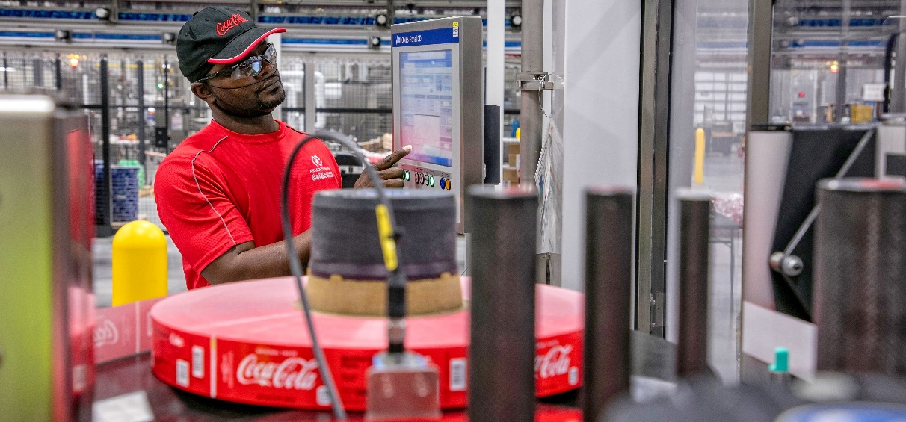
AC Strengthens Investment Commitment for 2021
- Arca Continental announces an investment of close to US$500 million in 2021,
60% more than in 2020, to strengthen its operations in all the markets it serves

Monterrey, Mexico, April 15, 2021.- Arca Continental, one of the world’s largest Coca-Cola bottlers, announced today that it is planning to invest close to US$500 million in 2021, which will be allocated towards strengthening and innovating its production, distribution and execution capabilities, as well as promoting digitalization and sustainability projects in its operations in Mexico, the U.S., Ecuador, Peru and Argentina.
In the midst of a challenging economic environment due to the Covid-19 pandemic, the company explained that approximately 42% of the total amount will be allocated to investment projects in Mexico.
Prior to its Annual Shareholders’ Meeting, the company’s Chairman of the Board of Directors, Jorge Humberto Santos Reyna, and CEO, Arturo Gutiérrez Hernández, spoke about Arca Continental’s performance in 2020 and outlined the main strategies for 2021.
“To remain true to the historical legacy of Arca Continental, we rose to the challenge in 2020. Our top priorities were to ensure safe working conditions for our associates, support the communities where we live and work, guarantee the continuity of our operations, and support our customers during severe mobility restrictions and the economic downturn in the countries we serve, all with a clear focus on the business strategies we have defined as part of our long-term vision,” stated Santos Reyna.
During the presentation of the company’s results, Gutiérrez said that 2020 sales for Arca Continental increased 4% year-over-year to 169,314 million pesos. EBITDA totaled 32,147 million pesos, 5.7% higher than 2019, mitigating a volume fall of 3.8% in the countries where it attends.
“In 2020 the company proved its capability to deliver sound results, even in adverse environments, always driven by our associates’ commitment and professionalism. We achieved our goals by adapting to the new circumstances of the market, speeding up innovation and digitalization projects, as well as perfecting customer and consumer service models to achieve a better performance, all while sustaining profitability and the positive evolution that distinguishes us,” explained Gutiérrez.
Key factors contributing to the company’s profitability were its operational and administrative discipline, as well as the successful completion of its synergy plan announced in 2017 which totaled US$90 million, driven largely by our new production plant in Houston, Texas, which initiated operations in March 2020.
The company stated that in 2021 it will continue strengthening its commitment to its associates and the community while advancing its customer service digital platforms, incorporating advanced analytics to improve point of sale service and expanding direct-to-consumer sales initiatives.
About Arca Continental
Arca Continental produces, distributes, and markets beverages under The Coca-Cola Company brand, as well as snacks in Mexico, Ecuador, and the United States. With an outstanding history spanning more than 95 years, Arca Continental is the second-largest Coca-Cola bottler in Latin America, and one of the largest in the world. Through its Coca-Cola franchise, the company serves more than 123 million people in the Northern and Western regions in Mexico, as well as in Ecuador, Peru, in the Northern region of Argentina, and in the Southwestern United States. Arca Continental is listed on the Mexican Stock Exchange under the ticker “AC”. For more information about Arca Continental, please visit www.arcacontal.com

