FIRSTSHOT CENTERS STO approved by CEZA for listing on CryptoSX Digital Asset Exchange

Manila Philippines, 24 April 2021

Cryptosx announced FirstShot Centers, LLC (“FirstShot”) has received formal approval from CEZA (“Cagayan Economic Zone Authority”) for security token offering and listing on Cryptosx.

FirstShot intends to raise up to US$100M from investors in the North America, Europe and Asia to acquire, repurpose and operate undervalued retail shopping centers across the US. Every FirstShot center or store will be reformatted as an entertainment hub specifically targeted for the firearm, ammunition and outdoor sporting industry and communities. Centers will be themed destination offering a state-of-the-art shooting range, outdoor sporting and adventure retail stores and unique experiences.

COVID have dealt the world economy a startling blow with shopping malls, big box stores and superstores lie empty across America. With purchase prices at a fraction of replacement costs, FirstShot mandate is to bring a reimagined retail landscape to vacant and distressed shopping malls. Each center can house a variety of national tenants that have been identified.

FirstShot will evaluate potential property and run analytics, determining if this is a viable opportunity for purchase and repurposing. Each property is acquired with a build out
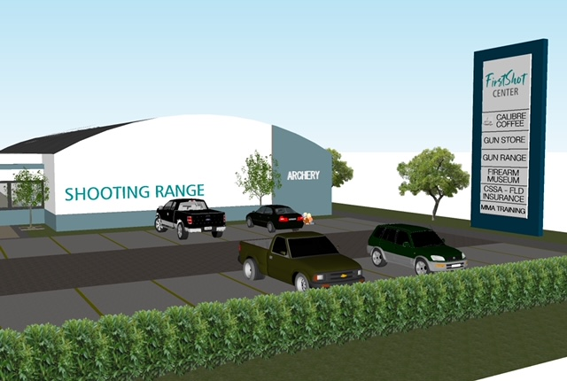

revenue-generating strategy that will result in cash-flow distributions to investors, creating appreciable value-add.

FirstShot Founder and CEO Brian Lovig has a long and successful career in commercial real estate as well long-standing relationships and passion with the firearm and commercial real estate communities. By relying on the insights built up over 30 years by the FirstShot Centers management team, the Company will implement a strategy to generate positive ROI for FS Token Holders.

FirstShot will leverage Cryptosx STO platform to list and provide secondary trading to international accredited investors. “We are absolutely thrilled to have FirstShot joining our stable of security tokens. Real estate is an industry that is particularly suitable for tokenization and FirstShot ingenuity with the firearm and shooting communities makes it a pioneer and first mover”. Cryptosx founder Philip Tam.

Find social media tabs at firstshotcenters.com. News releases are cataloged on firstshotcenters.com.

FirstShot Centers, LLC is a private, limited liability company headquartered in Las Vegas, Nevada. For additional information email brian@firstshotcenters.com and or go to www.firstshotcenters.com.

About Cryptosx
With the empowerment of world-leading technologies, Cryptosx is building a cutting-edge crypto exchange platform for Security Token Offering (“STO”) backed by Fiat/Crypto conversion capabilities. Cryptosx is compliant with all of the applicable financial and virtual exchange policies and regulations of the Philippine government under CEZA (Cagayan Economic Zone Authority). Cryptosx was awarded a Full Principal License by CEZA in 2018.

For more information, please visit: www.cryptosx.io and philip@cryptosx.io
This press release does not constitute an offer or invitation to the public to acquire, or solicitation of an offer to buy, nor may there be any offer, invitation, solicitation or sale of, any investment product, securities or other interests in which such offer, invitation, solicitation or sale is not authorised, or to any person to whom it is unlawful to make any such offer, invitation, solicitation or sale.

