SNOWLINE GOLD SIGNIFICANTLY EXPANDS PROPERTY HOLDINGS IN YUKON’S SELWYN BASIN

- Added 18,864 hectares of mineral claims across 4 existing projects
- Expands total land position to roughly 90,000 hectares in the Yukon
- Cements cornerstone position in the metal-rich Selwyn Basin
Vancouver, B.C., April 28, 2021 SNOWLINE GOLD CORP. (CSE: SGD) (US Pink Sheets: SNWGF) (the “Company” or “Snowline”) is pleased to announce it has staked additional claims, significantly expanding its land position around its 100% owned Rogue, Rainbow, Cynthia, and Ursa projects in the east central Yukon. In total, 782 new claims were staked for an additional 18,864 hectares. This brings Snowline’s mineral tenure in the Yukon to 89,724 hectares across its 7 projects. The new claims were strategically staked to cover structures, trends, and gold anomalies that extended beyond the bounds of its original holdings. The enhanced land position cements Snowline’s cornerstone position in an emerging gold district in the prospective Selwyn Basin.

“Snowline launched with seven high quality exploration projects throughout the Yukon and an extensive privately owned exploration database built over decades” said the Company’s Chief Executive Office Nikolas Matysek. “A comprehensive geological review led by Dr. Quinton Hennigh and Dr. Craig Hart determined that the bulk of Snowline’s properties may only cover the tip of the iceberg. This new staking has expanded Rogue, Rainbow, Cynthia, and Ursa’s footprint to better cover high priority exploration targets and to cement Snowline’s cornerstone position in the Selwyn Basin.”

Rogue
Recent staking has expanded the Rogue Project by 4.6 times to 11,227 hectares covering high priority gold targets that Snowline is intending to further explore in the upcoming season.

Snowline’s mineral tenure at Rogue was significantly increased with the staking of 321 new claims in three blocks—Arrowhead, Old Cabin and JP—targeting reduced intrusion related gold systems associated with members of the Cretaceous-aged Tombstone Plutonic Suite.

Holdings around the project’s primary Valley and Gracie targets on the Arrowhead block were increased by 117 claims (2,422 ha) to better cover the existing target zones and to secure prospective areas in their vicinity. Historical geochemical sampling by previous operators included two drainages downstream of the newly-staked ground with reported gold-in-silt concentrations of 160 and 100 parts per billion gold. Elsewhere, a soil sample returned 1.32 grams per tonne gold where an inferred fault striking north northeast from the Gracie zone crosses a contour soil sampling line, some 3.5 km northeast of the central Gracie target area.

An additional large block, Old Cabin, comprising 176 new claims (3,569 ha) was staked to connect and expand claim holdings over a suspected buried intrusive stock inferred from a small (roughly 200 m) granodiorite plug within a 2 x 4 km magnetic anomaly. Historical grab samples within this zone include quartz vein material assaying 8.7 g/t Au, and sulphide-rich skarn assaying 5.3 g/t Au. Elsewhere on the block, historical grab samples of quartz vein material have assayed up to 10.0 g/t Au. Streams draining the claim block consistently returned values in the hundreds of parts per billion gold., One particular stream draining from the magnetic anomaly returned gold-in-sediment values ranging from 233 to 1150 ppb Au. It is thought that a buried intrusion at Old Cabin could have an intact carapace at its top, with increased potential to host a significant reduced-intrusion-related gold deposit.

The third block, JP, comprises 28 new claims (563 ha) above and around a 900 by 600 m exposure of an intrusive stock 7 km southwest of the Valley target. Historical sampling found subparallel gold-bearing quartz veins averaging 2 cm in width within and adjacent to the intrusion, commonly assaying between 1 and 4 g/t Au with samples up to 36.0 g/t Au.

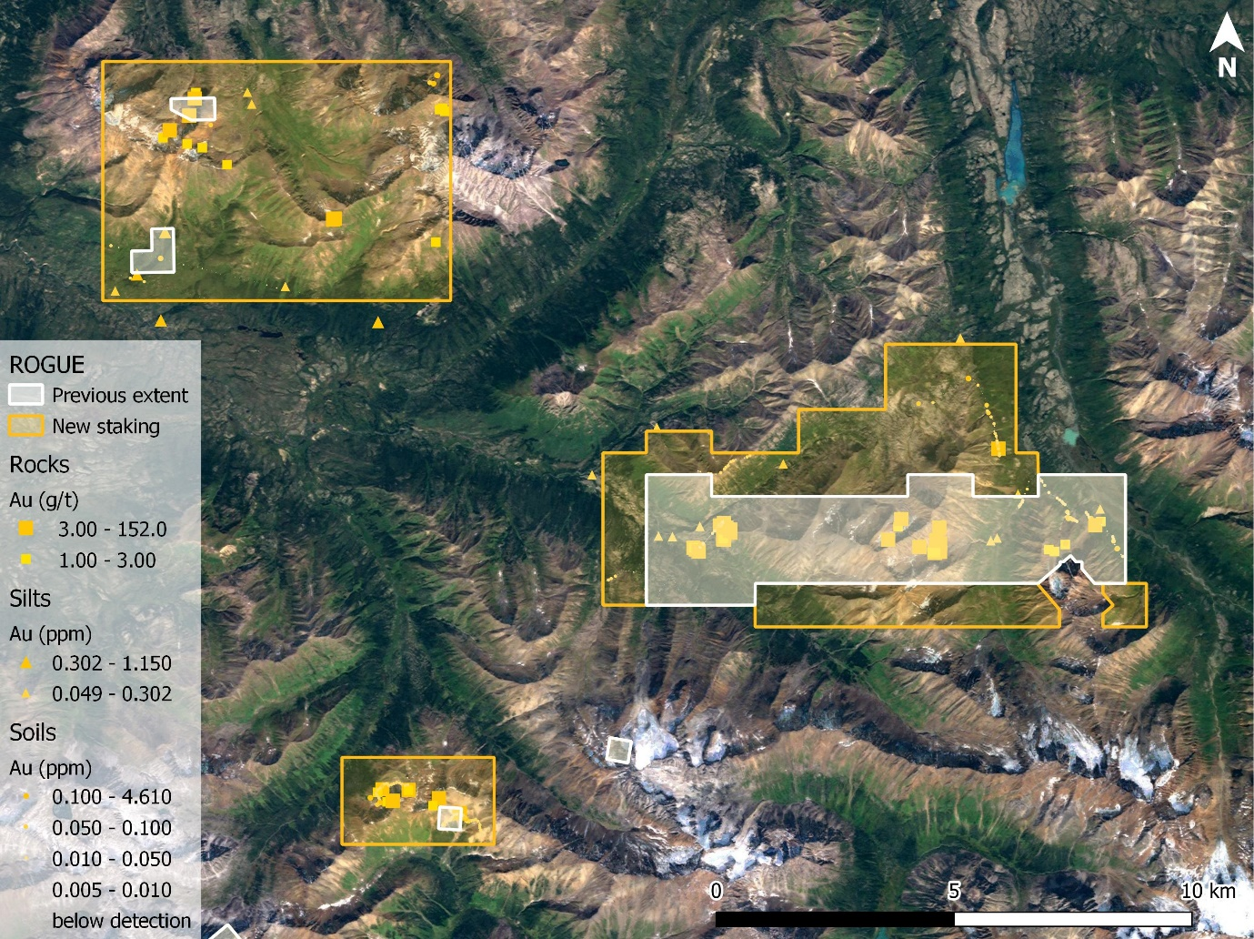
MAG
HIGH
VALLEY
GRACIE
OLD CABIN
ARROWHEAD
JP
Figure 1: Expansion of the 100% owned Rogue project provides expanded coverage around existing target areas, with extensive new land holdings around two poorly exposed intrusive stocks. Historical geochemical sampling of rocks, stream sediments and soils all indicate an extensive network of gold mineralization.

Rainbow
Recent staking has expanded the Rainbow Project 10 times, now totalling 1,255 hectares.

Rainbow covers a gold and pathfinder element soil anomaly associated with surface alteration caused by a recently discovered intrusion. Staking expands the property to include parts of the historical soil anomaly previously outside its boundaries, including a northwest zone with anomalous gold in soils to 0.93 g/t Au, silver in soils exceeding a 100 g/t Ag assay limit, and anomalous bismuth, tungsten and antimony. The new land position also covers a 3 km magnetic signature extending eastward from the soil anomaly.

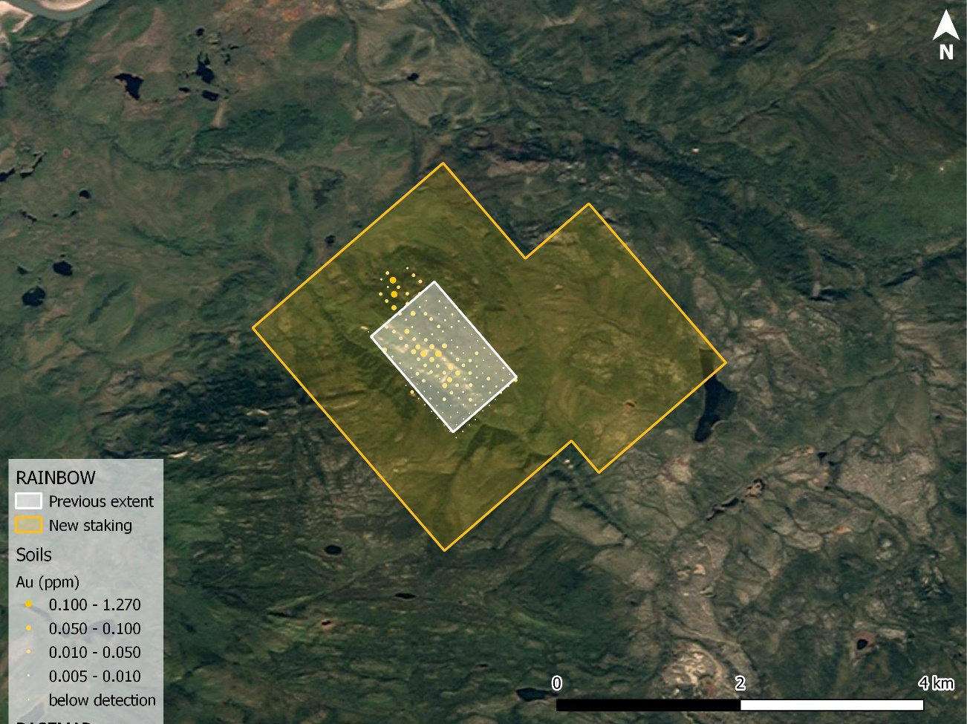
Figure 2: Historical soil sampling on the Rogue property indicates a km-scale, zoned multi-element soil anomaly associated with newly discovered felsic intrusives along the western edge of a 3 km zone of magnetic anomalism (blue oval). New staking better covers both the soil anomaly and magnetic signature. A stream draining the eastern end of the property returned elevated gold and pathfinder elements relative to other local streams, suggesting a broader extent to the mineralizing system than what is revealed in existing soils coverage.
Soil:
0.92 g/t Au
53.0 g/t Ag
224 ppm Bi
743 ppb Sb

Soil:
0.59 g/t Au
>100 g/t Ag
120 ppm Bi
200 ppb Sb

Soil:
1.27 g/t Au
89 ppm Bi
7.4 ppm Te

Silt:
Elevated Au, As

Grab:
7.98 g/t Au

Cynthia
Recent staking has expanded the Cynthia Project 6 times, now totalling 1,399 hectares.

Cynthia covers an area of gold mineralization between two adjacent exposures of a Cretaceous Tombstone suite intrusion. Mineralization is controlled by district-scale fault zones and is especially intense in the central part of the project. Surface grab samples in these zones commonly assay from 200 ppb to 3 grams per tonne gold, with values up to 16 g/t Au in a central zone. Cynthia is along strike of the past producing Plata silver mine, and is within 8 km of an inactive heavy equipment winter access trail that connects to the North Canol Road.

This staking gives secures a wider margin around known mineralized zones, and covers additional prospective ground on the altered shoulders of two intrusive exposures.

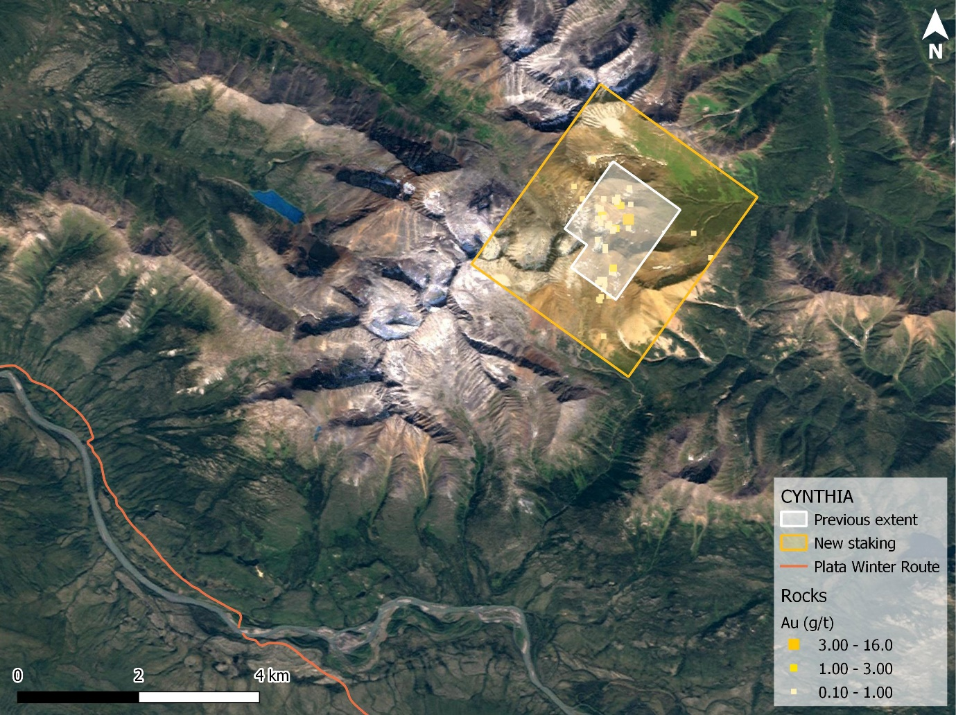
Figure 3: New staking at Cynthia affords broader coverage around the target area, including large, prospective gossanous shoulders to the exposures of the Tombstone suite intrusions (grey areas).

Ursa
Recent staking has expanded the Ursa Project 54 times, now totalling 7,755 hectares.

Ursa cover a 9 km trend of anomalous gold in stream sediment and soil samples, thought to be associated with sulphide minerals hosted in tightly folded Cambrian and Ordovician shales and cherts. Ursa also hosts a separate, 14 km-long trend of elevated to highly anomalous zinc along with elevated silver, copper, molybdenum, nickel and vanadium, thought to be associated with Devonian age enriched black shales.

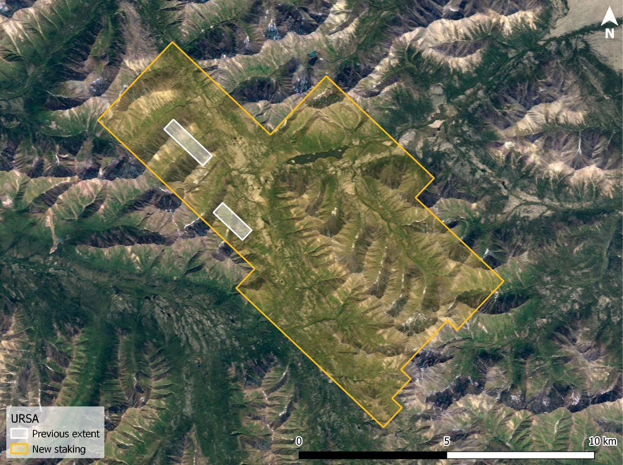
Figure 4: Expansion of the Ursa project is based on historical geochemical and prospecting data which delineate two distinct 10-km-scale trends, and may represent a new target type for the area.
BASE
METAL
TREND
GOLD
TREND

It should be noted that all exploration results discussed above are historical in nature. Most sampling has been performed within the past 10 years following standard industry practices, and while specific results have yet to be independently verified by Snowline, the Company has no reason to suspect the data are not reliable as general indicators of exploration potential.

Qualified Person

Information in this release has been reviewed and approved by Scott Berdahl, P. Geo., Chief Operating Officer of Snowline and a Qualified Person for the purpose of NI 43-101.

ABOUT SNOWLINE GOLD CORP.

Snowline Gold Corp. is a Yukon Territory focused gold exploration company with a 7-project portfolio covering over 90,000 ha. The Company is exploring its flagship 72,000 ha Einarson and Rogue gold projects in the prospective yet underexplored Selwyn Basin, with drilling expected to commence in mid-2021. Snowline’s projects all lie in the prolific Tintina Gold Province that hosts multiple million-ounce-plus gold mines and deposits, from Kinross’ Fort Knox mine to Newmont’s Coffee deposit. Snowline’s first mover claim position represents a unique opportunity to explore and expand a new greenfield, district-scale gold system.

ON BEHALF OF THE BOARD

Nikolas Matysek, B.Sc. (Geol)
CEO & Director

For further information, please contact:
Snowline Gold Corp.
+1-778-228-3020
info@snowlinegold.com

CAUTIONARY NOTE REGARDING FORWARD-LOOKING STATEMENTS

This news release contains certain forward-looking statements, including statements about the Company reviewing its newly acquired project portfolio to maximize value, reviewing options for its non-core assets, including targeted exploration and joint venture arrangements, conducting follow-up prospecting and mapping this summer and plans for exploring and expanding a new greenfield, district-scale gold system. Wherever possible, words such as “may”, “will”, “should”, “could”, “expect”, “plan”, “intend”, “anticipate”, “believe”, “estimate”, “predict” or “potential” or the negative or other variations of these words, or similar words or phrases, have been used to identify these forward-looking statements. These statements reflect management’s current beliefs and are based on information currently available to management as at the date hereof.

Forward-looking statements involve significant risk, uncertainties and assumptions. Many factors could cause actual results, performance or achievements to differ materially from the results discussed or implied in the forward-looking statements. Such factors include, among other things: risks related to uncertainties inherent in drill results and the estimation of mineral resources; and risks associated with executing the Company’s plans and intentions. These factors should be considered carefully and readers should not place undue reliance on the forward-looking statements. Although the forward-looking statements contained in this news release are based upon what management believes to be reasonable assumptions, the Company cannot assure readers that actual results will be consistent with these forward-looking statements. These forward-looking statements are made as of the date of this news release, and the Company assumes no obligation to update or revise them to reflect new events or circumstances, except as required by law.

