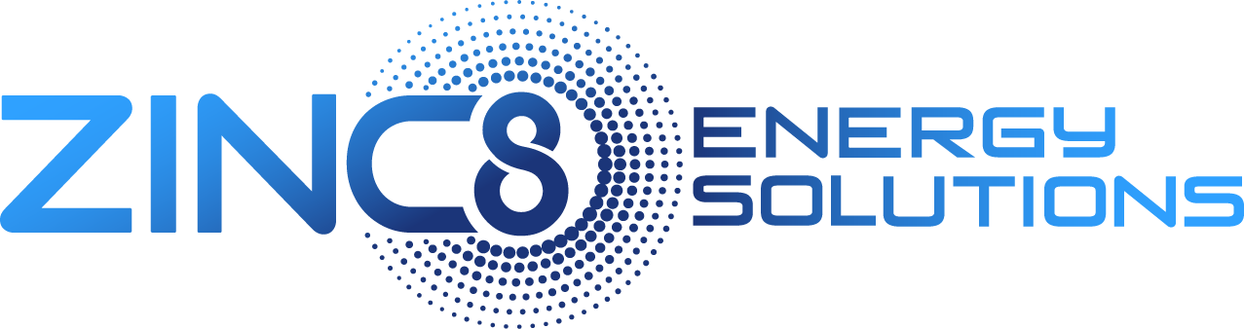
Zinc8 Energy Solutions Announces Fiscal Year 2020 Audited Financials SEDAR Filing and Provides Corporate Update
~Company presses on towards commercialization with recent contract success and completion of testing and assembly facility~
Vancouver, British Columbia, Canada – April 30, 2021 Zinc8 Energy Solutions Inc. (“Zinc8” or the “Company”) (TSXV: ZAIR)(OTC PINK:MGXRF)(FSE:0E9) today announced its audited financial statements for the fiscal year ended December 31, 2020 and its fiscal 2020 MD&A were filed on SEDAR. For detailed information on these results, please see Zinc8 Energy Solutions Inc. Fiscal Year 2020 Financial Statements and Management Discussion and Analysis as filed on SEDAR on April 30, 2021.

Fourth Quarter Corporate Highlights Include:
- Entered into an agreement in principle with Australian renewable energy project developers SmartConsult.
- Announced selection to join world-renowned Rocky Mountain Institutes’ Third Derivative (D3) accelerator program.
- Announced selection as one of the nine companies to join the manufacturing-focused Scale for ClimateTech in downstate New York (New York City)
Fiscal Year 2020 Corporate Highlights Include:
- Announced its first private sector deployment agreement with Digital Energy Corp. to install a Zinc-air Energy Storage System (ESS) in New York City.
- Announced its acceptance into New York City’s ACRE Cleantech Incubator Program at Urban Future Lab.
- Entered into an agreement in principle with Vijai Electricals agreeing to explore joint-venture projects concerning the deployment of Zinc8’s patented Zinc-air ESS. Additionally, the companies will explore the potential of manufacturing components of the Zinc-Air System in India.
- Announced as a winner of New York City’s Department of Buildings ‘Innovation Challenge’. The Company’s Zinc-air ESS was the only energy storage solution chosen as a winner. The winners of the challenge will be supported for inclusion in the 2020 NYC Building Code.
Subsequent to December 31, 2020:
- Successfully closed an oversubscribed private placement common share offering for gross proceeds of $15.5 million.
- Signed a host site agreement with the New York Power Authority (“NYPA”) and The University at Buffalo, The State University of New York (“UB”). The selection of the site allows for the demonstration of a 100-kilowatt/one-megawatt-hour (100KW/1MWh) 10-hour duration Zinc-air battery energy storage system in Buffalo, N.Y., to provide peak shaving capability by leveling out peaks in electricity consumption.
- Signed a $200,000 (U.S.) contract with one of the leading cloud providers to demonstrate its patented Zinc-air ESS and to validate and assess the Zinc-air storage technology. Zinc8’s technology will be tested for resilient backup application; the 10kW/80kWh unit will undergo required assessment tests agreed upon by the cloud provider to address its unique use cases in data centers.
“We’ve achieved a great deal during the first full year as a public company,” said Ron MacDonald,” President & CEO of Zinc8 Energy Solutions. “Through the hard work and perseverance of our team, combined with our leading long-duration energy storage technology, we were selected by “Scale for ClimateTech'' and the “Third Derivative (D3) accelerator programs and were a winner of New York City’s “Department of Buildings Innovation Challenge. As a result of this international success, and illustrated by our recent announcement, Zinc8’s energy storage technology has attracted the attention of influential organizations committed to having a positive impact on climate change.”
“These achievements will help accelerate Zinc8 on its path towards commercialization. Our new 16,000 sq. ft testing and assembly facility gives us the much needed space to build and run the required tests to complete the certification of the various system levels of the battery. Zinc8 will begin moving some personnel and equipment to the new facility effective immediately. Our cathode manufacturing group along with the Research & Development team will remain at our current Ash Street facility to expand their respective operational capabilities. Our goal is to construct 5 different test batteries each with a specific use case and set of parameters, which will demonstrate the flexibility and dependability of Zinc8’s long-duration energy storage system. The collection of data will be analyzed and presented to potential end-use customers allowing them to model the economic impact that a long-duration energy storage solution will have for their business as they work towards decarbonizing the economy.”
Corporate Update - The Path to Commercialization
In February 2021 we announced the closing of a private placement of common shares for total gross proceeds to the Company of over $15 million. This funding allows for Zinc8 to further expand its efforts towards offering units of its patented Zinc-air ESS for commercial use in multiple market segments.
Zinc8 has leased new premises comprising an initial testing and assembly facility, significantly increasing available square footage with the intention of building five batteries to complete the certification process and advancing the production schedule by establishing pilot production capability. These batteries will be subjected to their own unique tests focusing on the performance and gathering data on specific components of the battery in an effort to complete certifications for the various system levels of the zinc-air battery system.
2021 will be the anchor year as the Company aims to be in small-scale production in 18-24 months. Not only will we be testing the various system levels for certification, but we anticipate designing and running multiple demonstration projects, with each project having its own specific use case. With the assistance of accelerator program members, we are targeting a production range of between 3-10MW to begin in Q4 2022.
As an illustrative production and revenue model, for the first 12 months of production starting in Q4 2022, based on the 3 to 10MW production range mentioned above, the potential revenue impact could be $6 million to $20 million assuming $200 per kWh. Using New York City as the initial target market, this equates to a penetration range of 75 to 250 buildings, or approximately 0.4% of the 58,000 buildings in this market. As production ramps up in the second 12 months of production, a projected production range of 40 to 80MW could impact revenue by as much as $80 million to $160 million, with New York City market penetration of less than 3.4% (between 1,000 and 2,000 buildings). The third 12-month period of production could produce over 80MW of batteries and have an impact on revenue of up to $160+ million. During that period, over 2,000 buildings (over 3.4% market share) would have the Zinc8 ESS installed and operating in New York City.
About Zinc8 Energy Solutions Inc.
Zinc8 has assembled an experienced team to execute the development and commercialization of a dependable low-cost zinc-air battery. This mass storage system offers both environmental and efficiency benefits. Zinc8 strives to meet the growing need for secure and reliable power.
To watch a short video outlining Zinc8’s technology, please visit https://zinc8energy.com
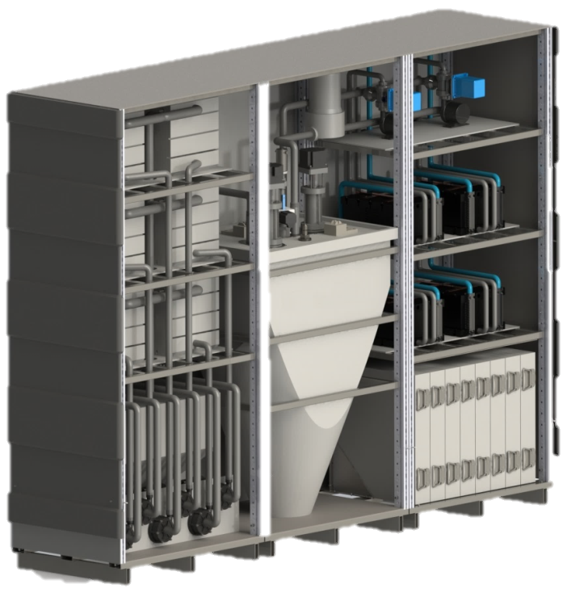
More about the Zinc8 Energy Storage System (ESS)
The Zinc8 ESS is a modular Energy Storage System designed to deliver power in the range 20kW - 50MW with capacity of 8 hours of storage duration or higher. With the advantage of rechargeable zinc-air flow battery technology, the system can be configured to support a wide range of long-duration applications for microgrids and utilities. Since the energy storage capacity of the system is determined only by the size of the zinc storage tank, a very cost-effective and scalable solution now exists as an alternative to the fixed power/energy ratio of the lithium ion battery.
Technology
The Zinc8 ESS is based upon unique patented zinc-air battery technology. Energy is stored in the form of zinc particles, similar in size to grains of sand. When the system is delivering power, the zinc particles are combined with oxygen drawn from the surrounding air. When the system is recharging, zinc particles are regenerated, and oxygen is returned to the surrounding air.

Applications
The flexibility of the Zinc8 ESS enables it to service a wide range of applications. Typical examples include:
- Smoothing energy derived from renewable sources such as wind and solar
- Commercial/Industrial backup replacing diesel generators
- Industrial and grid scale, on-demand power for peak shaving and standby reserves
- Grid-scale services such as alleviating grid congestion, deferring transmission/distribution upgrades, energy trading and arbitrage, and increasing renewable energy penetration.

Architecture
The Zinc8 ESS is designed according to a modular architecture that enables a wide variety of system configurations to be created from a small number of common subsystems. Each subsystem implements a single element of the technology:
- The Zinc Regeneration Subsystem (ZRS) provides the recharging function
- The Fuel Storage Subsystem (FSS) provides the energy storage function
- The Power Generation Subsystem (PGS) provides the discharging function

Notice Regarding Forward Looking Statements
All statements and disclosures, other than those of historical fact, which address activities, events, outcomes, results or developments that Zinc8 Storage anticipates or expects may or will occur in the future (in whole or in part) should be considered forward-looking statements.
Forward looking statements in this press release include that build and run the required tests to complete the certification of the various system levels of the battery; that we will construct 5 different test batteries each with a specific use case and set of parameters, which will demonstrate the flexibility and dependability of Zinc8’s long-duration energy storage system; that we can be in small-scale production in 18-24 months; that we are targeting a production range of between 3-10MW to begin in Q4 2022; that we can execute the development and commercialization of a dependable low cost zinc-air battery; that our mass storage system offers both environmental and efficiency benefits; and that we can help meet the needs for secure and reliable power. Zinc8 Energy Solutions believes the material factors, expectations and assumptions reflected in the forward-looking statements are reasonable at this time, but no assurance can be given that these factors, expectations and assumptions will prove to be correct. The forward-looking statements included in this news release are not guarantees of future performance. Such forward-looking statements involve known and unknown risks, uncertainties and other factors that may cause actual results or events to differ materially from those anticipated in such forward-looking statements including, without limitation: that we are not able to raise funds as expected; that our technology fails to work as expected or at all; that our technology proves to be too expensive to implement broadly; that customers do not adapt our products for being too complex, costly, or not fitting with their current products or plans; our competitors may offer better or cheaper solutions for battery storage; general economic, market and business conditions; increased costs and expenses; inability to retain qualified employees; our patents may not provide protection as expected and we may infringe on the patents of others; production problems may delay or prevent our timing projections from being achieved; and certain other risks detailed from time to time in Zinc8 Energy Solution’s public disclosure documents, copies of which are available on the Company’s SEDAR profile at www.sedar.com. Readers are cautioned that the foregoing list of factors is not exhaustive and are cautioned not to place undue reliance on these forward-looking statements.
The forward-looking statements contained in this news release are made as of the date hereof and the Company undertakes no obligations to update publicly or revise any forward-looking statements, whether as a result of new information, future events or otherwise, unless so required by applicable securities laws.
Neither the CSE nor any Market Regulator (as that term is defined in the policies of the CSE) accepts responsibility for the adequacy or accuracy of this release.

For more information please contact:
Zinc8 Energy Solutions Inc.
Mark Baggio
Incite Capital Markets
Kristian Schneck / Eric Negraeff
Ph: 604.493.2004
Email: investors@zinc8energy.com

