Turnkey Azure Datacenter (TAD)

An end-to-end solution for embracing the Azure Cloud encompassing design, deployment and management
nDivision’s TAD Solution Defines the Azure End State and Ensures Robust Management
We bring to bear a decade of best practices to design and deploy an Azure datacenter that matches our clients’ corporate standards and business needs. nDivision's Azure Managed Service utilizing Intelligent Automation delivers a high quality and cost-effective ongoing cloud experience.
Our enterprise customers tell us they need more than a partner who simply runs a tool to analyze their environment, identify workloads to be migrated and facilitate a migration. Customers either have a defined use case(s) or require guidance on best practice examples. Very often, there is also a need to be guided through the architecting process to meet corporate IT standards and compliance requirements as well as a need to understand how their Azure environment will be managed and kept up to date with new services/features and evolving business needs.

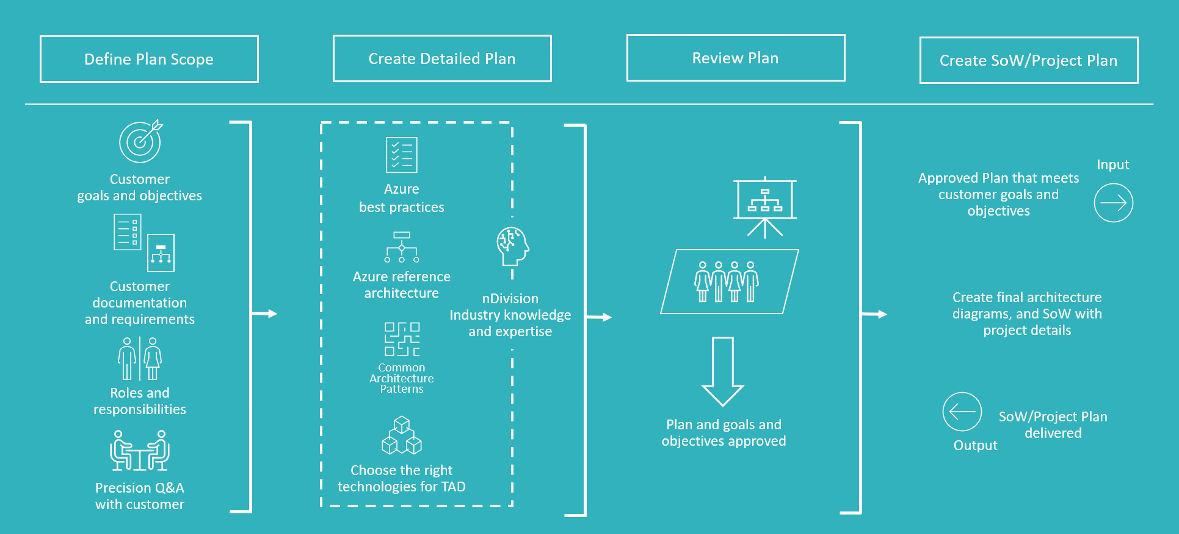
Common Architecture Patterns (CAPs)
Microsoft publishes 1,800 pages of Azure Reference Architectures and there are over 6,000 Azure Services. However, nDivision estimates that approximately 80% of TAD engagements share Common Architecture Patterns, which speeds up the process, as nDivision only needs to work with our clients to define the remaining 20% business-specific best practice technologies. Through this approach, we create a world-class Azure Landing Zone that takes into account scale, security, governance, networking, and identity.

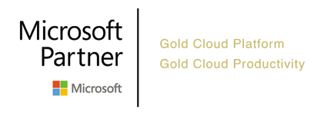
Roles and Responsibilities
We believe strongly that the success of a TAD engagement is predicated on clearly defined nDivision and customer responsibilities. nDivision’s resourcing structure has been determined through multiple projects and best practice procedures over many years. However, it is important that the customer’s roles and responsibilities are also clearly defined for their involvement in the TAD engagement. We use a RACI approach to identify the Cloud Service Owner, Workload Owner(s), Security Auditors, and key members of Operations to ensure a mutually successful outcome.

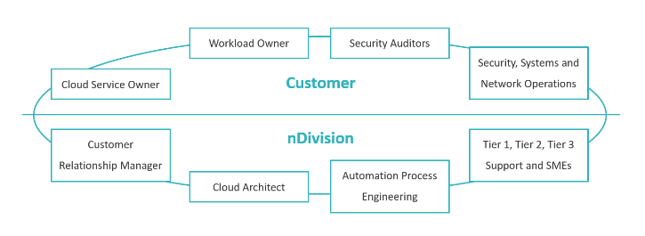
Autonomic Managed Service
nDivision uses Intelligent Automation to manage Azure, private clouds and networks resulting in 83% resolution of all incidents without any human involvement. This enables an exceedingly high quality and cost-effective ongoing solution. Furthermore, we will advise the client regarding new Azure features and services that are relevant and maintain a highly optimized TAD environment.

Controls and Governance
We advise the client on how to establish an Azure Collaboration Team (ACT) using the same RACI approach for the solutioning. nDivision works closely with the client’s ACT resources to define the methodology and processes for evaluating new features and services, ensuring compliance with controls and governance, designing automations, templatizing the DevOps process and updating the client’s Service Catalog.

