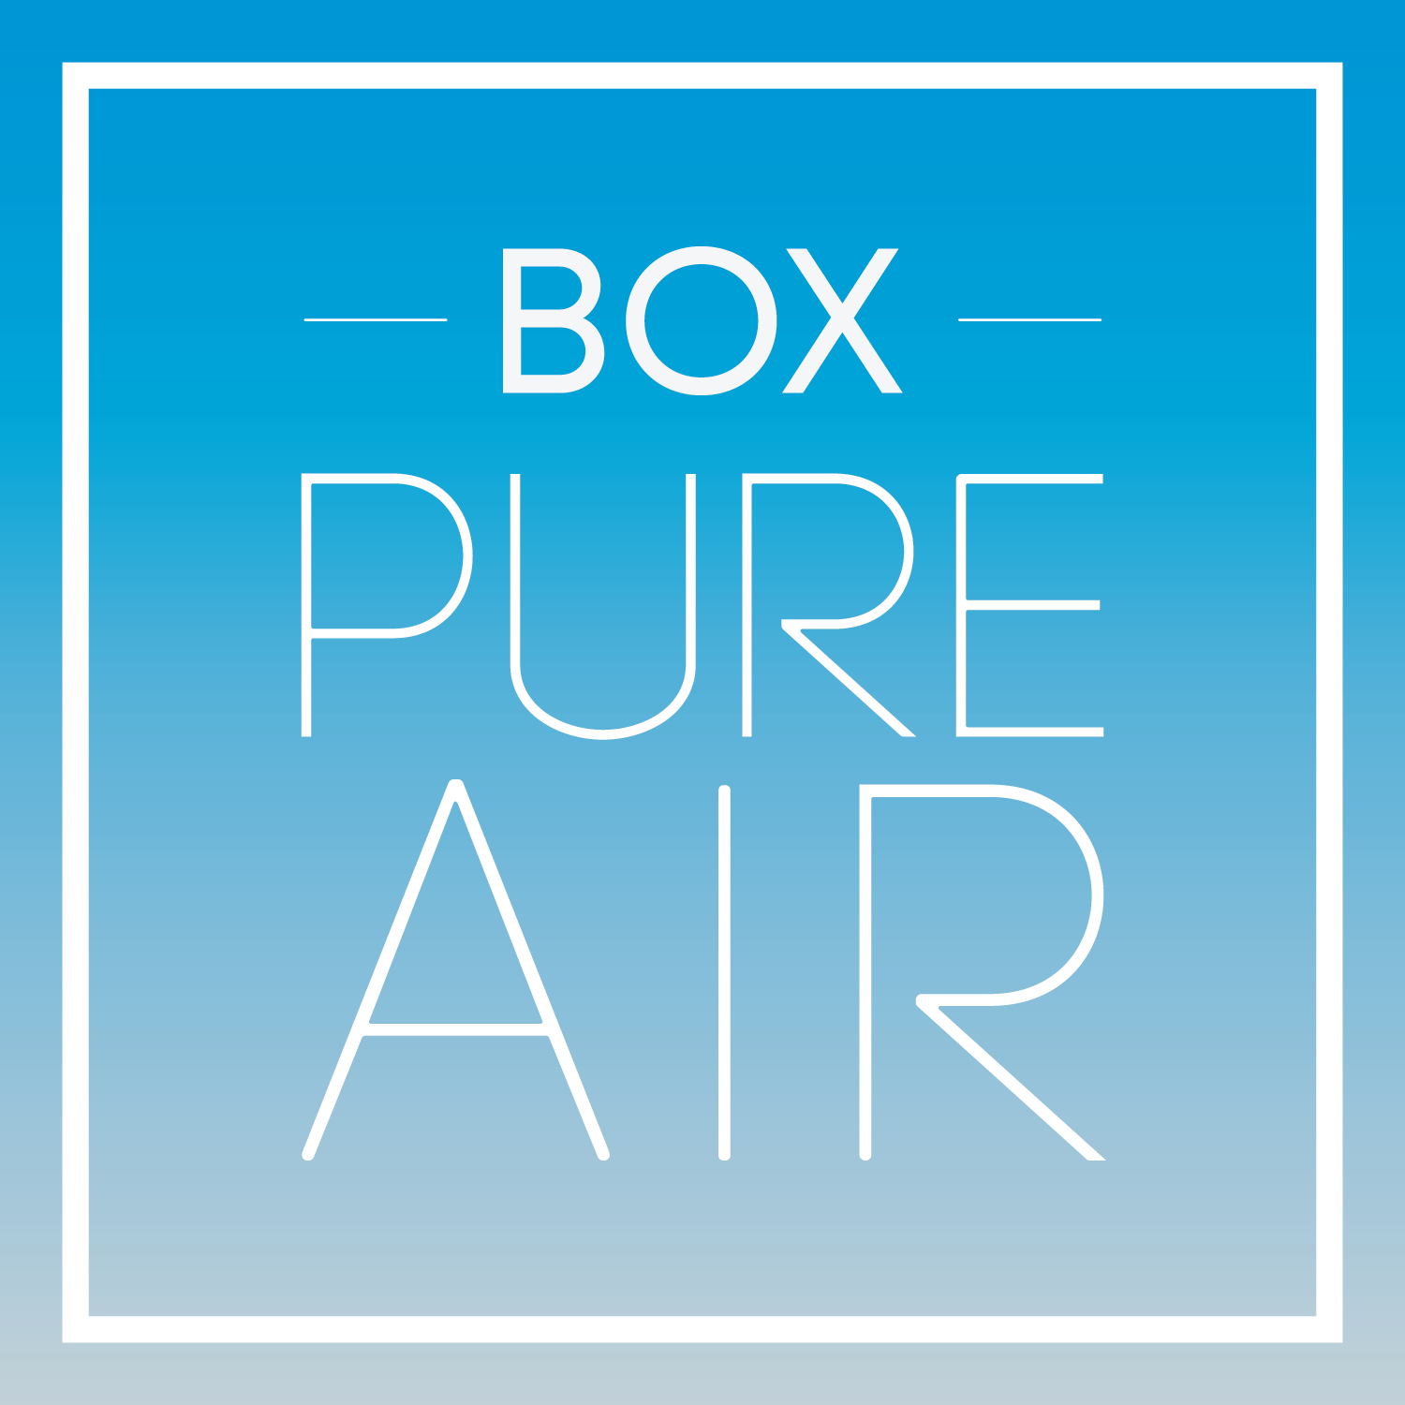
PRESS RELEASE

CONTACT INFORMATION:
BOX Pure Air
Benjamin Brookes
843.806.8455
bbrookes@boxpureair.com

RELEASE DATE:
May 4, 2021

AMERICA’S FIRST CLEAN AIR CITY- CHARLESTON, SOUTH CAROLINA

BOX PURE AIR Announces Safe Air Zones

Charleston, South Carolina, May 4, 2021 — BOX Pure Air, an exclusive distributor of AIRBOX HEPA Filtration Systems, today announced the opening of its office and sales center at 145 King Street, Suite 131 on May 4th. The opening of the BOX Pure Air King Street store is major step towards making Charleston, SC America’s first ‘Clean Air City’ by being able to provide AIRBOX HEPA Air Filtration units to the general public.

BOX Pure Air strives to help businesses and consumers create a safe and healthy clean air environment that is free of airborne pathogens. We exceed national standards of indoor air quality by following CDC requirements for air ventilation utilizing High-Efficiency Particulate Air (HEPA) certified filters and incorporating proven antimicrobial technologies.

BOX Pure Air’s founder, Ryan Cowell, a Mount Pleasant resident, said “Making Charleston America’s first clean air city is an ambitious but attainable goal. By working with governmental agencies and community stakeholders to create Safe Air Zones, I believe we will start to see our city in a post-COVID light.”

________________________________________________________________________________

BOX Pure Air starts with the AIRBOX Air Purifier, a best-in-class product developed by clean-room technologists and 100% hand-built by American craftsmen. It combines high-proficiency air filtration with clean-lined, modern design and style. The AIRBOX delivers commercial-grade clean air technology to keep employees, customers and clients safe and healthy in high-traffic locations.

AIRBOX Purifiers use certified HEPA technology that is tested by the Institute of Environmental Sciences and proven to be 99.99% effective in capturing particulates at .3 microns and even more effective at capturing particles that are both larger and smaller. When combined with our engineering solutions and design, the overall effectiveness of our purifiers increases to a certified 99.9%.

The CDC notes that engineering controls, such as installing HEPA filters and increasing air ventilation, are the most effective step in preparing workspaces against COVID-19. We also support our business customers with marketing assets to help communicate your commitment to providing BOX Pure Air to your clients and staff. Support includes branding kits personalized to your company and other content assets.

CLEAN AIR. PURE & SIMPLE.

To set up a Safe Air Zone in your house or workplace,
please visit BOX Pure Air on-line or in person at
www.boxpureair.com
Or
145 King Street, Suite 131
Charleston, SC 29401
(843)-637-3915

About BOX Pure Air
BOX Pure Air is a subsidiary of SinglePoint Inc. (OTC:SING) and is an exclusive distributor of AIRBOX HEPA Filtration Systems.

