Kisses From Italy Launches First Franchise in California As Part of a Planned National and International Rollout

MIAMI, FL / ACCESSWIRE / May 28, 2021 / Kisses from Italy Inc. (OTCQB:KITL), a publicly listed U.S. based company, restaurant chain operator, franchisor, and product distributor (the "Company"), is pleased to announce that the Company’s first franchise is now open for business in Chino, California and will begin operations today, Friday May 28th, as of 9:00 AM PDT (Pacific Daylight Time). Kisses From Italy initially announced the signing of the California franchise agreement, in January of 2020 with Ms. Sharon Preston, who possesses over 25 years of experience in the retail sector, and now becomes the first operating franchisee in the Company’s history.

The new California location, now bearing the name of the Kisses From Italy brand, will be offering the full Kisses From Italy’s menu that has been enjoyed and has received great reviews by the Company’s customer base in the State of Florida for the last five 5 years.

Michele Di Turi, President, co-CEO and co-founder of Kisses from Italy stated, “given what our organization has faced, along with the rest of the world, we cannot be anymore excited with the opening of our first operating franchise, in California. Sharon Preston, our new franchise partner at the Chino location has demonstrated to us a level of immense fortitude and determination that my co-founding partner, Claudio Ferri, and I will forever be grateful for. After all the trials and tribulations of this past year, Sharon has remained loyal and committed to launching the first Kisses From Italy franchise and the first location in the state of California.” “We are fortunate to have her as a partner and along the way Sharon has definitely become family to us.”

Sharon Preston stated, “I am excited to become part of the Kisses From Italy group. Their unique product offering and delicious menu bodes well for my store, especially in light of the recent mitigation of the impact of Covid and the fact that consumers have a lot of built-up demand for quality product offerings. I am eternally grateful for the opportunity to open a Kisses From Italy in Chino, California. The past year has been quite a journey, but we made it. I am looking forward to serving my community, family and friends.”

Mr. Di Turi further added, “this is the first step of our planned rollout both domestically and internationally. We are actively exploring a number of potential opportunities and are focused on rapid expansion and delivering value to our shareholders.”
The Chino California opening comes on the heels of the recent announcement of Kisses From Italy signing an agreement with Fransmart, an industry leader in the global franchise market and having a solid reputation in franchise development and franchising opportunities space, with a track record of turning emerging restaurant concepts into national and global brands. Fransmart has sold over 5,000 franchises worldwide and launched franchising for "Five Guys Burgers & Fries", "Qdoba Mexican Grill", "The Halal Guys", and have enabled many other new, emerging brands to grow rapidly into dominant chains.

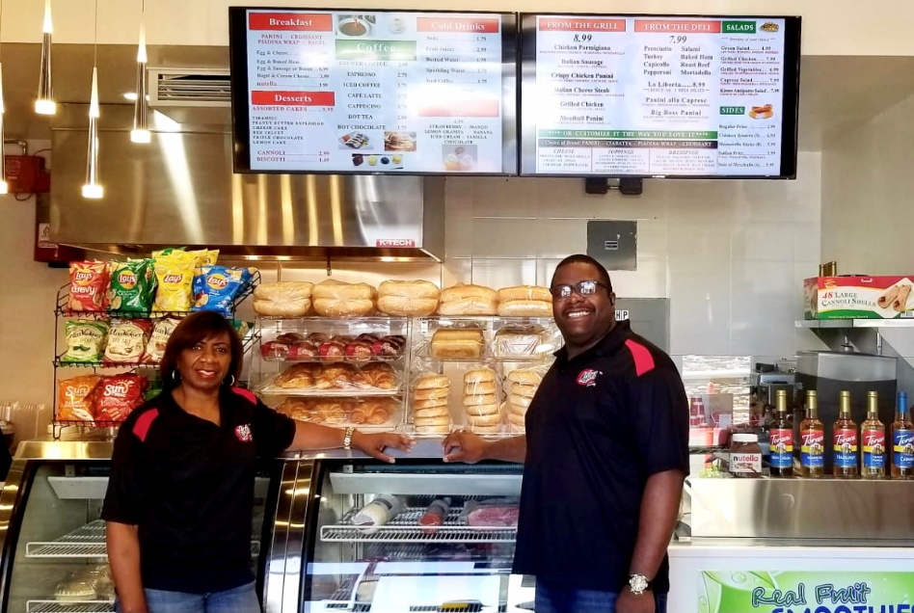
California Franchisee, Sharon Preston and Carlos Townsend, Head Chef at Kisses From Italy – Chino.

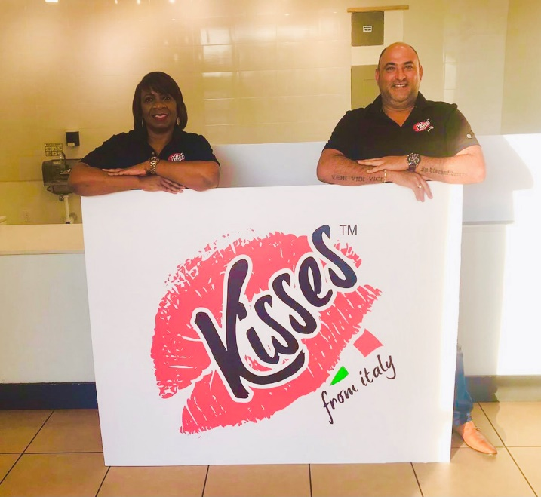
California Franchisee, Sharon Preston and Michele Di Turi, President, co-CEO and co-Founder of Kisses From Italy
visiting the California franchise site in January of 2020.

About Kisses from Italy Inc.
Kisses from Italy Inc. is a U.S.-based restaurant chain operator, franchisor and product distributor with locations in North America and Europe. The Company offers a quick-service menu and a unique take on traditional Italian delicacies with an All-American flair. Kisses from Italy offerings include sandwiches, salads, Italian roasted coffee, coffee-related beverage and an array of other products. In November of 2020, Kisses From Italy launched its retail branded products for distribution stores across Canada. Currently, our products are being offered in grocery stores and retail food stores.

The Company currently operates three corporate-owned stores. It successfully commenced operations in May 2015 with the opening of its flagship location in Ft. Lauderdale at 3146 NE 9th St. This was followed by three additional sites across the greater Ft. Lauderdale/Pompano Beach area. The Company recently opened its inaugural European location in Ceglie del Campo, Bari, Italy in October of 2019. In September of 2019, Kisses from Italy Inc. was given the approval by FINRA to trade its common stock and was approved for up-listing by the OTC Markets Group to the OTCQB in mid-October 2019 under the ticker symbol KITL.

Forward-Looking Statements
This press release may contain forward-looking statements, which are based on current expectations, forecasts, and assumptions that involve risks and uncertainties that could cause actual outcomes and results to differ materially from those anticipated or expected. These risks and uncertainties are further defined in filings and reports by the Company with the Securities and Exchange Commission ("SEC"). Actual results and the timing of certain events could differ materially from those projected in or contemplated by the forward-looking statements due to a number of factors detailed from time to time in our filings with the SEC. Reference is hereby made to cautionary statements set forth in the Company's most recent SEC filings which are available at www.sec.gov as well as the Company's website at www.kissesfromitaly.com. The Company undertakes no obligation to update or revise forward-looking statements to reflect changed assumptions, the occurrence of unanticipated events or changes to future operating results.
For more information, please visit www.kissesfromitaly.com

Contact Information:
Kisses from Italy Inc.
305-423-7129
info@kissesfromitaly.com
SOURCE: Kisses from Italy Inc.

