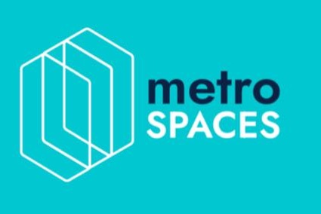

Metrospaces Initiates Construction of Phase III of Infinity View Villas and Sets Fractional Ownership as Sales Strategy

NEW YORK, NY -- Metrospaces, Inc. (OTC: MSPC), a PropTech company powered by Shokworks, has initiated the construction of an additional 3 villas at Infinity View Villas and will establish fractional ownership as sales strategy for Phase III.
Phase III of the Infinity View Villas project has begun, initially with the ground movements and excavations. The construction forecast is to deliver the villas to buyers in approximately 12 months.
The company will take a different marketing approach on the villas of Phase III from the one established in Phase I. The company will sell the Phase III villas by offering them under fractional ownership, with the option to either enjoy the villas and stay during their respective fraction or rent them out to tourists to generate outsized return. Additionally, the company will allow for payment of the fractional ownership acquisition via several crypto coins.
“Selling these villas under fractional ownership will allow for smaller investors to invest in high-yielding hospitality properties in the Dominican Republic. Also, allowing payment with crypto currencies will expand our buyer’s market. As an additional benefit to buyers, we will allow buyers to exchange their fractional property into stable tokens once our platform is up-and-running and fully compliant to allow for investment liquidity. We are very excited about this project, since not only will it be very profitable, but it will also serve as inventory for our MetroHouse and MetroCrowd platform. To get the project finalized quicker, the company has implemented a new plan to accelerate construction that will allow Phase I to be completely finalized and deliverable by end of 2021, a good 4 months ahead of schedule,” explained Brito.
Complete sales information and details, including size and pricing will be announced in the coming days.
Safe Harbor Statement: Statements in this news release may be "forward-looking statements". Forward-looking statements include, but are not limited to, statements that express our intentions, beliefs, expectations, strategies, predictions or any other statements relating to our future activities or other future events or conditions. These statements are based on current expectations, estimates and projections about our business based, in part, on assumptions made by management. These statements are not guarantees of future performance and involve risks, uncertainties and assumptions that are difficult to predict. Therefore, actual outcomes and results may, and are likely to, differ materially from what is expressed or forecasted in forward-looking statements due to numerous factors. Any forward-looking statements speak only as of the date of this news release and Metrospaces Inc. undertakes no obligation to update any forward-looking statement to reflect events or circumstances after the date of this news release.
Metrospaces Inc.

For more information:
https://metrospaces.com
http://inarchiarchitects.com

Contacts:

Kelly Hunter, khunter@sunwestpr.com, (972) 489-4361

