

GaN Systems and EPowerlabs Make Leaps in E-Mobility Power Solution
EPowerlabs’ GaN-based DC/DC converter is 1/3 smaller and 50% lighter than conventional converters
OTTAWA, Ontario, AND SAN SEbastián, Spain – September 30, 2021 – GaN Systems, the global leader in GaN power semiconductors, and EPowerlabs, an end-to-end engineering services firm specializing in e-mobility applications, announced a collaboration to deliver a high-density DC/DC power converter (DDC48-1K) for a wide range of 48V mobility applications for consumer, industrial, and automotive customers.

Using GaN solves space constraint challenges typical in electric mobility systems by providing more power in smaller form factors. The GaN converter is one-third smaller and 50% lighter than standard converters and has an overall efficiency of above 95%.

“Creating a more sustainable world through e-mobility is at the heart of our mission and leveraging technologies like GaN are vital in accelerating this move,” said Mikel Parel, CEO of EPowerlabs, “This is demonstrated by our GaN Systems-based converter, which reduces power losses by more than 50% compared to silicon-based designs in the market and is one-third the size of legacy converters."

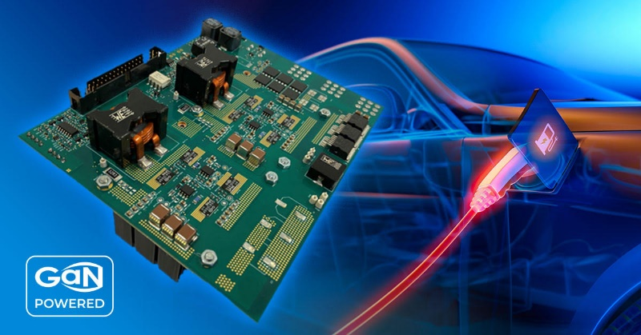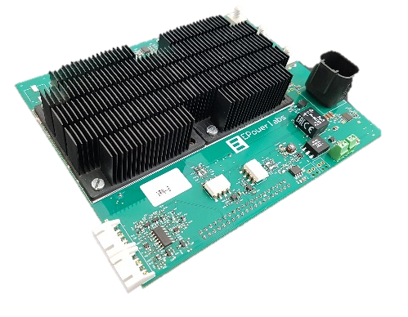

EPowerlabs’ GaN-based DC/DC power converter enables the small size and lightweight functionality required in e-mobility applications.

With an input voltage range of 24-60VDC and rated at up to 1kW continuous power with an overall efficiency above 95%, this converter offers a reliable and efficient solution for electric mopeds and scooters, EV systems and vehicles, and numerous transportation and robotics applications. Highlights:

- High Efficiency: Efficiency is 97.5% at full load, which is a 4% improvement from similar types of converters currently available in the market.
- High Power Density: Power density is 28W/in³ compared to 10W/in³ in converters using other topologies and switches.
- Smaller Weight: The design without the case weighs only 345g, and an air-cooled DC/DC of the same power weighs around 750g.

EPowerlabs’ GaN-based DC/DC converter uses GaN Systems 100V E-mode transistors (GS61008P), which leverage high-performance GaNPX® embedded packaging and the high current, voltage breakdown, and switching frequency of GaN. This combination allows high power, low loss performance, and thermal efficiencies in smaller, lighter power systems.

“It’s wonderful to see customers like EPowerlabs using our GaN transistors to make vast power system improvements within the e-mobility space. These changes all play a part towards the goal of using less energy and creating a more sustainable future,” said Jim Witham, CEO of GaN Systems.

For more information about the EPowerlabs GaN-based DC/DC converter, contact GaN Systems.

###

About GaN Systems
GaN Systems is the global leader in GaN power semiconductors with the most extensive transistors portfolio that uniquely addresses the needs of today's most demanding industries, including consumer electronics, data center servers, and power supplies, renewable energy systems, industrial motors, and automotive electronics. As an industry-leading innovator, GaN Systems makes possible the design of smaller, lower cost, more efficient power systems. The company's award-winning products provide system design opportunities free from the limitations of yesterday's silicon. By changing the transistor performance rules, GaN Systems enables power conversion companies to revolutionize their industries and transform the world.

For more information, please visit: www.gansystems.com or on Facebook, Twitter and LinkedIn and scan this QR code for our WeChat.

About EPowerlabs
EPowerlabs helps OEMs and Tier 1 develop, test, validate and integrate power electronics in mobility applications. Innovation, agility and quality are the core values of EPowerlabs. The company develops e-motor controllers, DC/DC and BMS system platforms to accelerate and ease vehicle development hurdles. EPowerlabs completes its offering with testing and validation services for power electronics, e-motors and battery systems. The company is based in Spain and working with both SMEs and large European listed companies.

For more information, please visit: www.epowerlabs.com or LinkedIn.

# # #

Media Inquiries:
Mary Placido
Trier and Company for GaN Systems
mary@triercompany.com
+1 (415) 218-3627

Juan López
StrategyComm for EPowerlabs
jlopez@strategycomm.net
+34 627 491 949

