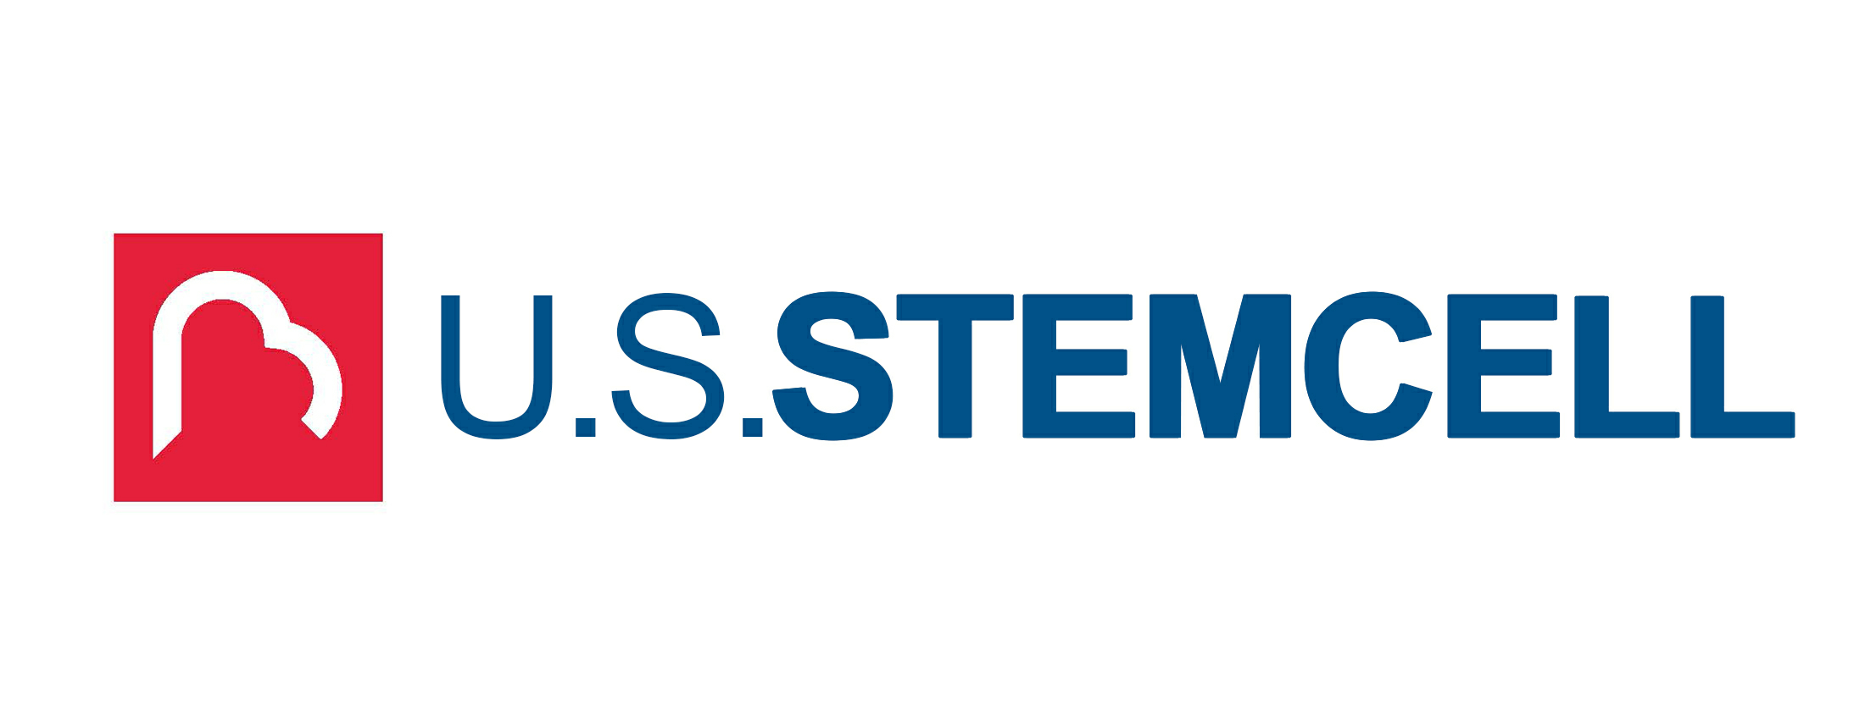

Media Contact: U.S. Stem Cell, Inc.
1560 Sawgrass Corporate Parkway, 4th FL
Sunrise, Fl 33323
Phone: 954.835.1500
Email: usstemcell@us-stemcell.com
For Immediate Release

USRM to Focus on Animal Health and Lead Pet-Care Innovation
___________________________________________

SUNRISE, FL – XX,XX , 2021 – U.S. Stem Cell, Inc. (OTC: USRM), a leader in the development of proprietary, physician-based stem cell therapies and novel regenerative medicine solutions will take steps to relaunch its veterinary division to tackle animal health innovation.

U.S. Stem Cell’s longstanding animal division, Vetbiologics, has for years provided the Veterinary field with comprehensive regenerative medicine solutions - from training to products and services. Vetbiologics now aims to expand further by stepping directly into the consumer driven pet-care industry.

U.S. pet market sales revenue has increased every year in the last decade, growing from $50.96 billion in 2011 to an estimated $99.1 billion last year. The pet industry experienced extraordinary growth during the COVID-19 pandemic; an impressive 12% of adults with children adopted pets because of and during the pandemic, effectively leaving animal shelters empty for the first time in US history. These middle-aged pets are now growing older, many with specialized needs — matched with wealthier pet-parents with significantly greater budgets to care of their aging pets. Of these pet owners, 21% spent more time and money on their pets during the pandemic and the trends are growing upwards.

The animal health division will focus on these new aging pet requirements, with a specialized focus on pet care, pain, wellness and geriatric care.

“The Company’s expansion and growth will directly target consumers as they adjust to pet ownership during and post-pandemic” states Mike Tomas, President & CEO. Adding “from caring for their newly adopted middle-aged or elderly animals to prioritizing their pets' wellness, we will provide solutions to pet parents.”

Given the expected market growth and trending movements of the pet industry, through the Vetbiologics division, the Company aims to strategically partner and develop top-tier products and services in line with the projected successes in the field. These offerings will be in addition to Vetbiologics' existing menu of science-based regenerative treatments and veterinarian-specific options.

U.S. Stem Cell, Inc. is an emerging leader in the regenerative medicine / cellular therapy industry specializing in physician training and certification and stem cell products in both human and veterinary stem cell processes. To management’s knowledge, USRM has completed more clinical treatments than any other stem cell company in the world in the past 20 years, and has certified more than 700 physicians and veterinarians in autologous stem cell therapy worldwide. The company will refocus on its animal health division while it evaluates its future opportunities for its human division and subsidiary.

Forward-Looking Statements: Except for historical matters contained herein, statements made in this press release are forward-looking statements. Without limiting the generality of the foregoing, words such as “may”, “will”, “to”, “plan”, “expect”, “believe”, “anticipate”, “intend”, “could”, “would”, “estimate”, or “continue”, or the negative other variations thereof or comparable terminology are intended to identify forward-looking statements. Forward-looking statements involve known and unknown risks, uncertainties and other factors, which may cause our actual results, performance or achievements to be materially different from any future results, performance or achievements expressed or implied by the forward-looking statements and represent our management’s beliefs and assumptions only as of the date hereof. Except as required by law, we assume no obligation to update these forward-looking statements, even if new information becomes available in the future. The Company’s business and the risks and uncertainties of the business are described in its filings with the Securities and Exchange Commission which can be found at sec.gov.

# # #

