TSXV – BMET
October 19, 2021 OTCQB – BMTLF
FRANKFURT – 1OI.F
BeMetals Receives High-Grade Gold Surface Sample Results from
Reconnaissance Field Work at Todoroki Project in Japan

Vancouver, British Columbia – BeMetals Corp. (TSXV: BMET, OTCQB: BMTLF, Frankfurt: 1OI.F) (the “Company” or “BeMetals”) is pleased to announce that its wholly owned Japanese operating company Kazan Resources (“Kazan”), has recently received a number of high-grade surface sampling results from geological reconnaissance field work, undertaken in August this year, at its Todoroki Property (“Todoroki” or the “Project”) on Hokkaido Island, in northern Japan (See Figure 1).

HIGHLIGHTS OF THE TODOROKI GOLD PROJECT RECONNAISSANCE SURFACE SAMPLING

- 9.43 grams per tonne (“g/t”) Gold (“Au”) and 442.5 g/t silver (“Ag”) over 2.1 metres (Composite chipped channel interval of outcropping vein)
- 9.29 g/t Au and 656.5 g/t Ag over 2.5 metres (Composite chipped channel interval of outcropping vein)
- 41.10 g/t Au and 1,070.0 g/t Ag over 0.1 metres (Chipped sample near historical vein adit)

John Wilton, President and CEO of BeMetals stated, “The Todoroki Project represents one of our five select, highly prospective, gold exploration properties in Japan. While the Company’s Kato Project (“Kato”) is currently our most advanced exploration project, these new reconnaissance surface sampling results from the Todoroki Property, illustrate the pedigree and prospective nature of our portfolio of gold projects in Japan. Our in-country team is already following up with further surface sampling in this area, which with future planned exploration work, will generate drill targets at Todoroki.

This first batch of results highlights the relatively near-term opportunity for BeMetals to generate concise, shallow depth, drill targets within the unmined high-grade gold veins of the historical Todoroki mine’s boundary. Also, the encouraging gold assays from the quartz vein float sampling trail, in the South Shiari River area, indicate that previously unrecognised vein targets exist in the upper levels of this epithermal gold system, covered by younger volcanic units. In addition, this new target area is potentially accessible from relatively shallow surface drilling along the mountainside.

In parallel with the Todoroki Project’s field reconnaissance work, new targets at the Kato Project are being refined from existing data for drill testing. Energold Drilling is working closely with the Company, and has shipped a new SDS C1500 core drill rig to Hokkaido, which is now being transported to the Kato exploration site. Drilling is expected to commence upon the anticipated easing of Covid-19 related international travel restrictions in Japan in-line with the significant reduction in daily case numbers and high levels of vaccine up-take now achieved.”

TODOROKI GOLD PROJECT

This Project targets high grade epithermal gold-silver mineralization encompassed within some 590 hectares of prospecting rights which include the historical Todoroki Mine discovered in 1896 – the oldest gold-and-silver mine in Hokkaido*. Recorded production at the Todoroki Mine from 1925 until 1943 was approximately 200,000 ounces of Au, and 7.4 million ounces of Ag. Mining was temporarily halted in 1943 but resumed operation after WWII. Mining continued intermittently until the 1980s but production information for this period is uncertain.

Detailed geological studies by a Japanese group in the early 1970s concluded that in addition to the 13 known vein occurrences at Todoroki, there were numerous other undeveloped veins and alteration halos surrounding potential vein zones that required investigation. The veins are composed of quartz, calcite, and adularia with local rhodochrosite. The veins are distributed over a 4.5km (East-West) by 1.5km (North-South) area and range in length between 500 and 1,500 metres, with documented widths ranging from 1 to more than 10 metres.

The objective of the current reconnaissance exploration work is to locate, sample, and map unmined veins in the historical mine area with the potential to provide drill targets for near term testing. This batch of surface sampling totalled 118 samples. Table 1 and Figure 2 illustrate the location and the gold and silver grades of the sampling results above 0.1 g/t Au. Of this batch 27 samples returned grades above 0.1 g/t ranging from 0.1 to 41.10 g/t Au with 0.6 to 1,070 g/t Ag. There were 91 samples below 0.1 g/t Au within this batch. The sampling of historical mine dump or stockpile material was avoided.

Figure 2 shows the location of the two chipped channel samples of 9.43 g/t Au with 442.5 g/t Ag over 2.10 metres of 9.29 g/t Au with 656.5 g/t Ag over 2.5 metres, respectively. These samples were taken across outcropping veins within the Koetsu Vein area. The presence of outcropping veins and mine development end faces with vein material in-situ underground, suggest that unmined portions of the Koetsu vein system may remain. Evidence on the surface east of these workings indicate that the veins continue in that direction. One core hole 600 metres northeast and along strike of the Koetsu veins was drilled in the early 1970s that intersected three vein zones. Only one vein was sampled at a depth of around 154.5 metres which yielded 116 g/t Au and 1,540 g/t Ag. The true thickness of the vein is unknown, but it was intersected between 154.4 and 155.7 metres (1.30 metre drilled width).

Sample ID number 633471 was chipped from the portal area of an adit and returned 41.10 g/t Au with 1,070.0 g/t Ag. While this vein was previously mined, some high-grade material remains in-situ. This could indicate that only the very highest-grade zones within the veins were historically mined, therefore providing potential for exploration near such partially extracted veins.

Of special interest within this batch of sampling results are those related to a quartz float trail referred to as the Shirai River (South) area (See Figure 2). This trail of auriferous quartz vein float material extends up to the base of younger cover volcanic units to the epithermal gold system. There are no historical records or physical evidence of mining activity in this area and samples ranging from 0.10 to 1.36 g/t Au in one drainage and 0.23 to 0.88 g/t Au in an adjacent area immediately South of the drainage are very encouraging. This data is interpreted to indicate that there is unexplored potential for higher level gold bearing veins extending up to and concealed under the covering volcanic units. Further exploration should be able to identify drill targets in this area, which significantly increases the scale of the target footprint on the Todoroki Property.

*Hasegawa, K. et al, 1973. Deposits in the Meiji and Todoroki Districts. Report on Surveys to Promote the Development of Important Minerals No. 7.

Figure 1: Regional Location of the Todoroki Gold Project
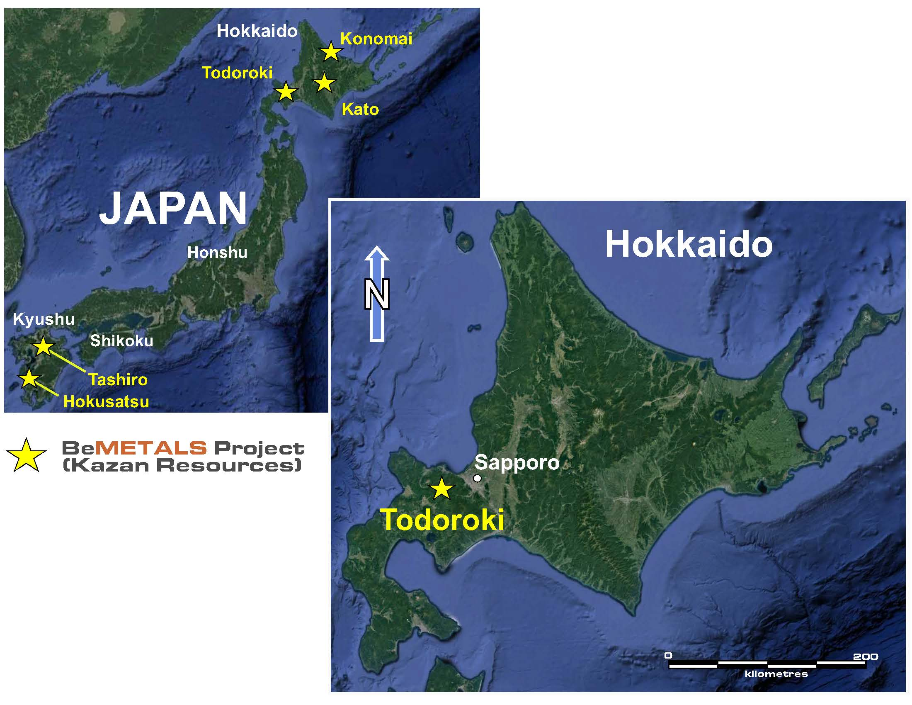
Figure 2: Simplified Geological Map of Todoroki Gold Project with Sample Locations
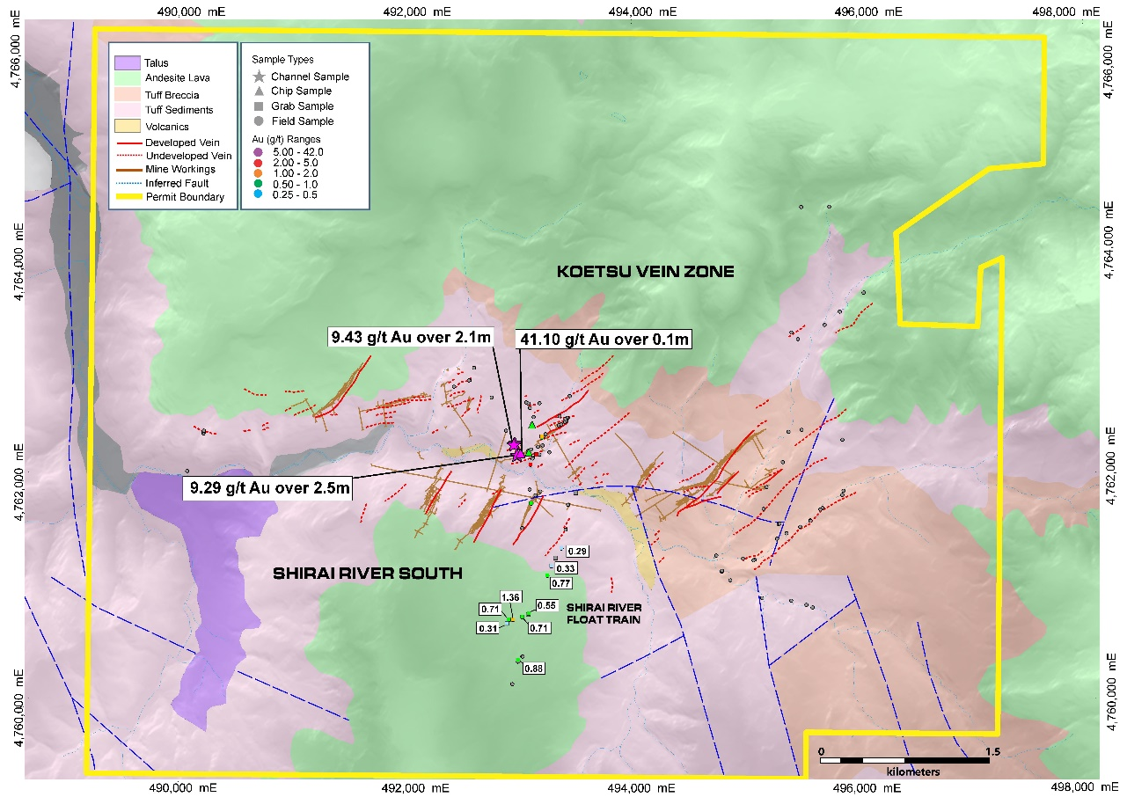
Table 1: Selected Analytical Results from Surface Samples (Gold grades above 0.1 g/t Gold)
LOCAL NAME | Sample ID | Easting | Northing | Sample Site | Sample Type | Estimated Width (m) | Gold g/t | Silver g/t
Koetsu Veins | 633475 | 492975 | 4762229 | outcrop | chipped channel | 1.05 | 11.45 | 519.0
Koetsu Veins | 633476 | 492968 | 4762220 | outcrop | chipped channel | 1.05 | 7.41 | 366.0
Koetsu Veins | 633284 | 493207 | 4762309 | outcrop | grab | NA | 0.96 | 63.1
Koetsu Veins | 633285 | 493206 | 4762315 | outcrop | grab | NA | 1.25 | 99.0
Koetsu Veins | 633479 | 493121 | 4762415 | outcrop | chipped | 0.1 | 0.96 | 49.5
Koetsu Veins | 633472 | 492990 | 4762144 | outcrop | chipped channel | 1.00 | 0.83 | 36.80
Koetsu Veins | 633473 | 492990 | 4762146 | outcrop | chipped channel | 1.25 | 13.15 | 805.0
Koetsu Veins | 633474 | 492990 | 4762148 | outcrop | chipped channel | 1.25 | 5.43 | 508.0
Koetsu Veins | 633471 | 493015 | 4762157 | adit | chipped | 0.1 | 41.10 | 1,070.0
Koetsu Veins | 633275 | 493159 | 4762155 | river float | grab | NA | 4.46 | 11.3
Koetsu Veins | 633369 | 493112 | 4761724 | float | grab | NA | 0.67 | 20.1
Koetsu Veins | 633463 | 493106 | 4762066 | outcrop | grab | NA | 2.36 | 290.0
Koetsu Veins | 633465 | 493092 | 4762170 | outcrop | chipped | 0.5 | 0.75 | 163.0
Koetsu Veins | 633501 | 493256 | 4761084 | float | grab | NA | 0.77 | 1.5
Shirai River (South) | 633358 | 493000 | 4760326 | float | grab | NA | 0.23 | 7.10
Shirai River (South) | 633359 | 492996 | 4760339 | float | grab | NA | 0.88 | 4.00
Shirai River (South) | 633362 | 493092 | 4760747 | float | grab | NA | 0.55 | 0.70
Shirai River (South) | 633363 | 493087 | 4760739 | float | grab | NA | 0.10 | 0.80
Shirai River (South) | 633364 | 493033 | 4760718 | float | grab | NA | 0.71 | 1.50
Shirai River (South) | 633365 | 492951 | 4760693 | float | grab | NA | 1.36 | 12.90
Shirai River (South) | 633366 | 492916 | 4760693 | float | grab | NA | 0.80 | 8.90
Shirai River (South) | 633367 | 492900 | 4760660 | float | grab | NA | 0.31 | 26.30
Shirai River (South) | 633498 | 493382 | 4761327 | float | grab | NA | 0.29 | 0.60
Shirai River (South) | 633500 | 493329 | 4761238 | float | grab | NA | 0.22 | 4.30
Shirai River (South) | 633501 | 493256 | 4761084 | float | grab | NA | 0.77 | 1.50
Shirai River (South) | 633502 | 493509 | 4761814 | float | grab | NA | 0.11 | 9.40
Shirai River (South) | 633503 | 493293 | 4761169 | float | grab | NA | 0.33 | 0.60
Note: Sample widths where quoted are approximate. The chipped channel samples were taken as best approximate orientation perpendicular across the vein width and sampled using hammer and chisel.
QUALITY ASSURANCE AND QUALITY CONTROL
On September 30, 2021, an independent laboratory, ALS Chemex in Vancouver, Canada, provided results from a set of samples from the Todoroki Gold Project 2021 surface program. These results were determined using 50g fire assay atomic absorption spectroscopy finish following fine crushing, riffle splitting and pulverizing, ALS analytical code Au-FA AA24. Over limit samples were completed using 50g fire assay with gravimetric finish, ALS analytical code Au-FA Grav22. The sampling was conducted following standard operating procedures for outcrop and surface sampling with an appropriate chain of custody sample dispatch. The results from ALS Chemex included the introduction of laboratory standards, blanks and duplicates into this batch of samples.
ABOUT BEMETALS CORP.
BeMetals is a precious and base metals exploration and development company focused on becoming a leading metal producer through the acquisition of quality exploration, development and potentially production stage projects. The Company has recently established itself in the gold sector with the acquisition of certain wholly owned exploration projects in Japan. BeMetals is also progressing both its advanced high-grade, zinc-silver-gold-copper polymetallic underground exploration at the South Mountain Project in Idaho through a preliminary economic assessment, and its tier-one targeted, Pangeni Copper Exploration Project in Zambia. Guiding and leading BeMetals’ growth strategy is a strong board and management team, founders and significant shareholders of the Company, who have an extensive proven record of delivering considerable value in the mining sector through the discovery, construction and operation of mines around the world.

The technical information in this news release for BeMetals has been reviewed and approved by John Wilton, CGeol FGS, CEO and President of BeMetals, and a “Qualified Person” as defined under National Instrument 43-101.1

ON BEHALF OF BEMETALS CORP.

“John Wilton”
John Wilton
President, CEO and Director

For further information about BeMetals please visit our website at bemetalscorp.com and sign-up to our email list to receive timely updates, or contact:

Derek Iwanaka
Vice President, Investor Relations & Corporate Development
Telephone: 604-609-6141
Email: diwanaka@bemetalscorp.com

Neither the TSX Venture Exchange nor its Regulation Services Provider (as that term is defined in the policies of the TSX Venture Exchange) accepts responsibility for the adequacy or accuracy of this news release

Cautionary Note Regarding Forward-Looking Statements
This news release contains "forward-looking statements" and “forward looking information” (as defined under applicable securities laws), based on management’s best estimates, assumptions and current expectations. Such statements include but are not limited to, statements with respect to future exploration, development and advancement of the South Mountain Project, the Pangeni project and the Japan properties, and the acquisition of additional base and/or precious metal projects. Generally, these forward-looking statements can be identified by the use of forward-looking terminology such as "expects", "expected", "budgeted", "forecasts", "anticipates", "plans", "anticipates", "believes", "intends", "estimates", "projects", "aims", "potential", "goal", "objective", "prospective", and similar expressions, or that events or conditions "will", "would", "may", "can", "could" or "should" occur. These statements should not be read as guarantees of future performance or results. Such statements involve known and unknown risks, uncertainties and other factors that may cause actual results, performance or achievements to be materially different from those expressed or implied by such statements, including but not limited to: the actual results of exploration activities, the availability of financing and/or cash flow to fund the current and future plans and expenditures, the ability of the Company to satisfy the conditions of the option agreements for the South Mountain Project and/or the Pangeni Project, and changes in the world commodity markets or equity markets. Although the Company has attempted to identify important factors that could cause actual results to differ materially from those contained in forward-looking statements, there may be other factors that cause results not to be as anticipated, estimated or intended. There can be no assurance that such statements will prove to be accurate, as actual results and future events could differ materially from those anticipated in such statements. The forward-looking statements and forward looking information are made as of the date hereof and are qualified in their entirety by this cautionary statement. The Company disclaims any obligation to revise or update any such factors or to publicly announce the result of any revisions to any forward-looking statements or forward looking information contained herein to reflect future results, events or developments, except as require by law. Accordingly, readers should not place undue reliance on forward-looking statements and information. Please refer to the Company’s most recent filings under its profile at www.sedar.com for further information respecting the risks affecting the Company and its business.

