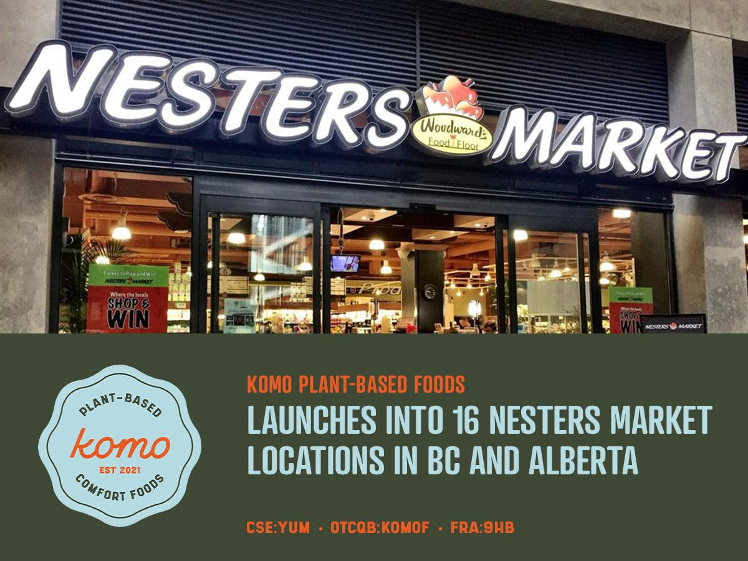

Komo Plant Based Foods Launches into 16 Nesters Market Locations in BC and Alberta

Vancouver, B.C. –November 2, 2021: Komo Plant Based Foods Inc. (CSE: YUM) (OTCQB: KOMOF) (FRA:9HB) (“Komo”), a premium plant-based food company, is pleased to announce that its full range plant-based comfort foods (7 SKUs) will be carried in all 16 Nester Market locations in British Columbia and Alberta beginning this month. In connection with the launch, Nesters Market is featuring Komo as “Pick of the Month” in a promotional email, social media and in-store marketing campaign.

"Nesters Market is proud and excited to feature Komo Comfort Foods in all 16 of our locations across British Columbia and Alberta. As a Western Canadian-owned company, we wholeheartedly support locally-owned Canadian businesses whenever possible, and look forward to growing into a successful partnership with Komo Comfort Foods,” says Erin Jane, Grocery Merchandising Coordinator at Nesters Market. “We stand behind Komo’s delicious and healthy plant-based comfort foods, and we know it will soon become a Nesters customer (and staff!) favourite. Look for free Komo product samples in the Nesters Marketplace booth at the Vancouver Wellness Show, taking place in February 2022."

“We’re on our mission to bring plant-based favourites to more people, places and plates.” says Komo operating subsidiary Komo Comfort Foods CEO Jeffrey Ma. We launched Komo with our local delivery service and consumers in BC and Alberta will now have more places to find our wholesome frozen meals. This announcement is especially exciting as Nesters Market will be our first retail partner to carry products outside of BC.”

Last month, Komo announced it has commercialized it’s products with a co-manufacturer and partnered with frozen food distributors to build out its retail network. Komo anticipates being on the shelves of more stores across Canada by the end of the year and in the United States by 2022.

About Nesters Market
Nesters Market is a proudly 100% Western Canadian privately-owned company whose core values are quality, integrity, a commitment to total customer satisfaction and recognition of the importance of its responsibility to the environment. Our Nesters Market mission is to contribute to the health and well-being of our communities by providing a broad range of safe, healthy and affordable food and household products as well as relevant, convenient services. Our ultimate, overarching goal is to Add Value to people’s lives; especially our loyal customers and our dedicated associates.

About Komo
Komo Plant Based Foods Inc. is a premium plant-based food company that develops, manufactures and sells a variety of plant-based frozen meals that are always hearty, satisfying, and made with wholesome ingredients. At Komo, our mission is to help make plant-based meals a staple on every dinner table by sharing our love for feel-good food that connects the people to the planet. We believe plant-based eating is the future and - Change can start with a single biteTM. Our experienced plant-based innovation and development team recreates vegan versions of traditionally cheesy and meaty classics, with 100% plants. Komo's products are sold direct-to-consumer through our eCommerce website and a distribution network of online and brick and mortar grocery, convenience and natural retailer channels. Our operating subsidiary Komo Comfort Foods launched in 2021 with our flagship products: plant-based Lasagna, Shepherd's Pie and Chickenless Pot Pie and has recently launched a new line - Komo Plant-Based Meal HelpersTM - versatile meal starters to allow the creation of many dishes at home. All of our products are 100% plant-based, made with wholesome ingredients, free from preservatives, and frozen for freshness. Freezing products is a natural and effective way of keeping food products for longer without having to use any preservatives. Komo’s meals have a 1-year frozen shelf life.

Learn more at: www.komocomfortfoods.com and follow on Instagram: @komocomfortfoods

For further information, please contact:

William White, President & CEO, Komo Plant Based Foods Inc.
will@komoeats.com
1-866-969-0882

The Canadian Securities Exchange has not reviewed, approved or disapproved the contents of this news release.

Cautionary Statement Regarding Forward-Looking Statements

Certain statements contained in this press release constitute forward-looking information. These statements relate to future events or Komo's future performance. The use of any of the words "could", "expect", "believe", "will", "projected", "estimated" and similar expressions and statements relating to matters that are not historical facts are intended to identify forward-looking information and are based on Komo's current belief or assumptions as to the outcome and timing of such future events. Actual future results may differ materially. In particular, Komo's product development plans, its ability to launch its products on food delivery apps, its ability to retain key personnel, its revenues, and its expectation as to the acceptance of its products by retailer stores and consumers constitute forward-looking information. Actual results and developments may differ materially from those contemplated by forward-looking information. Readers are cautioned not to place undue reliance on forward-looking information. The statements made in this press release are made as of the date hereof. Komo disclaims any intention or obligation to publicly update or revise any forward-looking information, whether as a result of new information, future events or otherwise, except as may be expressly required by applicable securities laws.

