
For Immediate Release

GaN Systems and USI Form Strategic Partnership to Accelerate
GaN Adoption in Electric Vehicles

- GaN Systems and USI have signed a strategic partnership agreement to co-develop GaN power modules for the automotive market.
- As a part of the strategic partnership, USI is acquiring a minority share of GaN Systems as part of the recent growth capital round.
OTTAWA, Canada, November 24, 2021 - GaN Systems, the global leader in GaN (gallium nitride) power semiconductors, today announced a strategic partnership with ASE Technology’s subsidiary, Universal Scientific Industrial Co., Ltd (USI), to co-develop GaN power modules for the EV market. As the electric vehicle shifts from using legacy silicon power transistors to the increased performance of GaN, power modules are also transitioning to meet the demands of low heat loss and superior voltage control in the power conversion process. GaN power modules enable higher efficiency, increased EV range, and increased EV performance.
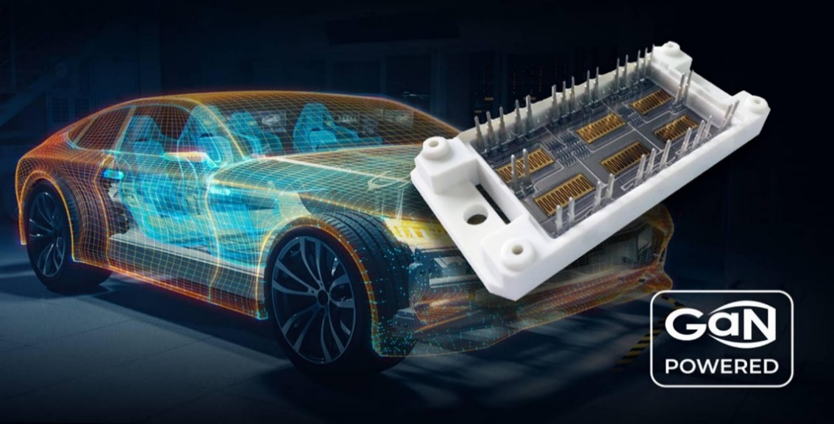
GaN powered electronics achieve the performance required in EV systems

“We are proud to partner with an industry leader like GaN Systems,” said JP Shi, USI’s SVP of Strategic Investment. “We have worked with GaN Systems for years and are impressed with the company’s leadership in high reliability, automotive-qualified GaN – an essential building block for EVs. We look forward to building optimized and highly efficient modules that will be the cornerstone of best-in-class DC-DC converters, on-board chargers, and traction inverters.”
The heart of the EV traction drivetrain is the semiconductor power module. USI has more than 20 years of experience in power electronics manufacturing of various package types and high-reliability modules, including power modules, IPMs (intelligent power modules), DC/DC converters, and RF power transistors. USI has been well-recognized by OEMs and Tier-1 suppliers in the automotive sector by introducing the automotive functional safety standard ISO26262 and being certified with Chapters II and VII for manufacturing.
Stephen Coates, GM and VP of Operations at GaN Systems, said, “With today’s announcement, USI joins our ecosystem of partners working to bring leading GaN technology to EVs. Through this partnership, we bring together USI’s leadership in complex, high-power integrated modules with our high-reliability GaN semiconductor technology to build truly disruptive, game-changing modules for next generation EVs. Building on our deep industry relationships with leaders like BMW, Toyota, and Vitesco, GaN Systems and USI will work together to accelerate GaN adoption across the EV platform.”
The Benefits of GaN
Power electronics and power conversion have a great influence on the cost and range of an electric vehicle. During each conversion cycle of electric energy, a certain amount of electricity is inevitably lost as heat due to the principles of physics. This impacts the total efficiency of an electric drive train. Innovative design with GaN offers a superior solution by enabling much higher efficiencies, ultimately lowering heat losses and allowing higher operating performance. The result is systems that are compact, easier to manufacture, and more cost-efficient.
# # #
About GaN Systems
GaN Systems is the global leader in GaN power semiconductors with the most extensive transistors portfolio that uniquely addresses the needs of today’s most demanding industries, including consumer electronics, data center servers, and power supplies, renewable energy systems, industrial motors, and automotive electronics. As an industry-leading innovator, GaN Systems makes it possible to design smaller, lower cost, more efficient power systems. The company’s award-winning products provide system design opportunities free from the limitations of yesterday’s silicon. By changing the transistor performance rules, GaN Systems enables power conversion companies to revolutionize their industries and transform the world. For more information, please visit: www.gansystems.com or on Facebook, Twitter and LinkedIn and scan this QR code for our WeChat.

# # #
Media Contact:

Mary Placido
Trier and Company for GaN Systems
Email: mary@triercompany.com
Phone: +1-415-218-3627

