Four-Piece Rock Band Bourbon Street: Playing a show in Wuppertal, Germany in December 2021

24/11/2021.Yorkie Lane, Statesboro, GA.

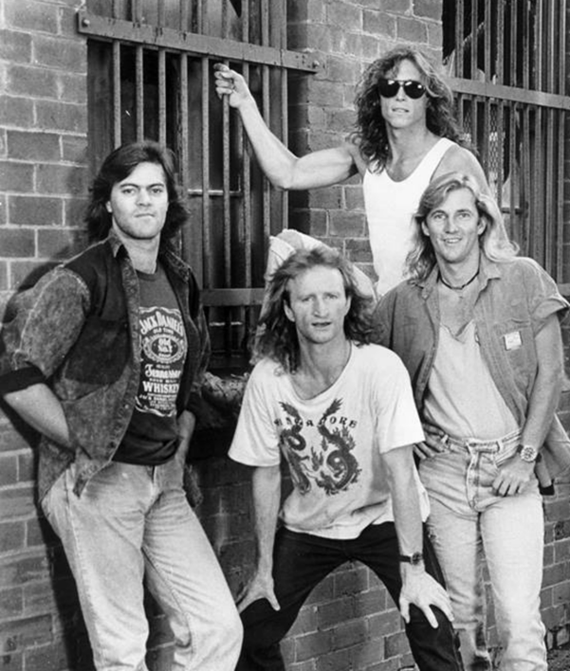
They may not be as young as they once were, but don’t expect to see Bourbon Street in rocking chairs anytime soon. This classic four-piece rock band is celebrating 35 years of partying and rocking the stage, and it isn't slowing down anytime soon.

After a yearlong hiatus when Bourbon Street could hardly play any shows due to the pandemic, the boys are now ready to get back in action. Bourbon Street will be playing a show in Wuppertal, Germany in December 2021, and while future concert dates for 2022 haven’t been announced yet, their recent activity is as good a sign as any that the band is looking to hit the streets and electrify crowds in their trademark style once again.

But with an extensive catalog of songs that the band has churned out over their 35-year career, fans can expect to hear the band's most popular songs live. About the upcoming show in Germany and future touring plans, guitarist Lenny Patch said, “It’s super-exciting to play in front of a crowd, the good ol’ fashioned way again. We’ve played in Wuppertal before and it’s always been a hell of a crowd there. This time, as the world’s findings its feet again and everyone wants to get back out there and resume normal life, I’m almost getting goosebumps just thinking about playing our songs to a roaring crowd once again.”

The guitarist was coy about plans for upcoming albums, saying “Well, you never really know. It’s always on the cards and as much as I’d like to do it, everyone in the band has got other engagements as well. So while I’m not sayin’ it’s never gonna happen, I think for now we’re pretty content with just being able to still be together and celebrate our 35 years, and throw more shows around the world again.What I can say is that we’re certainly gearing up for a lot more shows in the next year if the pandemic doesn’t put a raincheck on our plans.”

About Bourbon Street Band
Bourbon Street was formed in Byron Bay , New South Wales,Australia in 1987. Their name was inspired by the street in their hometown, which had a reputation as one of Australia’s most notorious red-light districts until it became gentrified. With no record label willing to sign them, the band took matters into their own hands and self-released their debut live album, Live at the Basement (recorded at Sydney’s Basement club) in July 1988. On the strength of the album’s lead single, Eyes the Size of Stars, they signed with Virgin Records and released 1990’s Heaven Tonight, which peaked at No. 21 on the ARIA Albums Chart, No. 1 on the independent chart and No. 24 on the New Zealand Albums Chart. It was produced by Ed Stasium (Ramones, Blondie).
Bourbon Street toured Australia throughout 1990 to promote Heaven Tonight, then spent 1991 on hiatus while various band members worked on side projects. This included a new line-up featuring guitarist Garry Gary Beers on bass guitar and backing vocals who had first played with Bourbon Street on an Australian tour in 1989 as an unnamed stand-in on bass guitar. During this time they performed under various names including Bourbon Street Blues Band until Gary suggested Bourbon Street. An Australian American rock band that helped shape what is now known as the New Orleans music scene, Bourbon Street has been rocking the stage for 35 years.
The band formed in 1987, but before that, they had already begun paving the way for the local music scene, which is now known around the world for its cultural contribution to both Australian and American music.

This past October 2021, Bourbon Street celebrated three decades on stage during a sold out show at the House of Blues in New Orleans. Playing to more than 1,000 fans who grew up listening to Bourbon Street’s music or who are influenced by its style, this show marked the band’s arrival on the scene before their original fans had even left it.
“It was like an out-of-body experience,” said guitarist Lenny Patch. “I noticed that I was on stage with some of my best friends playing our 30+year-old songs while people who were at our shows when we first started were singing along. We’re like a family, like an older brother and sister. It was like saying goodbye to your older sister who has supported you before you became famous.”

The key to Bourbon Street’s longevity is that they never strayed too far from their signature sound. Sure, the production has grown tighter over the years, but the core components are intact – soaring guitar solos, tight harmonies, winking lyrics, and one of the most singular voices in rock history. The songwriting style hasn’t changed much either - each song contains a memorable hook or riff that you won’t soon forget.
A great example is the first single from their fourth release, 2007’s Banned for Life. “Take it Off” is a winking ode to strip clubs that sounds just as playful as “Strip or Strip” which was released back in 1989. Aside from the lyrics and the hooky guitar riff, you’re hearing exactly what you loved about Bourbon Street thirty years ago: deep down funk and unbridled rock ‘n roll energy.

Bourbon Street has a 35-year catalog of songs that have been played continuously ever since they were first recorded. Now, after a lengthy concert hiatus, they are back in action and can once again be seen rocking desks and office cubicles throughout New Orleans. Learn more here www.bourbonstreetband.com

Media contacts
Contact Person: Dan Kihato,
Address:25 Railway Street, Treharris, CF46 6AG.United Kingdom.

