SUIC New York Office Announces A Solid Launch Lineup Of Its Starry Marketing Master Model That Will Bring Two Ecosystems, Midas Touch Lending-Borrowing and Beneway New Age Bank, To The 50 States In The U.S.

NEW YORK, Taipei, November 30, 2021 / Sino United Worldwide Consolidated Ltd. (OTC: SUIC) SUIC New York office announces a solid launch lineup of its Starry Marketing Master Model that will bring the Midas Touch lending and borrowing and Beneway new age banking ecosystems to the 50 states in the United States. SUIC New York office is the operating base from which to launch the SUIC and Midas Touch supply chain finance fintech businesses in North America.
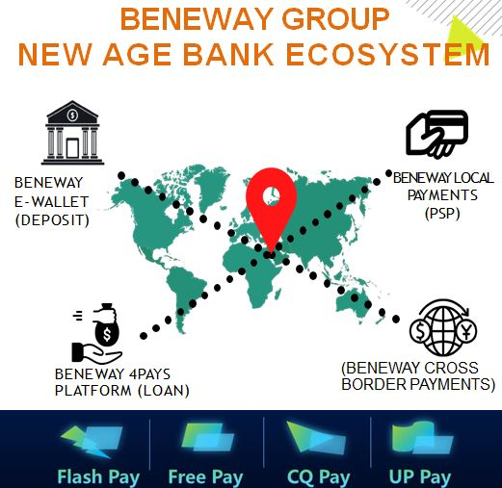

SUIC Midas Touch Ecosystem is a dynamic peer-to-peer bridge platform that connects SME merchants to qualified lenders in an extremely cost efficient manner, solving liquidity issues through a strong risk management framework, high-level transparency on loans and favorable service levels that meet the burgeoning demands of borrowers while offering them attractive rewards. This ecosystem is designed to expedite capital turnover which is the blood line for the survival of all businesses whilst the supply chain processes are running efficiently for a first-class user experience.

- Flash Pay™ Same Day Swipe-Funding where SME merchants can borrow and obtain immediate liquidity for the sale of their products
- Free Pay™ Delay Settlement to Offset Transaction Cost where the SME merchant acts like a lender
- CQ Pay™ is a P2P lending service for E-Commerce sales channels where they can get emergency loan from lender.
- Unified Procurement™ Combined Purchasing Powers Economies of Scale
Flash Pay™, Free Pay™, and Unified Procurement™ are the main drivers of the SUIC Midas Touch ecosystem’s strategy.

Beneway New Age Bank Ecosystem is a new age fintech ecosystem offering comprehensive financial services platform in the future that is highly competitive with traditional banking. Beneway’s core objective is to connect various financial service providers of digital wallets, electronic cards, P2P lenders, payment gateways and cross-border payments providers to synergize their products and services targeting a larger customer base and leveraging on the power of economies of scale. Beneway platform will add value by simplifying financial services that are made easy and convenient with technology and innovation being at the forefront.

FMW Media, Inc. will be conducting multi-series TV interviews on ‘New to The Street TV’ starting on November 16 Tuesday and will continue for 18 consecutive months. These interviews will be broadcasted on Fox News, Bloomberg, Fox Business Network, Newsmax, and the other TV outlets to hundreds of millions of households across North America and other countries. For more information about this Fox Business program, click: https://finance.yahoo.com/news/street-tv-signs-18-part-150000631.html?fr=yhssrp_catchall

SUIC Midas Touch is poised to create a strong and durable presence in the U.S. and North American markets to generate a larger pool of resources and leverage SUIC’s global brand as well as SUIC’s networks and expertise in its role as a gateway for international brands to reach millions of merchants worldwide. SUIC has several catalysts coming up in the near to medium term, including plans to expand SUIC Midas Touch offerings in 40 countries by 2022.

About Sino United Worldwide Consolidated Ltd., USA

The Sino United Worldwide Consolidated Ltd. provides research and development, venture financing for and investing in private enterprises and the public sector that develop products and services adopting core capabilities of the Internet of Things, cloud computing, mobile payment, Big Data, Blockchain, and Artificial Intelligence, to enhance and streamline existing processes, and establish new and exciting business models that will create revolutionary products and services. Shareholders of SUIC will be exposed to the diverse application of advanced services in various parts of the economy. Additionally, existing and potential customers can benefit from this company’s diversified portfolio of technologies. As one of the pioneering publicly traded technology companies, SUIC will help build tech-enabled businesses of the future. To learn more, please visit www.sinounitedco.com.
Please also read the full company report on SUIC by Globe Small Cap Research,
https://drive.google.com/file/d/1_f2vaVOfJT5_idLn87lM1Q_lGxnY_tHW/view

Forward-Looking Statement

This press release contains forward-looking statements within the meaning of Section 27A of the Securities Act of 1933, as amended, and Section 21E of the Securities Exchange Act of 1934, as amended. In some cases, you can identify forward-looking statements by the following words: "anticipate," "believe," "continue," "could," "estimate," "expect," "intend," "may," "ongoing," "plan," "potential," "predict," "project," "should," "will," "would," or the negative of these terms or other comparable terminology. However, not all forward-looking statements contain these words. Forward-looking statements are not a guarantee of future performance or results and will not necessarily be accurate indications of the times at which such performance or results are achieved. This press release is considered considering all Company filings contained in the Edgar Archives of the Securities and Exchange Commission at www.sec.gov.

Contact
Sino United Worldwide Consolidated Ltd.
New Release Department
929-391-2550

