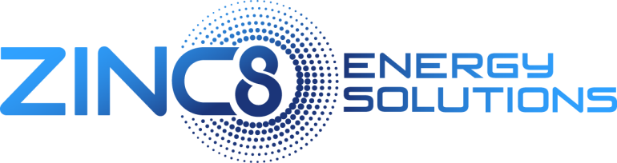
.
Zinc8 Energy Engages Consulting Firm in Effort to Advance Initiatives in New York State

~Adds advisor to the Board of Directors for the New York market~

Vancouver, British Columbia, Canada – December 17, 2021 Zinc8 Energy Solutions Inc. (“Zinc8” or the “Company”) (CSE: ZAIR / OTC: ZAIRF / FSE: 0E9) is pleased to announce the engagement of Ramboll Americas Engineering Solutions Inc. (“Ramboll”) to investigate potential manufacturing sites in the state of New York. Additionally, Zinc8 has engaged Robert F. Parker as an advisor to the Board of Directors for the New York market.

Ramboll will provide engineering consulting services in support of the evaluation of three potential sites in the state of New York which were identified through the coordinated efforts of Zinc8 and Empire State Development (“ESD”). Based on specific project requirements outlined by Zinc8, Ramboll’s scope of services include site-related information compilation, identification of permits and approvals, preliminary code review, “red flag” analysis and recommendations.

“The state of New York is one of the most ambitious states when it comes to the reduction of greenhouse gas (“GHG”) emissions as exemplified by New York City’s Local Law 97,” stated Mark Baggio, VP Business Development for Zinc8 Energy Solutions Inc. “Under Local Law 97, buildings with 25,000+ square feet of space will be required to meet new energy efficiency and GHG emissions starting in 2024. This represents a significant market opportunity for Zinc8’s zinc-air energy storage systems. We have built strong relationships with government agencies, incubators and private sector partners in New York. Between these relationships and the regulatory backdrop, the need to explore potential manufacturing opportunities in the state was evident to us.”

Mr. Robert. F. Parker has 25 years of experience in leadership, management, capital markets, and creating sustainable growth at public & private, non-profit, and government clients. Mr. Parker is a Director at Sif Capital Advisors and an Innovation Advisor to NYSERDA. Since 2005, he has focused on the ClimateTech sector, working as an entrepreneur, executive, banker, policy advisor, project developer, consultant, and investor. Robert’s ClimateTech sector experience spans: Solar / PV; Energy Storage / Battery; CarbonTech; Smart Grid, Monitoring & Energy Efficiency; Waste Energy; Heat-to-Power; Thermal Efficiency; Geothermal; Thermal Efficiency; AgTech & FoodTech; Smart Water; Policy, Energy Insurance & Risk Products; and Smart Water. Mr. Parker has advised more than 100 technology companies and helped raise nearly $500 Million for start-ups and Cleantech projects – with significant experience supporting cross-border expansion and renewable energy project development.

Zinc8 Energy Solutions focuses on developing and commercializing its low-cost, long duration ZESS for utilities, microgrid, and Commercial & Industrial markets. By using the patented ZESS as a standalone or an enabling technology, it allows opportunities for peak demand reduction, time-of-use arbitrage, and participation in both the value stacking programs and the distributed long-duration energy storage space, all in conjunction with the opportunity for a significant reduction in carbon footprint. The long duration (8-100+ hours) ZESS has no fire and explosion risk, has no capacity fade over extensive lifetime, and offers complete charge operational flexibility.

About Ramboll

Ramboll is a global engineering, architecture and consultancy company founded in Denmark in 1945. Our 16,000 experts create sustainable solutions across Buildings, Transport, Water, Environment & Health, Architecture & Landscape, Energy and Management Consulting. Across the world, Ramboll combines local experience with a global knowledgebase to create sustainable cities and societies. We combine insights with the power to drive positive change to our clients, in the form of ideas that can be realized and implemented.

About Zinc8 Energy Solutions Inc.

Zinc8 has assembled an experienced team to execute the development and commercialization of a dependable low-cost zinc-air battery. This mass storage system offers both environmental and efficiency benefits. Zinc8 strives to meet the growing need for secure and reliable power. To learn more about Zinc8’s technology, please visit: https://zinc8energy.com

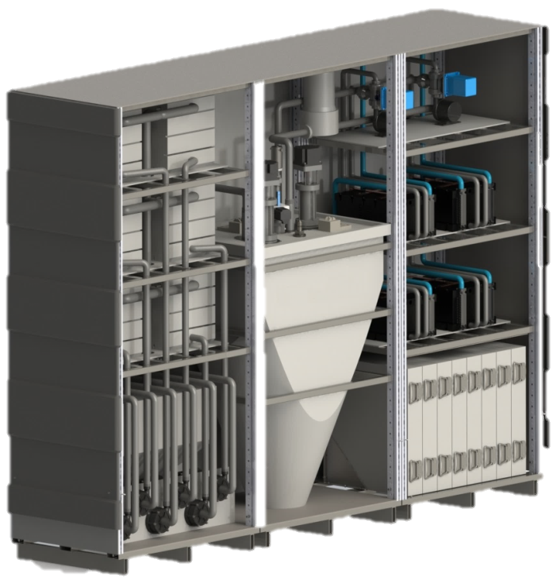
More about the Zinc8 Energy Storage System (ESS)
The Zinc8 ESS is a modular Energy Storage System designed to deliver power in the range 20kW - 50MW with capacity of 8 hours of storage duration or higher. With the advantage of rechargeable zinc-air flow battery technology, the system can be configured to support a wide range of long-duration applications for microgrids and utilities. Since the energy storage capacity of the system is determined only by the size of the zinc storage tank, a very cost-effective and scalable solution now exists as an alternative to the fixed power/energy ratio of the lithium-ion battery.
Technology
The Zinc8 ESS is based upon unique patented zinc-air battery technology. Energy is stored in the form of zinc particles, similar in size to grains of sand. When the system is delivering power, the zinc particles are combined with oxygen drawn from the surrounding air. When the system is recharging, zinc particles are regenerated, and oxygen is returned to the surrounding air.

Applications

The flexibility of the Zinc8 ESS enables it to service a wide range of applications. Typical examples include:
- Smoothing energy derived from renewable sources such as wind and solar
- Commercial/Industrial backup replacing diesel generators
- Industrial and grid scale, on-demand power for peak shaving and standby reserves
- Grid-scale services such as alleviating grid congestion, deferring transmission/distribution upgrades, energy trading and arbitrage, and increasing renewable energy penetration.

Architecture

The Zinc8 ESS is designed according to a modular architecture that enables a wide variety of system configurations to be created from a small number of common subsystems. Each subsystem implements a single element of the technology:
- The Zinc Regeneration Subsystem (ZRS) provides the recharging function
- The Fuel Storage Subsystem (FSS) provides the energy storage function
- The Power Generation Subsystem (PGS) provides the discharging function

Notice Regarding Forward Looking Statements
This news release contains certain statements or disclosures relating to Zinc8 Energy Solutions that are based on the expectations of its management as well as assumptions made by and information currently available to Zinc8 Energy Solutions which may constitute forward-looking statements or information (“forward-looking statements”) under applicable securities laws. All such statements and disclosures, other than those of historical fact, which address activities, events, outcomes, results or developments that Zinc8 Storage anticipates or expects may or will occur in the future (in whole or in part) should be considered forward-looking statements.
Forward looking statements in this press release include that we will commence the demonstration unit now, that we can validate a low-cost, long-duration (8-to-100-hour), and sustainable energy storage technology which can provide megawatt-scale standby power solutions; that we can execute the development and commercialization of a dependable low cost zinc-air battery; that our mass storage system offers both environmental and efficiency benefits; and that we can help meet the needs for secure and reliable power. Zinc8 Energy Solutions believes the material factors, expectations and assumptions reflected in the forward-looking statements are reasonable at this time, but no assurance can be given that these factors, expectations and assumptions will prove to be correct. The forward-looking statements included in this news release are not guarantees of future performance. Such forward-looking statements involve known and unknown risks, uncertainties and other factors that may cause actual results or events to differ materially from those anticipated in such forward-looking statements including, without limitation: that the demonstration unit does not provide the kind of data that can be applied in other projects or validate our technology; that our technology fails to work as expected or at all; that our technology proves to be too expensive to implement broadly; that customers do not adapt our products for being too complex, costly, or not fitting with their current products or plans; our competitors may offer better or cheaper solutions for battery storage; general economic, market and business conditions; increased costs and expenses; inability to retain qualified employees; our patents may not provide protection as expected and we may infringe on the patents of others; and certain other risks detailed from time to time in Zinc8 Energy Solution’s public disclosure documents, copies of which are available on the Company’s SEDAR profile at www.sedar.com. Readers are cautioned that the foregoing list of factors is not exhaustive and are cautioned not to place undue reliance on these forward-looking statements.
The forward-looking statements contained in this news release are made as of the date hereof and the Company undertakes no obligations to update publicly or revise any forward-looking statements, whether as a result of new information, future events or otherwise, unless so required by applicable securities laws.
Neither the CSE nor any Market Regulator (as that term is defined in the policies of the CSE) accepts responsibility for the adequacy or accuracy of this release.

For more information please contact:
Incite Capital Markets
Kristian Schneck / Eric Negraeff
Zinc8 Energy Solutions Inc.
Ron MacDonald
Ph: 604.493.2004
Email: investors@zinc8energy.com

