Transformational Coach Ruta Stasiunaite Reveals 3 Ways To Instantly Release Stress and Find Inner Peace

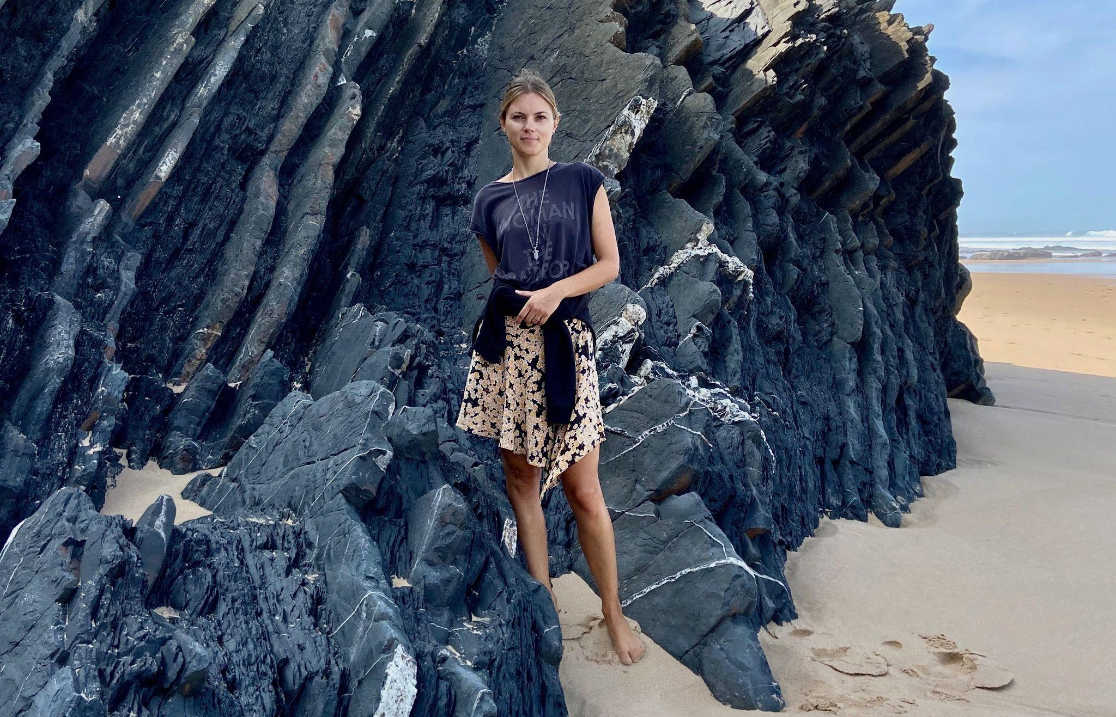
Aljezur, Portugal, January 3rd, 2022 - In the interview with Authority Sharks, Transformational Life Coach Ruta Stasiunaite shares three powerful ways to release stress and find inner peace.

According to Gallup, in 2021, about 43% of adults worldwide felt stressed, worried, sad, or angry for much of the day. This was by far the most stressful year in recent history. And 2022 might not look much different if effective techniques to deal with negative emotions are not applied.

“Fortunately, emotional stability is just a decision away no matter the circumstances,” - says Transformational Coach and Founder of Redefining Success, Ruta Stasiunaite. Ruta has been identified as a Top 1% coach within Europe by public relations giant Authority Sharks. With Redefining Success, she’s on a mission to help individuals master their minds, find inner peace and create fulfilling lives.

Ruta explains that a positive mental attitude not only determines the quality of one’s life but may as well positively affect longevity, making such a mindset shift a pivotal priority. “The way we respond to situations is entirely up to us, yet many only realize that at the very end of their lives, wishing they had relaxed and allowed themselves to be happier much earlier”.

As an expert in subconscious healing, Ruta has inspired thousands of entrepreneurs, leaders, and ambitious individuals to take charge of their states of mind and live balanced lives. In order to help clients easily and instantly strengthen their emotional stability and finally have a peace of mind even in the midst of uncertainty and chaos, she identified three proven ways to do so.

According to Ruta, these are the three tips anyone can apply right away:

- Distance yourself from perceived problems. Although each external threat might seem very real, once you figuratively step away and observe the situation from the side, the issue suddenly shrinks, substantially reducing the initial stressful response. You are not your emotions and thoughts, acknowledge them but do not identify with them.
- Declutter your mind and surroundings to simplify life. The more cluttered your internal and external environment is, the more you feel like it is too much to handle. Clean up the mess, reduce unnecessary daily time-wasters such as social media, and you will create space to be able to think clearly again, effortlessly dissolving overwhelm.
- Slow down to reduce pressure. Rush and urgency create complexity which accumulates tension over time. Instead, treat every moment with utter presence, acceptance, and gratitude. Let go of things you cannot control and focus on what you can learn from each experience. That way, you will find peace in the present moment.

Ruta reassures that everyone will go from stress and worry to resilience and a peaceful mind, significantly improving their relationships, productivity, and overall well-being with these three simple steps. And although it requires mindfulness, awareness, and determination, not doing so might cause severe relationship damage, burnout, a failed business, or continuous self-destructive behaviors.

To learn more and dive deeper into your transformational journey, follow Ruta’s work with Redefining Success on her Instagram and LinkedIn accounts for daily mindset maintenance and educational content.

