Up and Coming Financial Coach Daniel Marshall Shares 3 Tips to Help Everyone Become Financially Successful in 2022

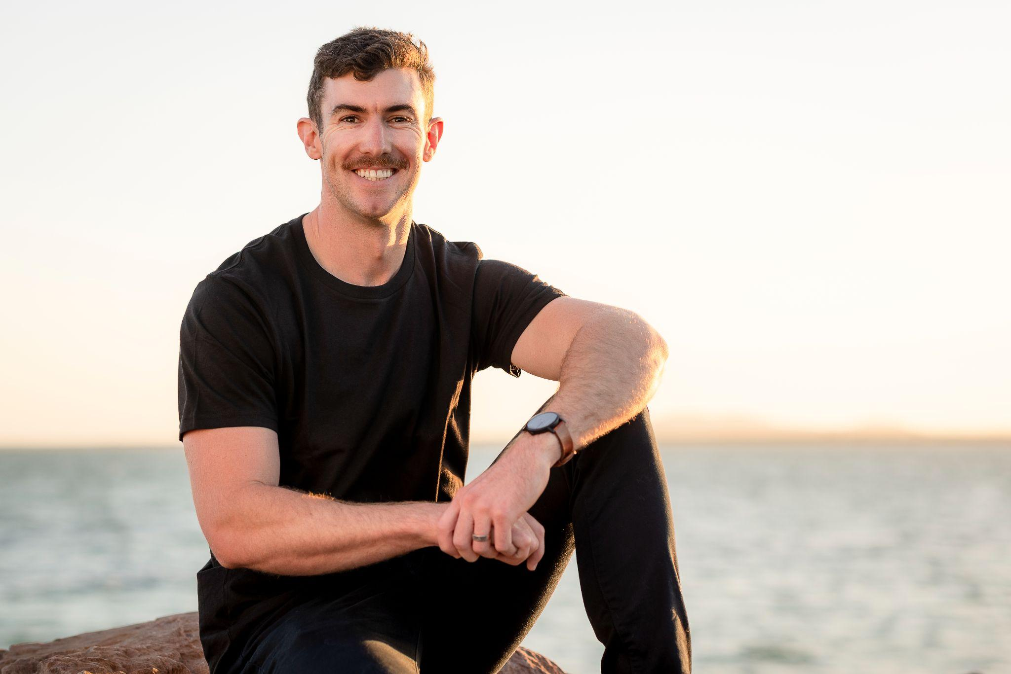
Whyalla, Australia, December 29th, 2021 - In a recent interview with Authority Sharks, Money Management and Mindset Coach, Daniel Marshall reveals his three tips to become financially successful.

Daniel Marshall is a Money Management and Mindset Coach, helping ambitious millennials increase their net worth by building their money mindset, teaching them successful money strategies, and keeping them accountable as they build the habits to become financially successful.

After working as a mechanical engineer in the Steel & Mining industry for more than a decade, Daniel quit his ‘safe’ career to go all-in on his passion and dreams despite being told by many that he was “crazy for leaving a secure job.”

This crazy decision has led Daniel to build the business and life he truly loves.

Here are three of Daniel’s top tips to help everyone become a financial success in 2022 and beyond:

- Decide what you REALLY want.

“Most people never sit down and get clear on what they truly want. So they end up coasting through life, never really getting anywhere, and never really feeling fulfilled or happy. I was this person for a long time. Once I decided I wanted to become a financial success and follow my dreams, then the steps I needed to take fell into place.”

- Commit 100% to making it happen.

“When I first started my new journey I heard this great question, ‘are you interested or are you committed?’ I now live my life by this question. I’ve seen far too many people dip their toes in the water and only ever be ‘interested’ in becoming financially successful. If you truly want to become a financial success, then you must decide to commit 100%.”

- Find a Mentor

“There are no such things as shortcuts in life, but I do believe there are cheat codes. Finding a great mentor is one of these cheat codes. A mentor is someone who has the results that you want. They can save you time, energy, and money on your journey to success. You don’t have to have a DIY mindset and do everything yourself. You don’t need to reinvent the wheel. I owe a lot of my success to the mentors and coaches I’ve had.”

If any of those mentioned above sparked a little bit of interest, and want to learn more about Wealth Creation & Success. Then head to this website and book a complimentary 30-minute session with Daniel.

