PHASE 2 EXPLORATION COMMENCES AT VALLE DEL TIGRE

Perth, Australia, January 12, 2022, Tempus Resources Ltd (“Tempus” or the “Company”) (ASX: TMR, TSX.V: TMRR, OTC: TMRFF) is pleased to announce that it has commenced the Phase 2 exploration program at its Valle del Tigre Project (VdT) located in south-eastern Ecuador. The Phase 2 program is a larger scale follow-up to the initial reconnaissance work conducted during February 2021 where areas with anomalous gold and copper were discovered (see Tempus announcement dated 25 March 2021).

Phase 2 exploration will include a Mobile Metals Ion (MMI) geochemistry sampling program over an area of focus of approximately 12.5 square kilometres, where approximately 1,100 MMI samples will be taken. Sample spacing is planned at 200 m x 50 m. Where possible, stream sediment and grab samples will also be collected. The Phase 2 program will overlap Phase 1 and cover the airborne geophysics chargeability anomaly identified by Tempus in 2019 (see Tempus announcement dated 16 December 2019). Trends identified by the geophysics coincide with known regional structures important to mineralization in the area. The geophysics highlights the NNW-SSE structure bound by NE-SW structures at VdT, which is similar to the controlling structures present at Fruta del Norte.

Results from the initial Phase 1 sampling program confirmed the presence of gold and copper mineralization at Valle del Tigre. Mobile Metal Ion (MMI) analysis used for the soil samples successfully demonstrated trends of over 2 km that are anomalous in gold and copper, bismuth, molybdenum, and nickel. MMI analysis is proving to be very effective as a vectoring tool for gold, copper, and other pathfinder elements in the Rio Zarza (“RZ”) and VdT area.

Tempus President and CEO, Jason Bahnsen commented “The Phase 2 exploration program at Valle del Tigre will provide a comprehensive expansion of the survey of mineralised areas identified in 2021 soil sampling and 2019 geophysics. With the prolific mineralisation in the region, we are looking for something of significant scale.”

The Valle del Tigre project is an early stage, exploration project in the highly prospective Cordillera del Condor mineral belt of southeast Ecuador. VdT’s licence boundary is situated approximately 2.5km northwest of Lundin Mining’s Fruta del Norte (FdN), epithermal gold-silver mine and approximately 15km southwest of the Mirador copper-gold porphyry deposit, owned by CRCC-Tongguan Investment Co., as shown in Figure 1. The property is underlain by the same sedimentary and volcanic rock formations and lies within the same rift faulting corridor as Fruta del Norte and the Jurassic Mineral Belt.

Figure 1 – Valle del Tigre & Rio Zarza Location
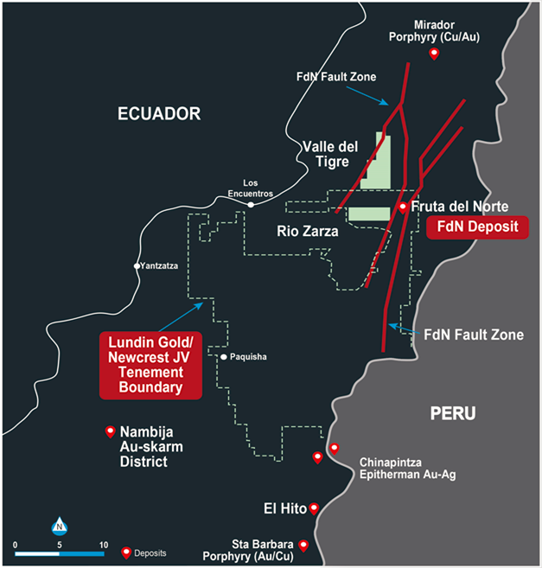

Figure 2 – Valle del Tigre - Phase 1 sample results map with geophysics background showing In-phase 90 hertz Total Divergence

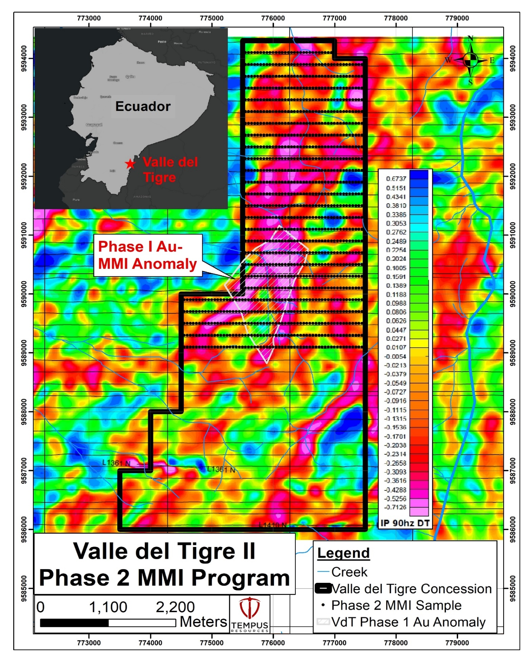

Competent Persons Statement

Information in this report relating to Exploration Results is based on information reviewed by Mr. Kevin Piepgrass, who is a Member of the Association of Professional Engineers and Geoscientists of the province of BC (APEGBC), which is a recognised Professional Organisation (RPO), and an employee of Tempus Resources. Mr. Piepgrass has sufficient experience which is relevant to the style of mineralisation and type of deposit under consideration and to the activity which he is undertaking to qualify as a Competent Person as defined by the 2012 Edition of the Australasian Code for reporting of Exploration Results, Mineral Resources and Ore Reserves, and as a Qualified Person for the purposes of NI43-101. Mr. Piepgrass consents to the inclusion of the data in the form and context in which it appears.
For further information:
TEMPUS RESOURCES LTD
Melanie Ross – Director/Company Secretary Phone: +61 8 6188 8181
About Tempus Resources Ltd
Tempus Resources Ltd (“Tempus”) is a growth orientated gold exploration company listed on ASX (“TMR”) and TSX.V (“TMRR”) and OTCQB (“TMRFF”) stock exchanges. Tempus is actively exploring projects located in Canada and Ecuador. The flagship project for Tempus is the Elizabeth-Blackdome Project, a high-grade gold past producing project located in Southern British Columbia. Tempus is currently midway through a drill program at Elizabeth-Blackdome that will form the basis of an updated NI43-101/JORC resource estimate. The second key group of projects for Tempus are the Rio Zarza and Valle del Tigre projects located in south east Ecuador. The Rio Zarza project is located adjacent to Lundin Gold’s Fruta del Norte project. The Valle del Tigre project is currently subject to a sampling program to develop anomalies identified through geophysical work.
Forward-Looking Information and Statements
This press release contains certain “forward-looking information” within the meaning of applicable Canadian securities legislation. Such forward-looking information and forward-looking statements are not representative of historical facts or information or current condition, but instead represent only the Company’s beliefs regarding future events, plans or objectives, many of which, by their nature, are inherently uncertain and outside of Tempus’s control. Generally, such forward-looking information or forward-looking statements can be identified by the use of forward-looking terminology such as ”plans”, ”expects” or “does not expect”, “is expected”, “budget”, “scheduled”, “estimates”, “forecasts”, “intends”, ”anticipates” or “does not anticipate”, or “believes”, or variations of such words and phrases or may contain statements that certain actions, events or results “may”, “could”, “would”, “might” or “will be taken”, “will continue”, ”will occur” or “will be achieved”. The forward-looking information and forward-looking statements contained herein may include, but are not limited to, the ability of Tempus to successfully achieve business objectives, and expectations for other economic, business, and/or competitive factors. Forward-looking statements and information are subject to various known and unknown risks and uncertainties, many of which are beyond the ability of Tempus to control or predict, that may cause Tempus' actual results, performance or achievements to be materially different from those expressed or implied thereby, and are developed based on assumptions about such risks, uncertainties and other factors set out herein and the other risks and uncertainties disclosed on Page 27 under the heading "Risk and Uncertainties" in the Company's Management’s Discussion & Analysis for the quarter ended September 30, 2021 dated November 15, 2021 filed on SEDAR. Should one or more of these risks, uncertainties or other factors materialize, or should assumptions underlying the forward-looking information or statements prove incorrect, actual results may vary materially from those described herein as intended, planned, anticipated, believed, estimated or expected. Although Tempus believes that the assumptions and factors used in preparing, and the expectations contained in, the forward-looking information and statements are reasonable, undue reliance should not be placed on such information and statements, and no assurance or guarantee can be given that such forward-looking information and statements will prove to be accurate, as actual results and future events could differ materially from those anticipated in such information and statements. The forward-looking information and forward-looking statements contained in this press release are made as of the date of this press release, and Tempus does not undertake to update any forward-looking information and/or forward-looking statements that are contained or referenced herein, except in accordance with applicable securities laws. All subsequent written and oral forward-looking information and statements attributable to Tempus or persons acting on its behalf are expressly qualified in its entirety by this notice. Neither the TSX Venture Exchange nor its Regulation Service Provider (as that term is defined in the policies of the TSX Venture Exchange) accepts responsibility for the adequacy or accuracy of this release.

