Snow Lake Lithium’s First Results from Drone Mag Survey Identify Multiple Extension Anomalies and Prospective Targets on SG Claims

MANITOBA, CAN, February 9, 2022 — Snow Lake Resources Ltd., d/b/a Snow Lake Lithium Ltd. (Nasdaq: LITM) (“Snow Lake” or the “Company”), is pleased to report that the first batch of data received from its drone magnetic survey first announced ( November 29, 2021 – Snow Lake Lithium Receives Government Grant for $62,000 CAD ), identified several highly prospective targets in the Company’s Sherritt Gordon (SG) pegmatite dykes.

Initial images from the EarthEx Drone Magnetic survey on the Snow Lake Lithium SG - Grass River (GR) Target area show strong correlation between magnetic lows in the data and the known pegmatite dykes that were sampled during last fall’s prospecting campaign (December 6th 2021 - Snow Lake Resources Ltd. Samples Up To 6.97 WT% Li2O from its Manitoba Project ). The drone system’s unique ability to fly low to the canopy and maintain centimeter precision RTK (real-time kinematic positioning) navigation results in exceptional levels of detail in the data, revealing features not before seen (Figure 1.0).

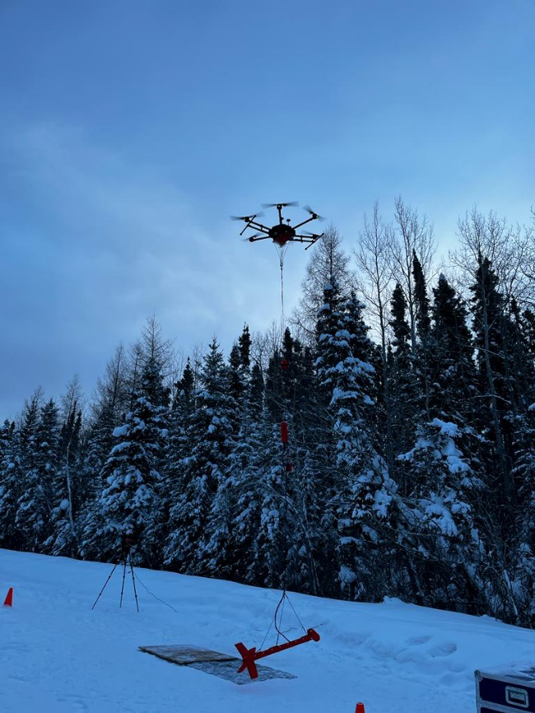

Photo 1 – Drone taking flight during survey over SG dyke
In addition to the known pegmatites, the EarthEx survey has revealed several other magnetically low lineaments with favorable structural orientations in the vicinity near the SG and GR dykes. The survey will continue over the Thompson Brothers Lithium deposit area this week.

Both the SR and GR dykes will be the primary targets for drill #3 being mobilized by BRL Drilling ( Feburary 2, 2022 - Snow Lake Lithium Contracts Additional Drill to Project After Extending the Strike Zone on First Hole ).

CEO Philip Gross commented “These are very exciting times for Snow Lake as we continue to progress the project and accelerate towards mining and full commercial production. The Sherritt Gordon claims have a long history of lithium attached to them, dating back to the 1940’s when they were original drilled. The drone data we obtained can now identify previously unknown extensions that greatly multiply the potential of this property. With the third drill en route, we are excited to start drilling these anomalies as soon as possible and to begin to establish our operations that we expect will position us as the preeminent carbon neutral lithium supplier to the North American automotive industry in the near future.”

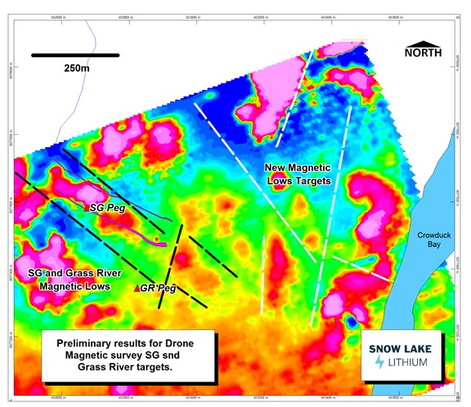
Figure 1.0 Preliminary Magnetic Image (1st VD) over the SG – Grass River Target Area

About Snow Lake Resources Ltd.

Snow Lake Lithium is committed to creating and operating a fully renewable and sustainable lithium mine that can deliver a completely traceable, carbon neutral and zero harm product to the electric vehicle and battery markets. We aspire to not only set the standard for responsible lithium mining, but we intend to be the first lithium producer in the world to achieve Certified B Corporation status in the process.

Our wholly owned Thompson Brothers Lithium Project covers a 55,318-acre site that has only been 1% explored and contains an identified-to-date 11.1 million metric tonnes indicated and inferred resource at 1% Li₂O.

Forward Looking Statements
This press release contains “forward-looking statements” that are subject to substantial risks and uncertainties. All statements, other than statements of historical fact, contained in this press release are forward-looking statements. Forward-looking statements contained in this press release may be identified by the use of words such as “anticipate,” “believe,” “contemplate,” “could,” “estimate,” “expect,” “intend,” “seek,” “may,” “might,” “plan,” “potential,” “predict,” “project,” “target,” “aim,” “should,” “will” “would,” or the negative of these words or other similar expressions, although not all forward-looking statements contain these words. Forward-looking statements are based on Snow Lake Resources Ltd.’s current expectations and are subject to inherent uncertainties, risks and assumptions that are difficult to predict and include statements regarding the expected use of proceeds and expected closing. Further, certain forward-looking statements are based on assumptions as to future events that may not prove to be accurate. These and other risks and uncertainties are described more fully in the section titled “Risk Factors” in the final prospectus related to our public offering filed with the Securities and Exchange Commission and other filings and reports that we file with the Securities and Exchange Commission. Forward-looking statements contained in this announcement are made as of this date, and Snow Lake Resources Ltd. undertakes no duty to update such information except as required under applicable law.

Contact: ir@snowlakelithium.com

www.SnowLakeLithium.com

twitter: @SnowLakeLithium

