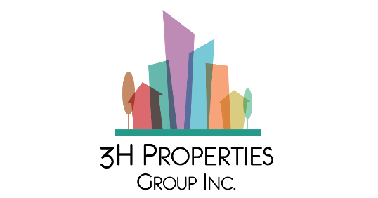

3H Properties Group Hosts Webinar with Industry Innovator, Jonathan F.P. Rose, on the Importance of Preservation in Affordable Housing

Vancouver, BC / ACCESSWIRE / February 17, 2022 – 3H Properties Group, a Canadian developer with a focus on 100% affordable housing, is hosting a webinar to discuss the critical role preservation plays in addressing the current housing crisis. Preservation in Affordable Housing, a fireside chat with American urban planner and real estate developer, Jonathan F.P. Rose, will be held on Wednesday, March 16, 2022 at 11 AM ET.

Bringing together developers, non-profits, government officials and community members, this webinar is open to anyone with an interest in tackling affordable housing through sustainable practices.

Register here for the webinar.

Did you know?
- In Canada, housing is considered “affordable” if it costs less than 30% of a household’s before-tax income.
- About 20% of renters spent more than half their income on rent, which housing advocates say puts them at high risk of becoming homeless.
- There is someone waiting on a list for affordable housing in more than 283,000 households across Canada.
“It’s a privilege to engage with Jonathan Rose, a thoughtful and progressive developer known for developing communities that are affordable and environmentally-responsible,” said Alfredo Hermano, CEO and Founding Partner of 3H Properties Group. “This critical discussion will allow us to dig deep into the issue of housing affordability in Canada and strategize with an industry veteran on innovative and green solutions. With a preservation plan in place, achieving CMHC’s goal of affordable housing by 2030 becomes more realistic.”

In some areas, existing affordable homes are quickly becoming unaffordable due to land scarcity and soaring construction costs. Housing preservation offers a faster, more lightly regulated opportunity to maintain affordability and is proven to be more cost effective than demolishing existing assets and constructing from new. A well thought out housing preservation solution is linked to a reduction in homelessness, housing waitlists and protects the billions of taxpayer dollars already invested in affordable rental housing. Without a preservation plan, CMHC’s goal of everyone in Canada having a home they can afford and that meets their needs by 2030 becomes increasingly out of reach.

Speakers:

Jonathan F.P. Rose
President of Jonathan Rose Companies, a multi-disciplinary real estate development and investment firm, that addresses the challenges of declining ecologies and the poor distribution of opportunity through the development of green affordable and mixed-income housing. Jonathan has led the firm’s vision, strategy and growth, developing award winning new projects, investment funds and city plans that model solutions to address the issues of community development, opportunity, inequality and the environment. For more information visit: https://www.rosecompanies.com/.

Alfredo Hermano
Because of Alfredo’s own experience as an immigrant child within a family who relied on community and affordable housing to thrive and succeed in life, his substantive time in the construction industry, and his unique abilities to build teams in a collaborative way, Alfredo not only started 3H Properties Group that is focused on 100% affordable housing, but is growing what he hopes will be a movement – to change rental housing for the better.

Praveen Varshney
With many accolades and a 30+ year track record of success, Praveen's main focus is ESG social impact investing – doing something good for the planet and for people while still making money. He and his family are well-known and respected as one of the go-to investors for entrepreneurs in this space. Ventures he's involved with include: Pyfera Growth Capital, Humanitas Smart Planet Fund, Little Kitchen Academy and TUT Trainer. Praveen joins Alfredo Hermano as Co-Founder, Advisor and Investor of 3H Properties.

About 3H Properties Group
3H Properties Group partners with non-profits and institutions to secure land in secondary markets across Canada to both develop 100% affordable housing into perpetuity and to provide long term investment opportunities. 3HP provides development services from concept, acquisition, and to completion. 3HP provides full turnkey solutions alongside its sister company, NGC, a medium-sized construction firm with its Canadian head office in Vancouver, B.C. and an office in Toronto, ON, as well as US offices in Tacoma, WA and Dallas, TX. For more information, visit: https://www.3hproperties.com.

Contact
Alfredo Hermano
CEO & Founding Partner, 3H Properties Group
info@3hproperties.com

Sources:
https://www.cmhc-schl.gc.ca/en...;
https://www.haventoronto.ca/si...
https://globalnews.ca/news/620...

