Pebble Beach Resorts and USGA unveil logo design for the
78th U.S. Women’s Open Presented by ProMedica

Design details convey the history of the moment, as the legendary resort prepares to host
the premier championship in women’s golf for the first time in 2023

PEBBLE BEACH, CALIF. (February 23, 2022) – 500 days before the best women golfers in the world arrive at Pebble Beach Resorts to vie for the most coveted title in women’s golf, Pebble Beach and the USGA have unveiled a logo to commemorate the history of the occasion. The 78th U.S. Women’s Open presented by ProMedica, coming to Pebble Beach, July 5-9, 2023, will be the first ever hosted at America’s #1 public golf course.

The new logo features three iconic images:
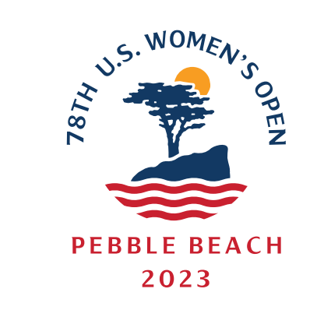
- Lone Cypress: a symbol of resilience that has stood on its rocky perch above the Pacific Ocean for hundreds of years. The tree has become synonymous with a golf course that has hosted 13 USGA championships.
- Sunrise: conveying the dawn of a new era as the best in women’s golf are set to compete on the championship course that has shaped so many legacies.
- Undulating red waves: evocative of the stripes of the American flag, represent the impact the event will make in women’s golf for generations to come.

The 2023 U.S. Women’s Open adds to the rich heritage of women’s championship golf at Pebble Beach, which has hosted two U.S. Women’s Amateurs as well as the annual TaylorMade Pebble Beach Invitational, the premier pro-am where female professionals compete for the same purse alongside the men.

About Pebble Beach Company
Pebble Beach Company, headquartered in Pebble Beach, Calif., owns and operates the world-famous Pebble Beach Resorts®, including The Lodge at Pebble Beach™, The Inn at Spanish Bay™, and Casa Palmero®. The company also operates five renowned golf courses: Pebble Beach Golf Links®, Spyglass Hill® Golf Course, The Links at Spanish Bay™, Del Monte™ Golf Course and The Hay®. Its other famed properties include scenic 17-Mile Drive®, The Spa at Pebble Beach™, Pebble Beach Golf Academy™, and Pebble Beach® Equestrian Center. It annually hosts premier events such as the Pebble Beach Concours d’Elegance®, AT&T Pebble Beach Pro-Am, TaylorMade Pebble Beach Invitational, Pebble Beach® Food & Wine, and the PURE Insurance Championship Impacting First Tee. Future site of the 2023 U.S. Women’s Open and 2027 U.S. Open Championships, Pebble Beach Golf Links® has hosted six U.S. Opens, five U.S. Amateurs, two U.S. Women’s Amateurs, one PGA Championship, and numerous other tournaments. For reservations or more information, please call 800-654-9300 or visit pebblebeach.com.

# # #

Media Contacts
Zach Melchiori / Patricia Nugent / Jamie Scalici
Pebble Beach Resorts
pebblebeachresorts@mower.com
212-284-9935 / 212-980-9194

Julia Pine
USGA
JPine@USGA.org
510-701-1491

