INFIELD MINERALS PROVIDES CORPORATE UPDATE
AND DETAILS ON THE DESPERADO PROPERTY IN NEVADA
March 02, 2022 – Vancouver, BC, Canada. Infield Minerals Corp. (TSX-V: INFD) (“Infield” or the “Company”) is pleased to provide a corporate update regarding its planned activities in 2022 and a review of its 100% owned Desperado property (“Desperado” or the “Property”) located in Nye County, Nevada.
Highlights
- 2021 exploration at Desperado has uncovered multiple high priority gold-silver target areas
- Infield is advancing Desperado in 2022 through the planning and permitting of a 2,000 metre initial drilling campaign
- The Company is focused on delivering value to our shareholders and continues to evaluate new opportunities
Desperado Property Details
The Desperado property covers an area of 1,410 hectares (3,480 acres) and is located in Nye County within the historical Ellendale mining district, approximately 40 kilometres east of the town of Tonopah. Desperado is readily accessible by a series of local dirt roads connecting with Highway 6. Gold and silver at the Property are hosted within a low-sulphidation epithermal environment. The mineralization is typically structurally controlled and found at or proximal to the contact between rhyolite and andesite, with precious metals commonly associated with silicification and disseminated pyrite.
2021 Desperado Exploration Results
In 2021, the Company completed a surface exploration campaign at Desperado that consisted of geological mapping, prospecting, rock and soil sampling, and ground geophysical surveying. This exploration work has led to the identification of multiple gold-silver target areas across the Property that are prospective for gold-silver discovery.
In a news release dated November 3, 2021, the Company reported positive results from the 2021 geophysical survey at Desperado. The induced polarization (“IP”) survey outlined more than forty (40) anomalous IP trends, which have since been assessed and prioritized through field inspection and desktop analysis. A key finding from these studies is that many of the IP anomalies which form strong targets are not exposed on surface, and therefore, have never been previously identified or tested.
Priority target areas have been grouped into two distinct zones within the Property (Figure 1). The eastern zone consists of a 2 kilometre by 4 kilometre flattened circular feature, which could represent a collapsed magma chamber, showing an alteration halo with width ranging from 250 metres to over 750 metres. The alteration halo consists mainly of clay +/- quartz altered rhyolite. Targets identified both within the alteration halo and central to the circular feature are found at or proximal to the contact between rhyolite and andesite along interpreted structures, often coincident with IP anomalies.
The western zone is interpreted as a normal fault uplifted block that exhibits a deeper level of epithermal mineralization at surface than what is observed in the eastern zone. In this western portion of the Property, the silver to gold ratio appears to be much higher than in the eastern zone, such as more than 100 to 1 compared to approximately 10 to 1, based on the few samples collected from the leftover rocks historically extracted from artisanal mine workings. Additional geological studies and exploration work, including drilling, would contribute to a better understanding of the geological evolution and mineral emplacement mechanisms of the project area.
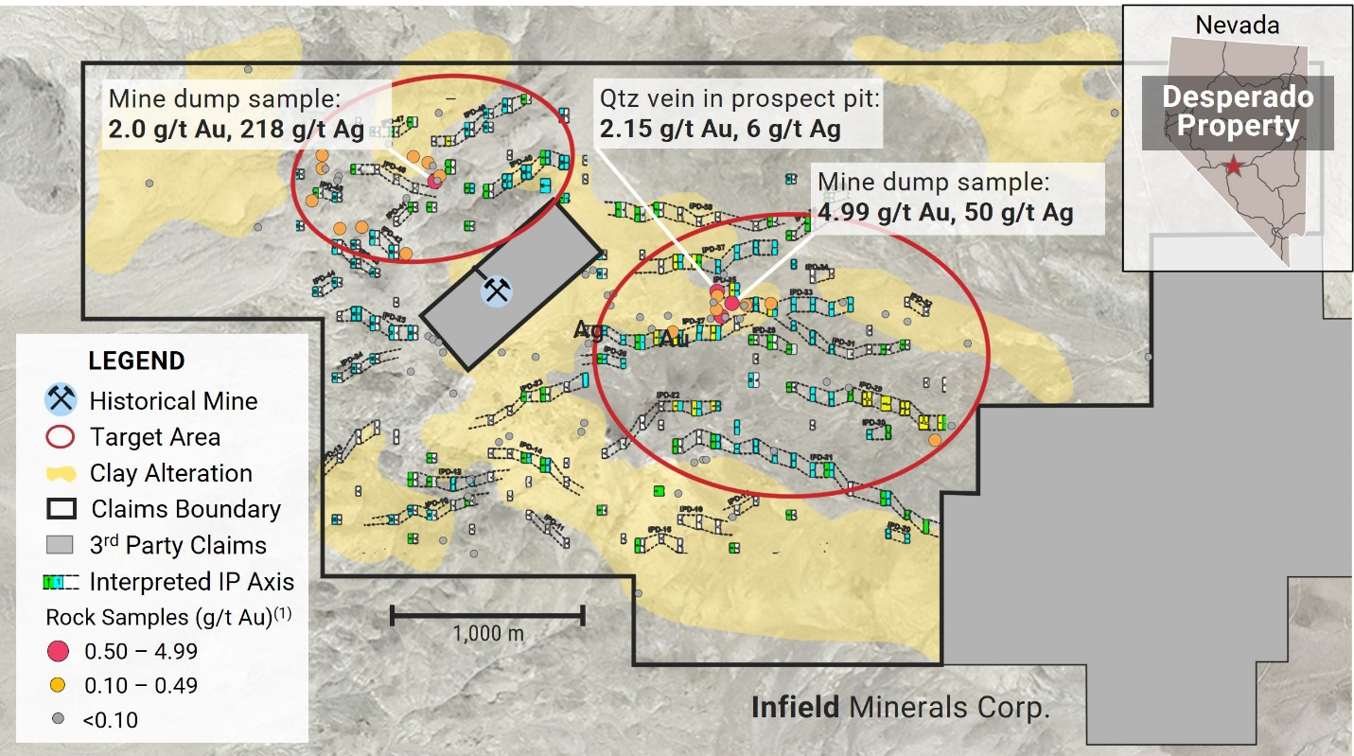Figure 1: Desperado property map outlining target areas with alteration, mineralization and IP axes
⁽¹⁾Rock samples collected by Infield were prepared and analysed by American Assay Laboratories in Sparks, Nevada, for fire assays (Au-FA30-ICP) and multi-element analysis (ICP-2A036). American Assay Laboratories is an independent geochemical analytical testing laboratory which is ISO-17025 accredited by IAS.
2022 Activities and Initiatives
The combination of geological, geochemical and geophysical data collected at Desperado has generated several compelling epithermal targets that the Company believes warrant drill testing. Infield is currently developing its inaugural drilling campaign at Desperado consisting of approximately 2,000 metres of reverse circulation drilling. Further data analysis is underway to refine targets and to select proposed drill holes. Once this step is completed, Infield will be in position to apply for a Notice of Intent drilling permit, which generally take three weeks to receive after the application has been submitted.
The Company is enthusiastic about the prospect of drill testing the compelling targets being outlined at Desperado. The execution of Infield’s plans is dependent on the timing and availability of resources, including contractor availability and the allocation of funds.
Infield is committed to conducting our exploration and operational activities responsibly and sustainably. In the spring of 2022, the Company intends to commence reclamation activities at the M1 property where access roads and drill pads were constructed during 2021 exploration.
The Company has an ongoing initiative of growing and delivering value through discovery, acquisitions and sustainable development of high quality, high potential assets. As such, Infield plans to continue advancing Desperado through its systematic exploration approach with the aim of realizing the Project’s full discovery potential. In addition, the Company is regularly evaluating exploration and development assets with a view of expanding and evolving Infield’s project portfolio.
“Infield is encouraged by the 2021 exploration results at Desperado and we are keen to advance the Property through drill hole targeting and permitting in 2022,” stated Evandra Nakano, President and CEO of Infield. Ms. Nakano continued, “We also continue to assess quality project opportunities that could further augment our portfolio and benefit our shareholders. Infield offers a solid foundation for potential consolidation of exploration and development assets, including a positive cash position, strongly held insider ownership, and an experienced technical and management team.”
Qualified Person
Technical information in this news release has been reviewed and approved by Richard Dufresne, P.Geo., Vice-President Exploration for Infield Minerals Corp., and a Qualified Person for the purposes of National Instrument 43-101.
The potential quantity and grade of mineralization described herein is conceptual in nature as there has been insufficient exploration to define a mineral resource and it is uncertain if further exploration will result in targets being delineated as a mineral resource.
For more information, please contact Evandra Nakano, the CEO, President and a director of the Company, at +1 (604) 220-4691 or email: info@infieldminerals.com.
On Behalf of the Board of Directors of Infield Minerals Corp.
Evandra Nakano
President, CEO & Director
About Infield
Infield Minerals is currently exploring for gold and silver in mining-friendly Nevada. Our mission is to grow and deliver value through discovery, acquisitions and sustainable development of high quality, high potential assets for the social and economic benefits of our stakeholders. Founded in 2020, Infield is led by a team of mining entrepreneurs with extensive technical and resource evaluation experience.
www.infieldminerals.com
Neither TSX Venture Exchange nor its Regulation Services Provider (as that term is defined in the policies of the TSX Venture Exchange) accepts responsibility for the adequacy or accuracy of this release.
Forward-Looking Statements
Statements included in this announcement, including statements concerning Infield’s plans, intentions and expectations, which are not historical in nature, are intended to be, and are hereby identified as, “forward‐looking statements”. Forward-looking statements include, among other matters, the exploration plans for the Desperado property. Forward‐looking statements may be, but are not always, identified by words including “anticipates”, “believes”, “intends”, “estimates”, “expects” and similar expressions. Infield cautions readers that forward‐looking statements, including without limitation those relating to Infield’s future operations and business prospects, are subject to certain risks and uncertainties (including geopolitical risk, regulatory, COVID-19 and exchange rate risk) that could cause actual results to differ materially from those indicated in the forward‐looking statements. There can be no assurance that any forward-looking statement will prove to be accurate or that management's assumptions underlying such statements, including assumptions concerning future developments, circumstances or results, will materialize. The forward-looking statements included in this news release are made as of the date of this new release and Infield does not undertake to update or revise any forward-looking information included herein, except in accordance with applicable securities laws.

