

GaN Systems to Showcase Newest Innovations at APEC 2022
Leading Solutions Across All Targeted Markets from Fast-Charging GaN Chargers,
Best-Sounding Class-D Audio, EV Powertrain Solutions, And More Are on Display

HOUSTON (APEC) AND OTTAWA, Canada – March 3, 2022 – GaN Systems, the global leader in GaN (gallium nitride) power semiconductors, today announced that it will showcase the industry’s newest lineup of power electronics solutions at the 37th annual Applied Power Electronics Conference (APEC) from March 20-24, 2022 in Houston. GaN Systems’ solutions enable smaller and lower-cost systems for its customers while delivering next-generation efficiency and leading quality and reliability.
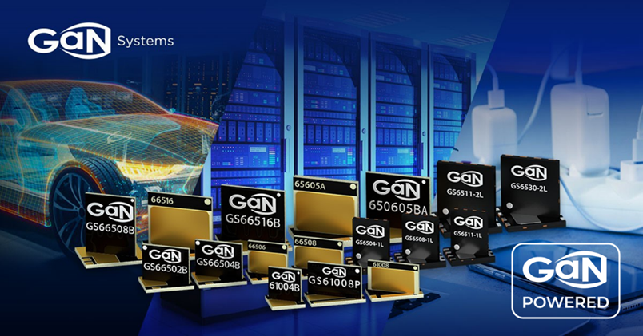

GaN Systems APEC 2022 booth #1324 will include:
- GaN Chargers: The company will showcase the world’s smallest 65W and 100W GaN chargers and a wide range of optimized chargers for smartphones, laptops, and other consumer devices from 45W to 240W from Dell, Philips, Harman, and other leading brands. GaN Systems’ array of charger reference designs that support faster time-to-market will be on display, including the 65W QR GaN charger, 100W Dual USB-C Intelligent PD GaN charger, and 250W AC/DC GaN adapter.
- GaN Audio: GaN Systems will showcase the Syng Alpha Cell, one of TIME's 100 Best Inventions of 2021, and highlight solutions providing the best sounding Class-D audio with products like Orchard Audio's Starkrimson Stereo Ultra amplifier and all-in-one Starkrimson Streamer Ultra, and the new 500W Heatsinkless Audio Amplifier from Axign and GaN Systems. Additionally, the company will showcase its 400W Class-D audio reference design and its new 300W Boost Converter reference design for automotive, motorcycle, and marine applications.
- Leading EV Power Solutions: GaN Systems is the clear leader in automotive GaN and will showcase onboard charger, traction inverter, and DC-to-DC converter implementations. GaN Systems is building on this success with partners Vitesco Technologies and USI for next-generation powertrain solutions. Vitesco’s Head of Innovation in the Electrification Technology business unit, Dr. Gerd Rösel, said, “GaN transistors help to minimize heat losses, particularly the switching losses at the high switching frequencies we require. GaN components outperform silicon chips in every respect.”
- Transistors, Power Module Solutions, and More: The company's newest generation of high-performance, lower-cost transistors will be shown. Several high-power and IPM form factor power modules will be on display for applications in the industrial and EV segments that require much higher power.
To see an in-depth review of managing thermals in high-density applications, GaN Systems will present a technical session titled “Thermal Design Considerations for GaN-Based Power Adapters with Multi-Heat Sources” on March 22, 2022, 9:10 AM – 9:30 AM Central Time at Location 361ABC.
“Efficient power generation, distribution, and conversion are key factors in driving sustainability and reducing emissions, and GaN is more efficient and more cost-effective than both silicon and silicon carbide," said Paul Wiener, VP of Strategic Marketing at GaN Systems. "The power industry is rapidly transitioning to GaN for best-in-class efficiency, design flexibility, costs, and more. We see rapid adoption across all of our target markets – automotive, consumer, enterprise, and industrial."
Visit GaN Systems at APEC 2022
GaN Systems will demonstrate the latest designs and products at Booth 1324. Contact us here or reserve an appointment or meet with GaN Systems virtually at the show.

# # #

About GaN Systems
GaN Systems is the global leader in GaN power semiconductors with the most extensive transistors portfolio that uniquely addresses the needs of today's most demanding industries, including consumer electronics, data center servers, power supplies, renewable energy systems, industrial motors, and automotive electronics. As an industry-leading innovator, GaN Systems makes it possible to design smaller, lower cost, more efficient power systems. The company's award-winning products provide system design opportunities free from the limitations of yesterday's silicon. By changing the transistor performance rules, GaN Systems enables power conversion companies to revolutionize their industries and transform the world.
For more information, please visit: www.gansystems.com or on Facebook, Twitter and LinkedIn and scan this QR code for our WeChat.

# # #

Media Inquiries:
Mary Placido
Trier and Company for GaN Systems
mary@triercompany.com
+1 (415) 218-3627

