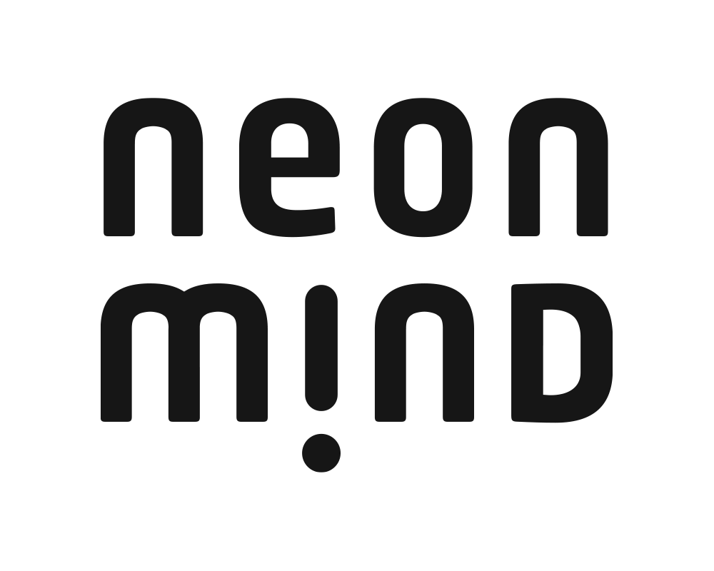
NeonMind Reports Business Highlights on Partnership Activities, Clinical Pipeline and Corporate Developments
- Completed concrete milestones in its strategy to become a leading psychedelic drug developer and specialty clinics operator

- Developed clear drug development pathway for NEO-001, the industry’s first psilocybin-based obesity treatment with near-term clinical milestones
- Partnered with well-established specialty treatment providers, SRx Health Solutions and BioScript Solutions to build out a network of NeonMind-branded specialty mental health clinics across Canada
Oakville, Ontario – March 10, 2022: NeonMind Biosciences Inc. (CSE: NEON) (OTCQB: NMDBF) (FRA: 6UF) (“NeonMind'' or the “Company”), an integrated drug development and wellness company focused on bringing innovative psychedelic-based treatments to people suffering from obesity and mental health disorders, today provided a summary of business highlights on the Company’s activities and progress across its Pharmaceutical and Medical Services Divisions.
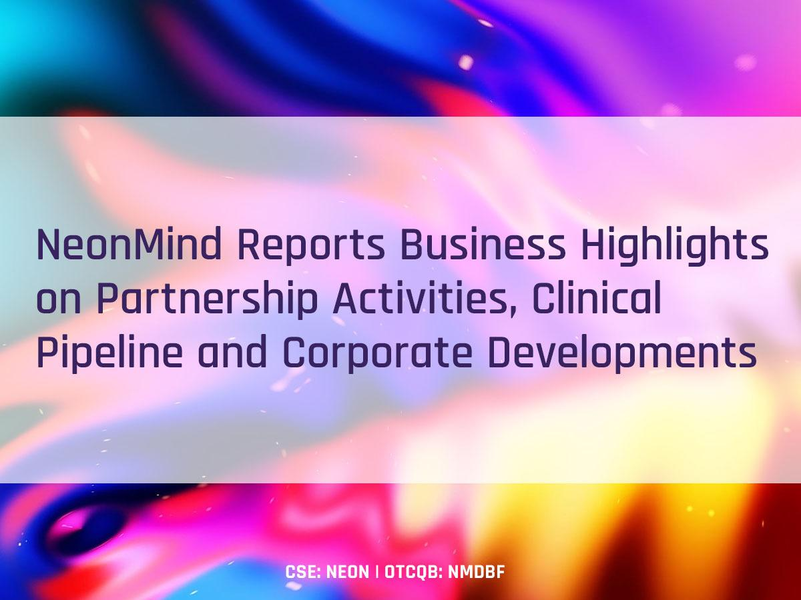

Pharmaceutical Division Highlights
- Successfully completed a pre-Investigational New Drug (pre-IND) consultation with the U.S. Food and Drug Administration (FDA) regarding proposed clinical trials for NeonMind’s lead obesity drug candidate, NEO-001. The Company expects to file its IND application in the first half of 2022] and initiate a Phase 1/2 clinical study [during the course of this year.
- Filed four new provisional patent applications with the United States Patent and Trademark Office to protect NeonMind’s proprietary data derived from the Company’s initial preclinical trial examining the potential use of psilocybin as a treatment for weight loss.
- Completed an integrated drug development plan for its lead drug candidate targeting obesity, NEO-001, a high-dose psilocybin treatment coupled with behavioral therapy and lifestyle intervention, aimed to improve the efficacy of chronic weight management in adults.
- Established a Research and Development Advisory Board and expanded NeonMind’s team with regulatory experts to successfully execute its integrated drug development plan and streamline its corporate structure for capital efficiencies.
- Appointed drug development executive Philippe Martin as Chairman of the Company’s Research and Development Advisory Board.
Medical Services Division Highlights
- Established strategic alliances with SRx Health Solutions and BioScript Solutions, leading Canadian specialty healthcare services and medical treatment providers, to establish and operate a network of NeonMind specialty clinics to deliver evidence-backed innovative treatments for a variety of mental health needs.
- Announced inaugural specialty mental health clinic location in Mississauga, Ontario; expected to begin treatment services in the second half of 2022.
- Appointed emergency and addiction expert, Dr. Dinesh Bhayana, as site medical director of its inaugural specialty mental health clinic.
- Formed a Specialty Clinics Advisory Board with Canadian medical leaders in mental health and to guide planning and operation of NeonMind clinics, protocols and treatment models across Canada.
“We made significant progress in our corporate transformation to become a psychedelic drug developer and specialty mental health clinics operator,” said Robert Tessarolo, President & CEO of NeonMind. “Our strategic focus provides near-term revenue generation and a proprietary groundbreaking treatment for obesity, both of which provide exposure to exciting and novel treatments for mental health and wellness. We now have a clear drug development pathway to bring NEO-001, the first and only psychedelic-based treatment for obesity, into clinical trials. Additionally, our strategic alliances with SRx and BioScript will enable us to quickly establish a network of NeonMind-branded specialty mental health clinics across Canada. As the psychedelic industry continues to undergo rapid expansion, we are well positioned to execute on our growth strategy and develop innovative therapeutic uses for psychedelic compounds to treat weight management conditions and mental health disorders.”
Corporate Highlights
- The Company’s common shares, listed on the OTCQB Venture Market, became eligible for electronic clearing and settlement through the Depository Trust Company (“DTC”) in the United States.
- Completed divestiture of assets related to its consumer division, including e-commerce operations and underlying functional food assets, as well as shares owned in Translational Life Sciences Inc. for a combined consideration of approximately C$1.1 million plus royalty. In connection with the divestiture of the consumer division, Amber Allen has resigned as Vice President of Sales, effective January 17, 2022.
- Launched a new website at www.neonmindbiosciences.com.
- As a result of NeonMind’s growing specialty clinic operations, the Company has established its new headquarters in Oakville, Ontario. The full address is 295 Robinson Street, Suit 100, Oakville, ON L6J 1G7.
About NeonMind Biosciences Inc.
NeonMind operates two divisions: (i) a pharmaceutical division engaged in drug development of psychedelic compounds with two lead psilocybin-based drug candidates targeting obesity; and (ii) a medical services division focused on launching specialty mental health clinics that integrate psychedelic therapeutics into traditional psychotherapy settings.
In its pharmaceutical division, NeonMind has two distinct psilocybin drug development programs targeting obesity. NeonMind’s lead candidate, NEO-001, employs psilocybin as an agonist at the serotonin 5- HT2A receptor, which is involved in the hallucinogenic effect of psychedelics. The Company’s second drug candidate, NEO-002, employs low-dose psilocybin as an agonist at the 5-HT2C receptor, which controls appetite.
NeonMind and its strategic partners are building NeonMind-branded specialty mental health clinics in Canada that incorporate evidence-backed innovative treatments to address a variety of mental health needs. For more information on NeonMind, go to www.NeonMindBiosciences.com.
Rob Tessarolo, President & Chief Executive Officer, NeonMind Biosciences Inc.
rob@neonmind.com
Tel: 416-750-3101

Investor Relations:
KCSA Strategic Communications
Scott Eckstein/Tim Regan
neonmind@kcsa.com
Tel: 212-896-1210

The Canadian Securities Exchange has not reviewed, approved nor disapproved the contents of this news release.
Cautionary Statement Regarding Forward-Looking Statements
Certain statements contained in this press release constitute forward-looking information. These statements relate to future events or NeonMind’s future performance. The use of any of the words "could", "expect", "believe", "will", "projected","estimated" and similar expressions and statements relating to matters that are not historical facts are intended to identify forward-looking information and are based on NeonMind’s current belief or assumptions as to the outcome and timing of such future events. Actual future results may differ materially. In particular, NeonMind’s drug development plans, its ability to retain key personnel, and its expectation as to the development of its intellectual property and other steps in its preclinical and clinical drug development constitute forward-looking information. Actual results and developments may differ materially from those contemplated by forward-looking information. Readers are cautioned not to place undue reliance on forward-looking information. The statements made in this press release are made as of the date hereof. NeonMind disclaims any intention or obligation to publicly update or revise any forward-looking information, whether as a result of new information, future events or otherwise, except as may be expressly required by applicable securities laws.

