FOR IMMEDIATE RELEASE
Los Angeles, March 18, 2022

ePlay Digital CEO To Participate In Mass Participation World Sports Metaverse Panel
Registration open for WEB3.0, The Metaverse and Mass Participation Panel - Mar 31, 2022

ePlay Digital Inc. (CSE:EPY | OTC:EPYFF | FSE:2NY2) (the “Company”) today announced that the ePlay CEO will be discussing Klocked World and the Sports Metaverse at the upcoming Mass Participation World event. The session facilitated by Chris Robb, includes Sam Middlehurst, the CEO and co-founder of admiral.digital, Jeffrey Foo, CEO, MOVE by LIV3LY, and Trevor Doerksen, CEO of ePlay Digital and co-creator of the award-winning Klocked World Sports Metaverse. The WEB3.0, The Metaverse and Mass Participation event takes place March 31 and registration is now open.
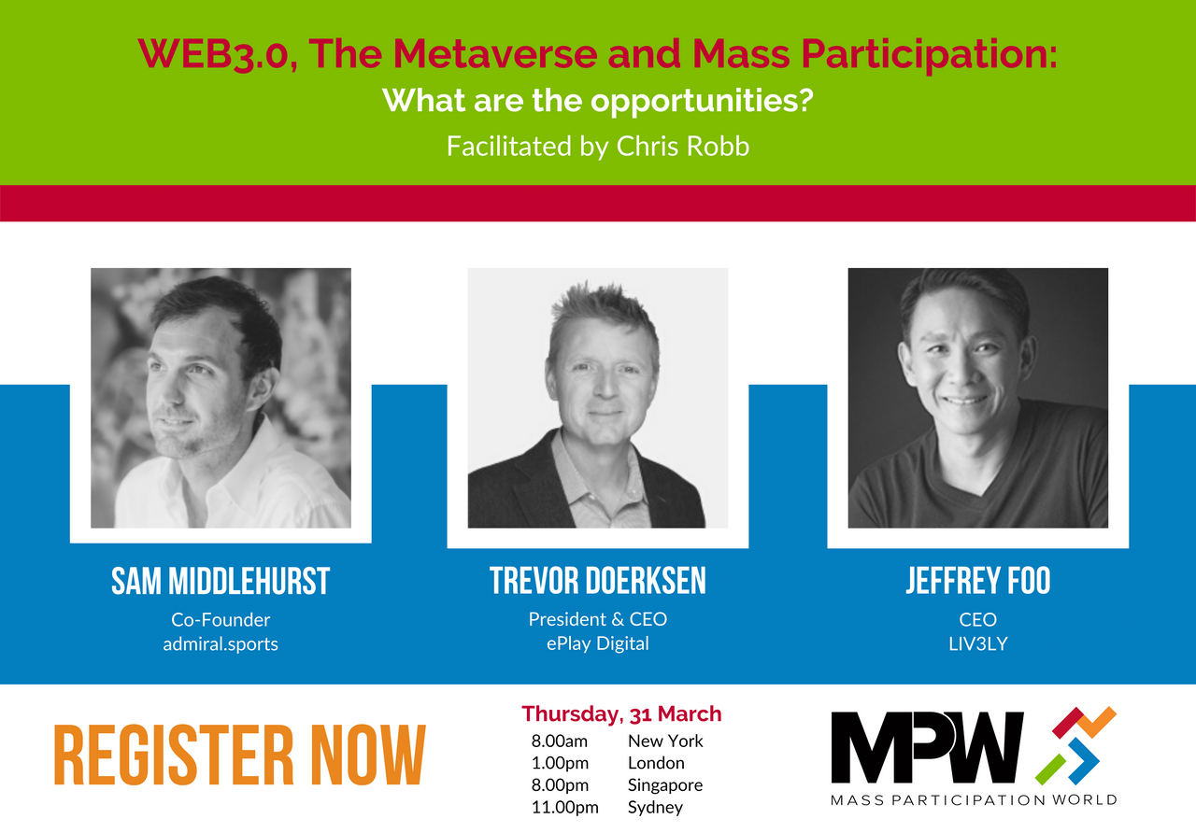
Mass Participation World facilitates year-round engagement and collaboration with a global community of mass participation professionals, and aspiring industry leaders. Mass participation sports, like marathons, cycling, Olympics, etc. play a massive role in the future health and wellbeing of the world.

“Getting together to discuss the future of mass participation events as they are impacted by global forces and technology change is key to adapt to ongoing disruption,” says Chris Robb, CEO of Mass Participation World. “What are the opportunities in Web3.0 and the metaverse two significant disruptions that the sports ecosystem is embracing?”

“Many, perhaps all, of our businesses, sports, and personal lives were massively impacted by the COVID-19 pandemic,” says Trevor Doerksen, CEO of ePlay Digital and co-creator of Klocked. “At the same time, technologies such as Web3.0 and metaverse started to transform sport, recreation, hobbies, gaming, and more. What comes next? What are the opportunities? Join the discussion.”

To register and get more information click here .

About ePlay
ePlay Digital Inc. is a mobile game and sports metaverse creator and publisher specializing in sports, esports and entertainment augmented reality titles, including the award-winning augmented reality running app, Klocked.run, sports gaming app Fan Freak, flagship title Big Shot Basketball and Howie Mandel mobile game collaboration - HowiesGames.com. ePlay is operated by an award-winning team of sports, gaming and eSports leaders as well as broadcast and digital technology industry experts, software engineers and athletes who have brought dozens of game titles to market for companies including Time Warner Cable, ESPN, Sony Pictures, AXS TV, Intel, AXN, Fiat, CBS, and others.

ePlay’s wholly-owned subsidiary Mobovivo eSports specializes in augmented reality, 3D metaverse, mobile game development and mobile eSports streaming.

ePlay Released Games
Howie Go Viral - iOS / Android
Outbreak ES - iOS
Outbreak Unlimited - iOS / Android
SwishAR ES - iOS
SwishAR - iOS / Android
Big Shot Basketball - iOS / Android
Big Swish - iOS
Big Shot Swish ES - iOS
Klocked Augmented Reality Fitness App - Klocked.me
Klocked World - Sports Metaverse
Fan Freak Sports App

Further Information
Further details are available under the Company’s profile on SEDAR at www.sedar.com and the Company’s profile on the CSE’s website at www.thecse.com/

For further media information, or to set up an interview, please contact:
ePlay Digital Inc.
(310) 684-3857‬
E-mail: info@eplaydigital.com
Website: www.eplaydigital.com

Canadian Securities Exchange (CSE): Symbol EPY
Deutsche Boerse Xetra - Frankfurt Stock Exchange: Symbol 2NY2; WKN: A2AN4D; ISIN CA26885W1041

