NEWS RELEASE

Roscan Gold continues to expand the gold mineralization at Kabaya and intersects 2.09 gpt gold over 21m and 1.49 gpt gold over 28m

Toronto, Ontario. – March 23, 2021 – Roscan Gold Corporation (“Roscan” or the “Company”) (TSX-V: ROS; FSE:2OJ; OTCQB:RCGCF) is pleased to announce positive Reverse Circulation (“RC”) drilling results at Kabaya (Figure 1) from an additional 53 holes totaling 5,969 meters (m) at Kabaya.

In order to both discover new gold zones outside our existing resource area and to expand the potential gold resources in our existing resource at Kabaya, Roscan designed an aggressive RC drilling program. This drilling was comprised of 60% step-out holes to test for new gold zones along the North South strike from KB1 to cover the underexplored zone between KB1 and KB3. The remaining 40% of the RC drill holes were focused on an infill drilling program in KB1 and KB2. The excellent gold recovery of 95.65% in saprolite from the metallurgical test work (News release of October 25, 2021) with near surface mineralization points to the economic potential of these targets.

The current drilling results at KB3 outlines an estimated strike length of 200m, a width of 80m and a 100m vertical depth. This zone is open at depth and laterally. There is an 850m gap between KB3 and KB1-2, the main gold mineralization that is yet to be fully tested.

The infill holes at KB1 and KB2 enlarge the different grade envelopes and has infilled some areas to expand the continuity of the gold mineralization. KB1 and KB2 have a combined strike length of 985m, a horizontal width of 180m wide and still open to 225m vertical depth at KB1.

Drilling Highlights:
Kabaya - Step-out Reverse Circulation Drill Holes

- 1.98 gpt gold over 11m from drill hole RCDBS22-0078 from 57m (KB3)
    - Including 5.67 gpt gold over 2m from 64m
And
- 2.09 gpt gold over 21m from 109m
    - Including 4.13 gpt gold over 3m from 121m

- 4.79 gpt gold over 7m from drill hole RCDBS21-035 from 133m (North of KB1)
    - Including 18 gpt gold over 1m from 137m

- 1.19 gpt gold over 15m from drill hole RCDBS22-0080 from 33m (KB3)
    - Including 8.99 gpt gold over 1m from 34m

- 2.40 gpt gold over 4m from drill hole RCDBS21-026 from 50m
    - Including 7.72 gpt gold over 1m from 50m (KB3)

- 1.56 gpt gold over 6m from drill hole RCDBS21-027 from 19m (KB3)

Drilling Highlights: - In fill Kb1-KB2 Reverse Circulation Drill Holes

- 7.43 gpt gold over 5m from drill hole RCDBS22-0062 from 76m
    - Including 17.2 gpt gold over 2m from 76m

- 1.46 gpt gold over 31m from drill hole RCDBS22-0061 from 117m
    - Including 3.29 gpt gold over 2m from 124m
    - Including 5.57gpt gold over 2m from 137m

- 1.49 gpt gold over 28m from drill hole RCDBS22-0082 from 49m
    - Including 4.20 gpt gold over 1m from 54m
    - Including 4.47 gpt gold over 1m from 67m
And
- 1.36 gpt gold over 8m from 108m
    - Including 3.91 gpt gold over 1m from 111m

- 1.52 gpt gold over 11 m from drill hole RCDBS21-047 from 22m
    - Including 5.31 gpt gold over 1m from 30m

- 1.16 gpt gold over 13m from drill hole RCDBS22-0054 from 0m
    - Including 3.72 gpt gold over 1m from 6m

- 1.05 gpt gold over 5m from drill hole RCDBS22-0083 from 35m
    - Including 3.51 gpt gold over 1m from 37m

Notes: 1: True width yet to be determined; 2: Table 1 – Assay Highlights, 3: 0.5gpt used as cut-off with 2m internal dilution, 4: No top-cut.

Nana Sangmuah, President and CEO, stated, " Drilling at Kabaya continues to expand the footprint of the gold mineralization which bodes well for the pending maiden resource in Q2. We are excited by the fresh rock intercepts at KB3 that points to a larger mineralized system within the 850-meter gap zone between KB1-2 and KB3, which is yet to be fully tested.

We are currently drilling additional RC and Diamond holes at our Mankouke, Disse and Kandiole targets and look forward to reporting additional assay results as they become available.”

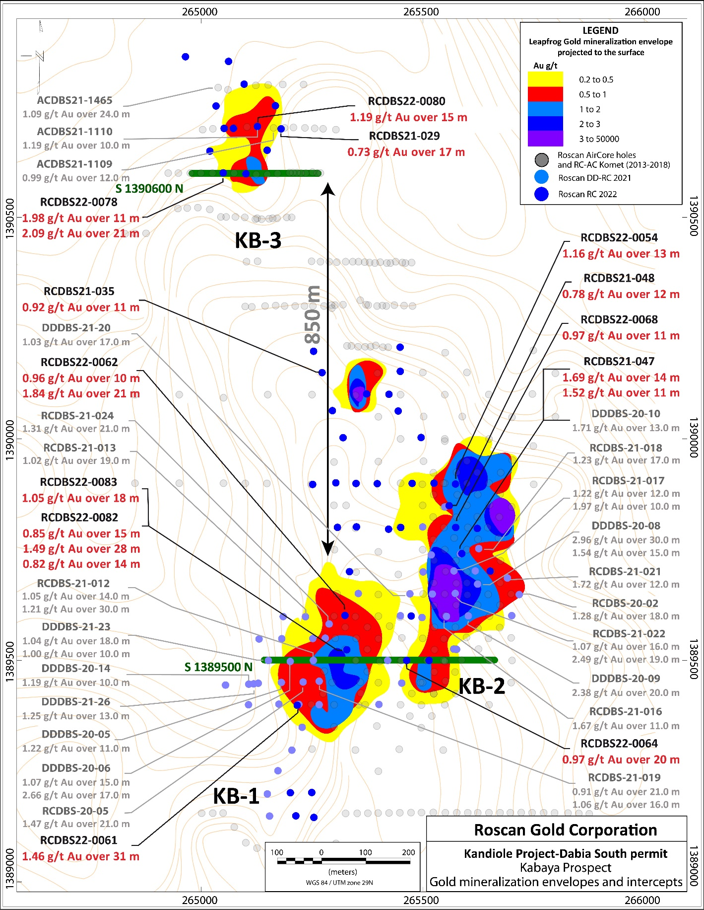
Figure 1: Kabaya gold deposit, drilling plan view, gold contouring envelopes
projected to the surface and drill holes locations

The gold mineralization at Kabaya (Figure 2-3) is disseminated and associated with a strong kaolinization after the saprolite process going deep between the fresh foot and hanging walls. From the few fresh rock observations, this powdery zone corresponds with the albite-dolomite-pyrite-arsenopyrite alteration in a volcano-sedimentary sequence. The gold host rock is an alternate between tuffaceous and greywacke facies. As in the Mankouke gold deposit, the carbonaceous bedded mudstone constitutes the folded footwall. The gold zone is also limited by an NNE-SSW weakness, fractured, and sheared zones in hanging and foot walls contacts

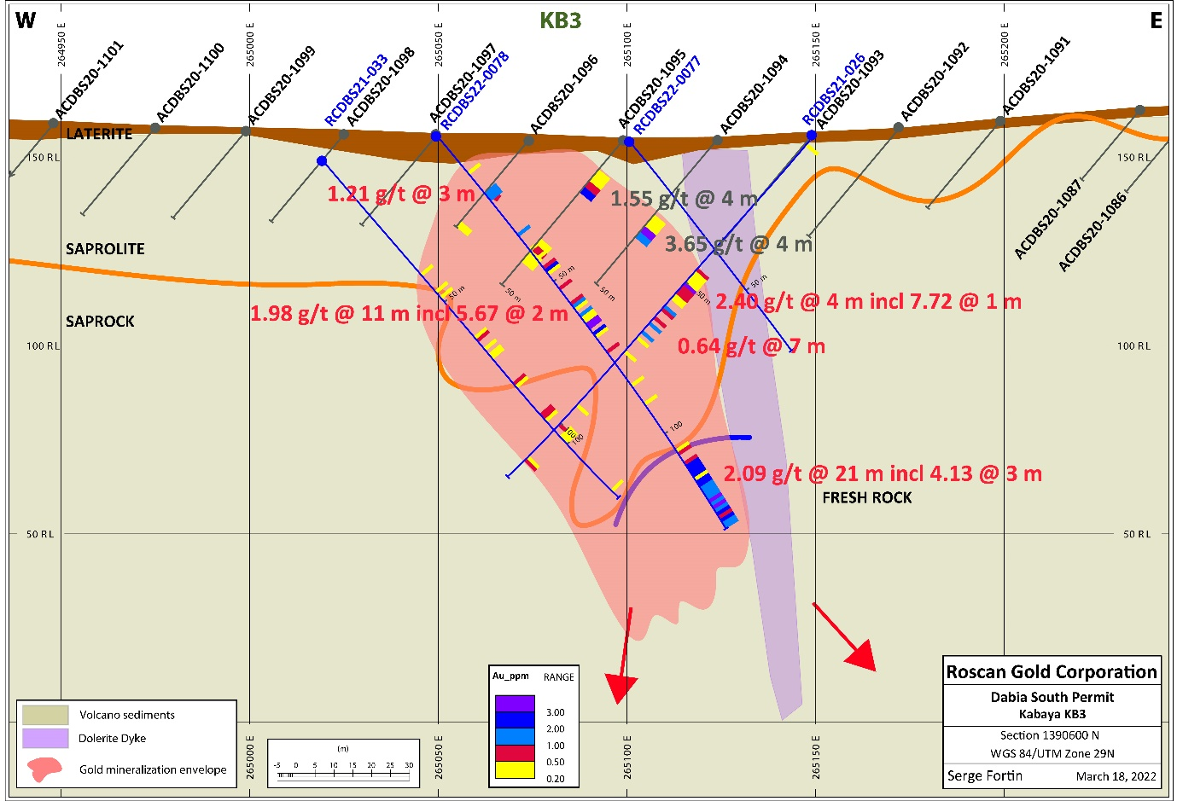
Figure 2: Kabaya gold deposit, KB3 satellite North, section A 1390600N

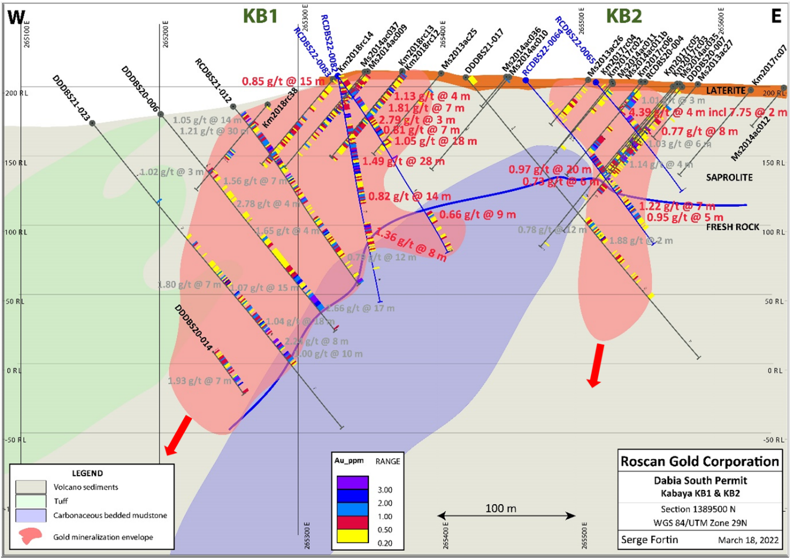
Figure 3: Kabaya gold deposit, KB1 and KB2, Section 1389500N

The Kabaya Deposit is part of a prolific regional Siribaya-Mankouke-Seko structural corridor (Figure 4). The Kabaya gold orebody is likely on an NNE-SSW splay structure contouring the Disse quartz diorite intrusion from the VTEM (Versatile Time Domain Electromagnetic) airborne survey interpretation. The Roscan large land package covers well this major auriferous structure over 25km, including the splays around Disse intrusive, occurring new gold discoveries.

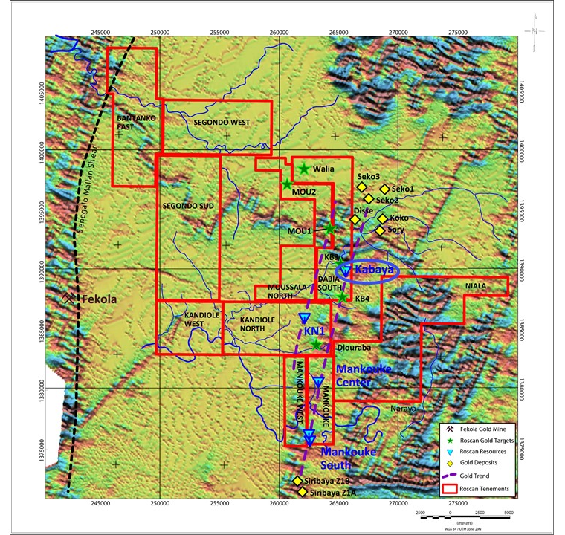
Figure 4: Roscan permits on the Airborne Magnetic geophysics background with the Roscan resources zones, the targets in development, the gold deposits around

Drilling and Analytical Protocol

Roscan uses Geodrill Reverse Circulation (RC) to drill until maximum 170m to reach the target. In 2021, (holes RCDBS21-026 to RCDBS21-048), the samples have sent for preparation and 50g fire assays to Bureau Veritas Bamako laboratory and since January 2022, the samples are sent to the ALS Laboratories in Bamako, Mali and assayed at their analytical facilities to Ouagadougou for 2 kg Bottle Roll with atomic absorption finish including tail analysis for results more than 0.05ppm. Roscan applied industry-standard QA/QC procedures to the program using reference materials, blanks, standards, and duplicates.

Table 1: Drillhole Highlights at Kabaya (Dabia South)

Table 2: Drillhole ID of Kabaya (Dabia South)

Qualified Person (QP) and NI 43-101 Disclosure
Greg Isenor, P. Geo., Director for the Company, is the designated Qualified Person for this news release within the meaning of National Instrument 43-101 (“NI 43-101”) and has reviewed and verified that the technical information contained herein is accurate and approves of the written disclosure of same.

About Roscan

Roscan Gold Corporation is a Canadian gold exploration company focused on the exploration and acquisition of gold properties in West Africa. The Company has assembled a significant land position of 100%-owned permits in an area of producing gold mines (including B2 Gold’s Fekola Mine which lies in a contiguous property to the west of Kandiole), and major gold deposits, located both north and south of its Kandiole Project in West Mali.

For further information, please contact:

Nana Sangmuah
President & CEO
Tel: (902) 832-5555
Email: info@Roscan.ca

Forward Looking Statements
This news release contains forward-looking information which is not comprised of historical facts. Forward-looking information is characterized by words such as “plan”, “expect”, “project”, “intend”, “believe”, “anticipate”, “estimate” and other similar words, or statements that certain events or conditions “may” or “will” occur. Forward-looking information involves risks, uncertainties and other factors that could cause actual events, results, and opportunities to differ materially from those expressed or implied by such forward-looking information. Factors that could cause actual results to differ materially from such forward-looking information include, but are not limited to, changes in the state of equity and debt markets, fluctuations in commodity prices, delays in obtaining required regulatory or governmental approvals, and other risks involved in the mineral exploration and development industry, including those risks set out in the Company’s management’s discussion and analysis as filed under the Company’s profile at www.sedar.com. Forward-looking information in this news release is based on the opinions and assumptions of management considered reasonable as of the date hereof, including that all necessary governmental and regulatory approvals will be received as and when expected. Although the Company believes that the assumptions and factors used in preparing the forward-looking information in this news release are reasonable, undue reliance should not be placed on such information. The Company disclaims any intention or obligation to update or revise any forward-looking information, other than as required by applicable securities laws.

Neither the TSX Venture Exchange nor its Regulation Services Provider (as that term is defined in the policies of the TSX Venture Exchange) accepts responsibility for the adequacy or accuracy of this release.

