Croshi Inu – The 1000x Shiba Inu Rival That’s Taking the Cronos Network by Storm.
Croshi Inu is a decentralised, peer-to-peer digital asset and meme token on the newly launched Cronos blockchain. It aims to rival its ERC relative, SHIBA INU – and is doing everything right so far…
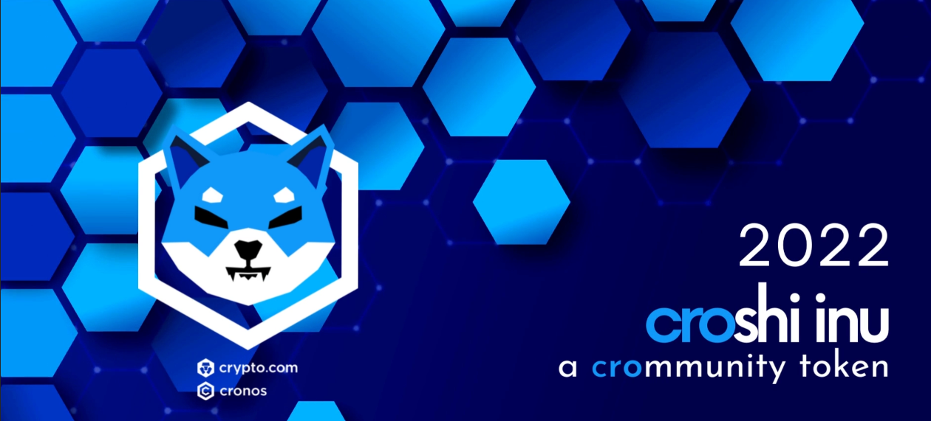
London, UK / ACCESSWIRE / 07, 04, 2022 / $CROSHI INU is a meme-token that launched on the Cronos Smart Chain on the 27th March 2022. The project aims to be the biggest player in Cronos meme-token space and has had great success already, reaching an ATH of $2.4m in just 4 days.
They are one of the only two meme-tokens listed on MMF!
There’s a large number of new investors looking for the next huge potential coin like SHIB, and DOGE.. Croshi is exactly that.
Branding and token image is at the heart of their vision for success. Croshi wants to be a fun, and ‘easy to access’-token for all.
Their low fees and easy accessibility through Crypto.com makes It possible for all walks of life to invest. Breaking the barriers for retail to invest easily and confidently is a priority.
Croshi’s long-term mission is to bring an easy and seamless transaction process for all users on the Cronos Smart Chain. Our owners are Doxxed and have completed KYC with Mad Meerkat Finance and Rugdoctor.

What are they planning?
They want to provide users with a comprehensive platform with an array of utilities such; Bridging, Staking, Farming and Swapping - breaking down barriers of entry to the amazing new Cronos chain.
With their attentive branding, devoted community, and well-skilled team, they place themsleves a cut above the rest! Priding themselves as one of the first major meme-tokens on the Cronos Smart Chain.
Along with this – they want to be a major player in the CRO-NFT market.

Why Cronos?
At the time of writing, CRO is currently 18th on the Global Crypto-currency index with $11bn Market Cap, BNB is ranked 4th with $71bn, with ETH at number two, sitting at $403bn. It won’t be long before CRO catches up with BNB which would mean an almost 7x for all tokens on the CRO network….
Now do you see why you are so early on this journey?
From signing a $100 million deal with Formula One to taking on the title sponsorship of the famous former Staples Center in a $700 million deal, Cronos (CRO-USD) is changing the game on how to lure the mainstream to a new product or unique space like cryptocurrency.
Croshi aims to follow in the footsteps of its father, by implementing unique and smart-marketing strategies to bring exposure to our platform and beloved $CROSHI token.
How to Buy!: https://www.youtube.com/watch?v=EumXqwRPkFE
Token Information:
Tax: 7%
Liquidity Locked for 6 months
Doxxed owners
KYC Complete
Mad Meerkat Finance Listed

All links: https://linktr.ee/croshiinu
Telegram: https://t.me/croshiinu
Website: https://croshi.com/
Twitter: https://twitter.com/CroshiInu?t=-XHHKZNgmByJMCyyaYSLLw&s=09

Contract Address (CRC20): 0x10faae6A25354544081D1aa3438e66086218d851

