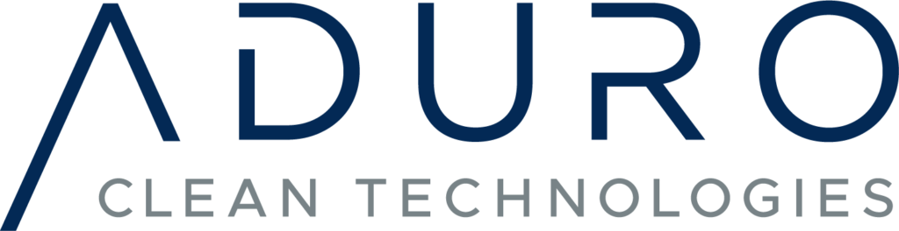

Aduro Announces Closing of First Tranche of Private Placement

THIS NEWS RELEASE IS NOT FOR DISTRIBUTION TO U.S. NEWSWIRE SERVICES FOR DISSEMINATION IN THE UNITED STATES

Sarnia, ON, April 12, 2022 – Aduro Clean Technologies Inc. (“Aduro” or the “Company”) (CSE: ACT) (OTCQB: ACTHF) (FSE: 9D50), a Canadian developer of patented water-based technologies to chemically recycle plastics, and to transform heavy crude and renewable oils into new-era resources and higher-value fuels, is pleased to announce that it has closed the first tranche of its previously announced private placement offering of units (the “Offering”). The Company issued an aggregate of 2,226,036 units (the “Units”) at a price of $0.70 per Unit for aggregate gross proceeds of C$1,558,225. The Company may complete additional tranches of the Offering for cumulative gross proceeds of up to $2 million.

“As we continue to deliver on our strategic plan we are pleased to see the positive response from our growing investor base.” said Ofer Vicus, the Chief Executive Officer and a director of Aduro. “We also continue to show our strong commitment and alignment with our shareholders with all our board members investing in this current financing round.”

Each Unit is comprised of one common share of the Company (each, a “Common Share”) and one Common Share purchase warrant (each, a “Warrant”). Each Warrant will entitle the holder to acquire one additional Common Share at a price of $1.00 per share, for a period of two years from the date the Units are issued. If during the exercise period of the Warrants, but after the resale restrictions on the shares have expired, the Company's shares trade at or above a weighted average trading price of $1.25 per share for ten (10) consecutive trading days, the Company may accelerate the expiry time of the Warrants by giving written notice to warrant holders by dissemination of a news release that the Warrants will expire 30 days from the date of providing such notice.

Of the 2,226,036 Units issued, 149,983 Units were issued to directors of the Company for gross proceeds of $104,988. The issuance of the Units to the directors of the Company were “related party transactions” within the meaning of Multilateral Instrument 61-101 – Protection of Minority Security Holders in Special Transactions (“MI 61-101”). The Company relied on section 5.5(b) of MI 61‐ 101 for an exemption from the formal valuation requirements of MI 61‐ 101 in respect of the Units issued to the directors of the Company as no securities of the Company are listed on a specified market as defined in MI 61‐ 101. Aduro relied on section 5.7(a) of MI 61-101 for an exemption from the minority approval requirements of MI 61-101 in respect of the Units issued to the directors of the Company as neither the fair market value of the Units issued to the directors of Aduro, nor the consideration paid for the Units issued to them, exceeded 25% of the Company’s market capitalization. No additional insiders or related parties of the Company participated in the first tranche of the Offering and no new insiders or control persons were created in connection with the closing of the first tranche of the Offering.

In connection with the closing of the first tranche, the Company paid $80,304 in finder's fees, equal to 7% of the gross proceeds raised and issued 114,720 finder's warrants which entitle the holder thereof to purchase one additional Common Share at a price of $1.00 per Common Share at any time prior to April 8, 2024.

The proceeds of the first tranche of the Offering will be used for general working capital purposes. The securities issued in the first tranche of the Offering are subject to a four month hold period from the date of issuance.

Because of the strong interest shown in the Offering, in addition to other prospectus exemptions commonly relied on in private placements, any further tranches of the current Offering will be available to existing shareholders of the Company who, as of the close of business on [April 11, 2021] (the “Record Date”) held Common Shares of the Company (and who continue to hold such Common Shares as of the closing date), pursuant to the prospectus exemption set out in BC Instrument 45-534 – Exemption from prospectus requirement for certain trades to existing securityholders and in similar instruments in other jurisdictions in Canada (the “Existing Shareholder Exemption”). As at the date hereof, the Existing Security Holder Exemption is available in each of the provinces of Canada, with the exception of Newfoundland and Labrador. The Existing Shareholder Exemption limits a shareholder to a maximum investment of $15,000 in a 12-month period unless the shareholder has obtained advice regarding the suitability of the investment and, if the shareholder is resident in a jurisdiction of Canada, that advice has been obtained from a person that is registered as an investment dealer in the jurisdiction. Shareholders that subscribe for Units under the Existing Shareholder Exemption will, among other things, need to represent in writing that they meet applicable requirements of the Existing Shareholder Exemption, including that, on or before the Record Date, such person became and continues to be a shareholder of the Company.

The Company will also make any further tranches of the Offering available to certain subscribers pursuant to BC Instrument 45-536 – Exemption from prospectus requirement for certain distributions through an investment dealer (the “Investment Dealer Exemption”). In accordance with the requirements of the Investment Dealer Exemption, the Company confirms that there is no material fact or material change about the Company that has not been generally disclosed.

The proceeds of any further tranches of the Offering are expected to be used for general working capital purposes.

None of the securities acquired in the Offering will be registered under the United States Securities Act of 1933, as amended (the “1933 Act”), and none of them may be offered or sold in the United States absent registration or an applicable exemption from the registration requirements of the 1933 Act. This news release shall not constitute an offer to sell or a solicitation of an offer to buy nor shall there be any sale of the securities in any state where such offer, solicitation, or sale would be unlawful.

About Aduro Clean Technologies

Aduro Clean Technologies is a developer of patented water-based technologies to chemically recycle waste plastics; convert heavy crude and bitumen into lighter, more valuable oil; and transform renewable oils into higher-value fuels or renewable chemicals. The Company’s Hydrochemolytic™ technology activates unique properties of water in a chemistry platform that operates at relatively low temperatures and cost, a game-changing approach that converts low-value feedstocks into 21st-century resources. With funding and support from Bioindustrial Innovation Canada, the company has developed a pre-pilot reactor system to upgrade heavy petroleum into lighter oil.

For further information, please contact:

Ofer Vicus, CEO
ovicus@adurocleantech.com

Abe Dyck, Investor Relations
ir@adurocleantech.com
+1 604-362-7011

Investor Cubed Inc.
Neil Simon, CEO
nsimon@investor3.ca
+1 647 258 3310

Forward-Looking Statements

This news release contains forward-looking statements. All statements, other than statements of historical fact that address activities, events, or developments that the Company believes, expects or anticipates will or may occur in the future, are forward-looking statements. The forward-looking statements reflect management’s current expectations based on information currently available and are subject to a number of risks and uncertainties that may cause outcomes to differ materially from those discussed in the forward-looking statements. Forward looking statements in this news release include: information with respect to the Offering; statutory hold periods; the principal uses of the proceeds of the Offering; the exemptions available in connection with the Offering; and the plans for commercialization of the Company’s technology. Although the Company believes that the assumptions inherent in the forward-looking statements are reasonable, forward-looking statements are not guarantees of future performance and, accordingly, undue reliance should not be put on such statements due to their inherent uncertainty. Important factors that could cause actual results to differ materially from the Company’s expectations include, but are not limited to, the following: the proposed further tranches of the Offering may not proceed as anticipated or at all; the anticipated prospectus exemptions may not be available or relied upon in the Offering; the intended use of proceeds may not remain in the best interests of the Company; the Company may be unable to achieve commercialization of its technology or business as anticipated or at all; adverse market conditions and other factors beyond the control of the parties. The Company expressly disclaims any intention or obligation to update or revise any forward-looking statements whether as a result of new information, future events or otherwise, except as required by applicable law.

Not for distribution to U.S. Newswire Services or for dissemination in the United States. Any failure to comply with this restriction may constitute a violation of U.S. Securities Laws

