$BioFi Ecosystem Announcement – Biometric Financial (BioFi) announces a new integration partnership with Tel Solutions Africa LTD

$BioFi Safeguards Your Personal data while Leveraging the Blockchain and Decentralized Web 3.0 services

Monday, 9 May, 2022 8:00 AM UTC

Topic: BioFi Ecosystem Update

WELDON SPRING, MO / ACCESSWIRE / 9 May, 2022 /

Biometric Financial (BioFi), an innovative ecosystem and Tel Solutions Africa LTD, owner of the BroadSpectrum mobile money platform announce today an integration partnership that will combine BioFi biometrics into the BroadSpectrum mobile money platform, and include Tel Solutions as an official Provider in the Biometric Financial ecosystem.

The BroadSpectrum mobile money platform serves a community size of approximately 2.5 million users across Ghana, with a further reach of 12 million potential users across the African continent. The BioFi biometric solution will be utilized to authenticate participants on the BroadSpectrum platform, while leveraging the $BioFi token as the method of payment for authentication services.

Tel Solutions will also be appointed as official distributor of the Phenix X1 smartphone for the Western region in Africa, including sales and electronic distribution of the UniSafeBox password manager.

The BioFi project represents a Utility Token and a secure set of solutions that leverages biometric security to provide decentralized finance (DeFi) products and services riding on the blockchain. The Phenix X1 smartphone is designed with a highly secure area to protect against fraudsters and to ensure security when running financial apps, transacting online, mining cryptocurrencies, and storing digital assets. UniSafeBox combines biometric encryption technology with blockchain hashing algorithms to secure passwords and a wide array of personal sensitive information.

The Broadspectrum mobile money platform provides the right infrastructure that gives clients a choice on how to manage and use their money to do more. It also helps the client to avoid disconnections and disruptions using reminders of payments due and updates on expenditure. It is a powerful and robust African payment platform which enables clients to also track expenses, save, and access loans from the comfort of their phone.

Brian Maw, CEO and Co-Founder of Finnovant, Inc., stated, "I am very excited for this partnership as the BioFi team and TelSolutions share the values of helping make the lives of customers better by creating simple, user-friendly access to a range of utility and secure solutions."

Providers of the BioFi ecosystem can integrate easily with biometric API’s, highlighting the unique utility advantage that the entire service can bring. The Biometric Financial website showcases many examples of utility currently available or in development, while providing services to tens of thousands of users globally.

BioFi is truly global in nature, not bound by a single language or territory, and designed to be user friendly with the added benefit of helping people feel more secure as access is tied to them individually.

Biometric Financial website:
https://biometricfinancial.org/home/

"The TSA digital payments aggregator platform provides the right infrastructure that gives clients a choice on how to manage and use their money to do more with convenience,” says Maxwell Dodd, COO at TelSolutions Africa, Ltd. "Our partnership with Finnovant will add best-in-class biometric security to our highly acclaimed platform, delivering greater security while maintaining ease of use."

About FINNOVANT
Finnovant Inc. was founded with the vision of helping business leaders dramatically improve the way they interact with their critical information and customers. Our focus is on developing emerging technologies with secure blockchain solutions in the areas of Financial Services, Governance, IoT, Healthcare, and more and improving digital security for our customers. Finnovant provides biometric authentication which helps thwart Identity Theft and Fraud.

Follow the company at Finnovant.com, Twitter, LinkedIn , Facebook, Instagram, Telegram, Discord

Chris Benedict
Finnovant, Inc.
1-844-724-8911
cbenedict@finnovant.com

About Tel Solutions Africa LTD

Tel Solutions Africa is positioned with the right leadership with the knowledge and skill to launch and drive penetration of digital and M2M solutions. Founded in 2017 by former Airtel and Vodafone Telecom executives, offering communication solutions, Fintech and mobile money solutions, and serving as a manufacturer's rep for Western Africa.

Maxwell Dodd
Tel Solutions Africa
+233 (0) 26 600 0014
dmaxwell@telsolutionsafrica.com
https://broadspectrumdigitalpayments.com/

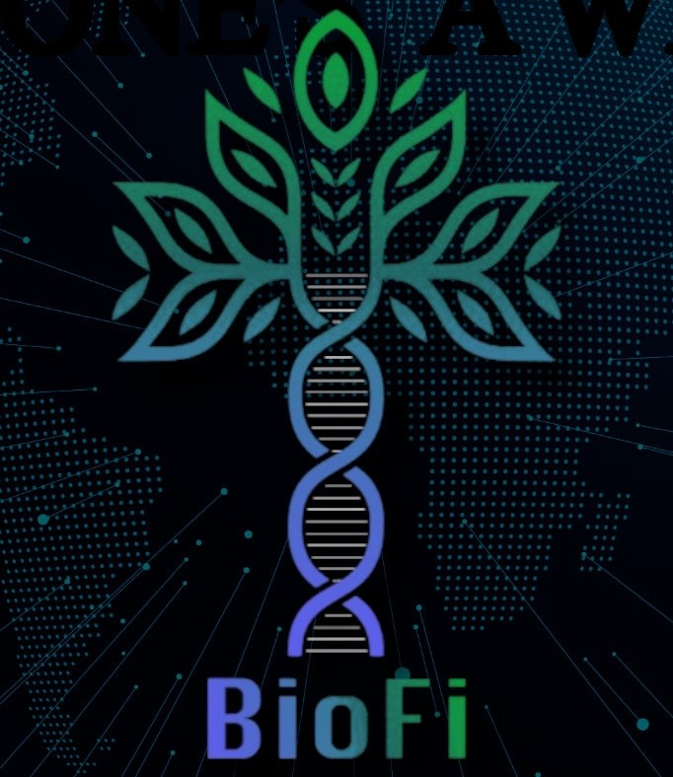

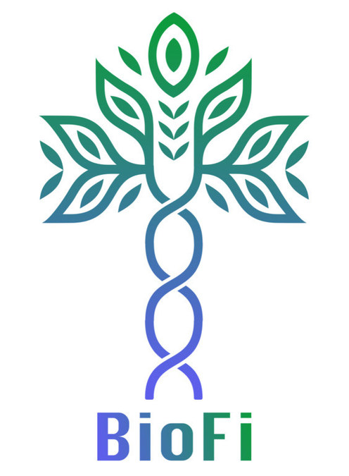

SOURCE: Finnovant Inc.

