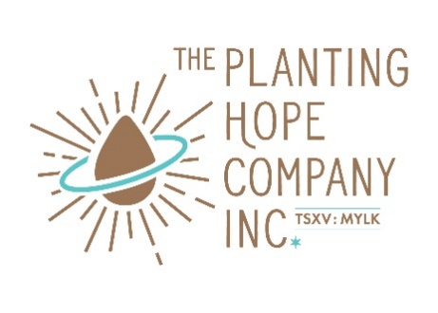
Planting Hope Launches Bilingual Packaging on Top Product Lines to Serve Canadian Retail Demand

- Planting Hope’s investment in bilingual packaging will enable the Company to sell products to grocery retailers across Canada
- Major Canadian grocery retailers have expressed keen interest in Planting Hope’s Hope and Sesame®, Mozaics™, and RightRice® brands

CHICAGO, IL and VANCOUVER, BC / ACCESSWIRE / May 11, 2022 – The Planting Hope Company Inc. (TSXV: MYLK) (FRA: J94) (“Planting Hope” or the “Company”), a plant-based food and beverage company focused on producing the world's most nutritious and planet-friendly products, is pleased to announce it is creating compliant bilingual packaging to serve Canadian retail grocery channels.
“Canadian-compliant bilingual packaging will allow Planting Hope to enter major Canadian retailers and reach both Francophone and Anglophone consumers across Canadian grocery markets,” said Julia Stamberger, CEO and Co-founder of Planting Hope. “Investing in Canadian market-specific packaging across our top selling items will enable us to meet the demand we have been receiving from Canadian consumers and retailers for our plant-based, planet-friendly products.”
Planting Hope has received significant interest in Hope and Sesame® Sesamemilk, Mozaics™ Real Veggie Chips, and RightRice® Veggie Rice from major Canadian grocery retailers both through its presence at the Canadian Health Food Association NOW conference in Vancouver in April 2022, and through its Canadian market broker, LeBeau Excel. Canadian market-compliant bilingual packaging is required to hold shelf space at most national Canadian retailers; only smaller retail chains and independents will accept product stickered with Canadian-compliant ingredients and nutritional information.
Initial products to be launched in Canada in Q3 2022 with bilingual packaging will be:
- Five flavors of Hope and Sesame® in shelf-stable 1L cartons: Barista, Original, Unsweetened Original, Unsweetened Vanilla, Chocolate Hazelnut
- Five RightRice® flavors: Original, Garlic Herb, Cilantro Lime, Spanish, Lemon Pepper
- Three RightRice® Risotto flavors: Creamy Parmesan, Wild Mushroom, Basil Pesto
- Three Mozaics™ Real Veggie Chips flavors in 3.5oz bags: Sea Salt, BBQ, Salsa

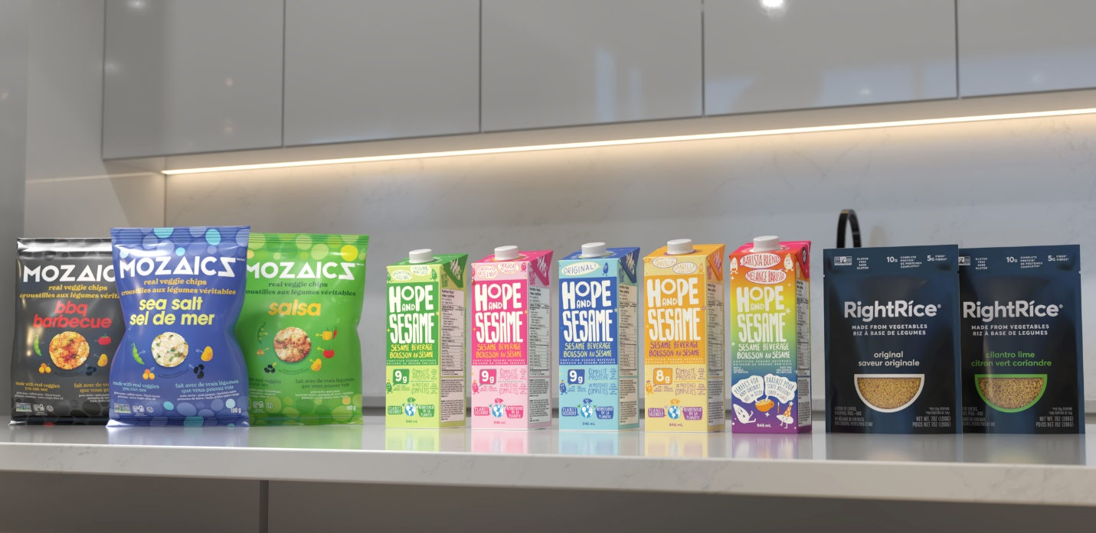
Caption: Canadian-compliant bilingual packaging for Mozaics™, Hope and Sesame®, and RightRice®

About The Planting Hope Company Inc.
Planting Hope develops, launches, and scales uniquely innovative plant-based and planet-friendly food and beverage brands. Planting Hope's award-winning and cutting-edge products fill key unmet needs in the skyrocketing plant-based food and beverage space. The Planting Hope brand family includes Hope and Sesame® Sesamemilk and Sesamilk™ creamers, RightRice® Veggie Rice, Mozaics™ Real Veggie Chips, and Veggicopia® Veggie Snacks. Founded by experienced food industry entrepreneurs, Planting Hope is a women-managed and woman-led company focused on nutrition, sustainability, and diversity. For more information visit: www.plantinghopecompany.com.

Contacts

Company Contact:
Julia Stamberger
CEO and Co-founder
(773) 492-2243
julia@plantinghopecompany.com

Media Contact:
Rachel Kay Public Relations
Becca Stonebraker
(818) 383-3929
becca@rkpr.net

Investor Relations Contact:
Caroline Sawamoto
Investor Relations
(773) 492-2243
ir@plantinghopecompany.com

Neither the TSX Venture Exchange nor its Regulation Services Provider (as that term is defined in the policies of the TSX Venture Exchange) accepts responsibility for the adequacy or accuracy of this release.

Forward-Looking Statements
This news release contains "forward-looking statements" or "forward-looking information" (collectively referred to hereafter as "forward-looking statements") within the meaning of applicable Canadian securities legislation. All statements that address activities, events, or developments that the Company expects or anticipates will, or may, occur in the future, including statements about the Company's ability to execute on its goals, the timing pertaining to these goals, the potential demand for the Company’s products, the timing and success of anticipated product launches and distribution of the Company’s products, and the Company's business prospects, future trends, plans and strategies. In some cases, forward looking statements are preceded by, followed by, or include words such as "may", "will," "would", "could", "should", "believes", "estimates", "projects", "potential", "expects", "plans", "anticipates", "continues", or the negative of those words or other similar or comparable words. In preparing the forward-looking statements in this news release, the Company has applied several material assumptions, including, but not limited to, the assumption that demand for the Company’s product will be sustained or increase in accordance with management’s projections, that the Company’s current business objectives can be achieved and that its other corporate activities will proceed as expected, and that general business and economic conditions will not change in a materially adverse manner. Although the management of the Company believes that the assumptions made and the expectations represented by such statements are reasonable, there can be no assurance that any forward-looking statement herein will prove to be accurate. Forward-looking statements involve known and unknown risks, uncertainties, and other factors which may cause the actual results, performance, or achievements of the Company to be materially different from any future results, performance, or achievements expressed or implied by such forward-looking statements. Although management of the Company has attempted to identify important factors that could cause actual results to differ materially from those contained in forward-looking information, there may be other factors that cause results not to be as anticipated, estimated, or intended. Risks and uncertainties applicable to the Company, as well as trends identified by the Company affecting its industry can be found in the Company’s annual information form dated January 6, 2022 and the Company's continuous disclosure record available on SEDAR at www.sedar.com. Such cautionary statements qualify all forward-looking statements made in this news release. The Company undertakes no obligation to update or revise any forward-looking statements, whether as a result of new information, future events, or otherwise, except as required by applicable law.

