

GaN Systems and Phihong Technology Announce the Industry's Highest Power Density Gaming Laptop Power Supply

NUREMBERG, Germany (PCIM Europe 2022) AND OTTAWA, Canada – May 11, 2022 – GaN Systems, the global leader in GaN (gallium nitride) power semiconductors, and Phihong Technology (Phihong), a premier power supply company, today announced the debut of Phihong’s 280W GaN charger, the industry’s highest power density power supply for gaming laptops. This revolutionary new GaN charger will be showcased in GaN Systems’ booth #509 (Hall 9) at PCIM Europe 2022.

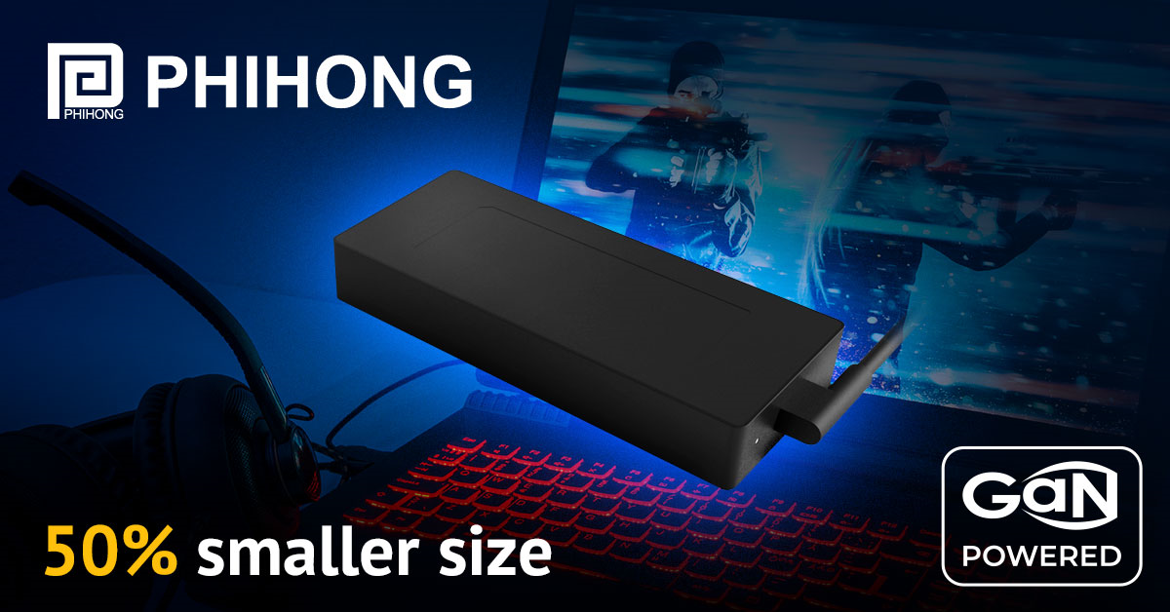

Phihong’s 280W GaN gaming power supply highlights a performance level that leads the industry in an ultra-compact size of 160 x 69 x 25 mm case and a 700g lightweight design. This charger is 50% smaller and 30% lighter than legacy 280W gaming chargers.
At 16W/in³ power density, Phihong's 280W GaN charger breaks through design limits and challenges long-held in the industry. The 280W GaN charger is highly efficient, with a 95% full load conversion efficiency and < 0.2W no-load standby loss.
This charger brings breakthrough R&D and innovation to the power supply industry and laptop gaming market, merging Phihong’s power solutions design and development expertise and GaN Systems’ leading GaN power semiconductors. Phihong’s 280W GaN gaming power supply combines a high-efficiency topology structure, zero voltage and zero current soft switching technology, digital control, and features GaN Systems’ power semiconductors.
GaN Systems power semiconductors enable power supply manufacturers to deliver smaller, lighter weight, cost-effective, reliable solutions. The advantages of GaN allow more efficient and unrivaled power density to power supplies while providing the higher power and faster charging times that are important to consumers today.
“In this very mobile world, users want thin, sleek mobile devices and seek the same requirements for the chargers that go along with them. With GaN, gone are the days of the "brick" power supply,” said Jim Witham, CEO of GaN Systems, "It's great to see Phihong design in GaN Systems in their AC adapters to achieve the small size and high power demanded by laptop users."
GaN Systems will showcase Phihong’s 280W GaN charger and an array of GaN chargers for smartphone and laptop charging, up to 4X smaller than conventional chargers ranging from 45W to 280W at PCIM Hall 9, Booth #509.
Contact us here to reserve an appointment or meet with GaN Systems virtually at the show.

# # #

About GaN Systems
GaN Systems is the global leader in GaN power semiconductors with the most extensive transistors portfolio that uniquely addresses the needs of today's most demanding industries, including consumer electronics, data center servers, power supplies, renewable energy systems, industrial motors, and automotive electronics. As an industry-leading innovator, GaN Systems makes it possible to design smaller, lower cost, more efficient power systems. The company's award-winning products provide system design opportunities free from the limitations of yesterday's silicon. By changing the transistor performance rules, GaN Systems enables power conversion companies to revolutionize their industries and transform the world.
For more information, please visit: www.gansystems.com or on Facebook, Twitter and LinkedIn and scan this QR code for our WeChat.

# # #

Media Inquiries:
Beth Trier
Trier and Company for GaN Systems
beth@triercompany.com
+1 (415) 285-6147
And
Mary Placido
Trier and Company for GaN Systems
mary@triercompany.com
+1 (415) 218-3627

