NORAM RECEIVES RESULTS FOR CVZ-81 WITH HIGH-GRADE LONG INTERCEPT OF 330FT WITH WEIGHTED AVERAGE 1169 PPM LI AND LI HIGH OF 1810 PPM

Vancouver, British Columbia – June 30, 2022 – Sandy MacDougall, CEO of Noram Lithium Corp. (“Noram” or the “Company”) (TSXV: NRM | OTCQB: NRVTF | Frankfurt: N7R) is pleased to announce the successful completion of CVZ-81 (PH-03) and release of the final assay results. The Company completed core hole CVZ-81 at a depth of 451.5 feet (137.6 m). Sampling for assay began at 55 ft (16.8 m) and continued to the bottom of the hole, an interval thickness of 416.5 ft (126.9 m) was intersected. The hole ended in mineralization and the weighted average lithium values present were as follows:

Depth of Interval Intersection | Total thickness | Weighted Average Lithium (ppm)
35 ft to 451.5 ft (10.7 m to 137.6 m) | 416.5.0 ft (126.9 m) | 1086.0 ppm
Including:
35 ft to 365 ft (10.7 m to 111.3 m) | 330.0 ft (100.6 m) | 1169.0 ppm

CVZ-81 was the last hole drilled in Noram’s Phase VI drilling program and had better than expected results, as did most of the holes in this in-fill drilling program. Now that the final assays are in, efforts are being focused on updating the geological/lithium grade models to be used in the upcoming PFS. The grades and thicknesses of mineralization seen in the Phase VI holes are anticipated to substantially improve the outlook for the Zeus deposit and upgrade approximately 175 million tonnes of the deposit from the inferred resource category to indicated resource.” comments Brad Peek, VP of Exploration and geologist on all six phases of Noram’s Clayton Valley exploration drilling.
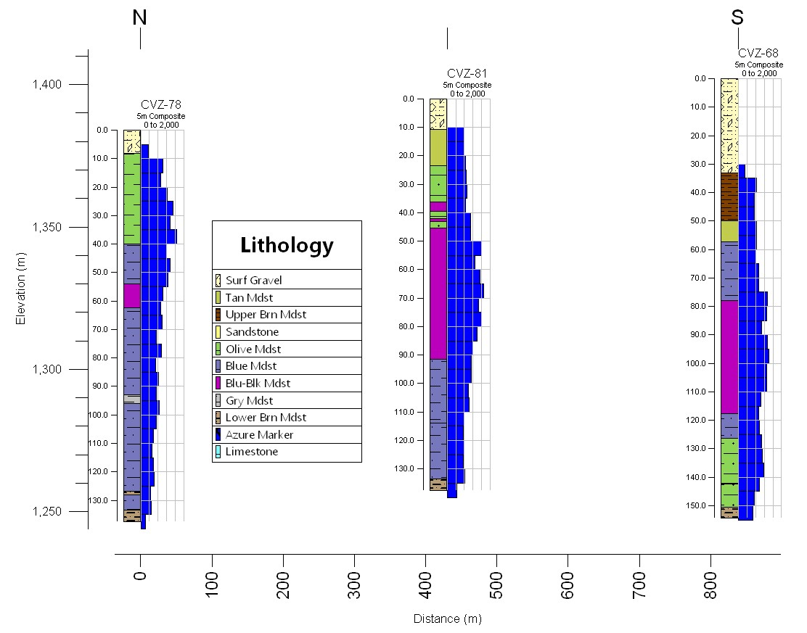
Figure 1. Comparative stratigraphy and assay results for drill hole CVZ-81 as compared to CVZ-78 and CVZ-68, which were drilled as part of the Phases V and VI programs. As can be seen on the cross section, all 3 holes had long intercepts of high-grade lithium mineralization. The histogram on the sides of the holes are the composited lithium grades in ppm Li. The cross section has a 4X vertical exaggeration.

Hole ID | Sample No. | From (ft) | To (ft) | From (m) | To (m) | Li (ppm)
CVZ-81 | 1851338 | 35 | 45 | 10.7 | 13.7 | 960
CVZ-81 | 1851339 | 45 | 55 | 13.7 | 16.8 | 710
CVZ-81 | 1851340 | 55 | 65 | 16.8 | 19.8 | 830
CVZ-81 | 1851341 | 65 | 75 | 19.8 | 22.9 | 750
CVZ-81 | 1851342 | 75 | 85 | 22.9 | 25.9 | 950
CVZ-81 | 1851343 | 85 | 95 | 25.9 | 29.0 | 820
CVZ-81 | 1851344 | 95 | 107 | 29.0 | 32.6 | 1000
CVZ-81 | 1851345 | 107 | 118 | 32.6 | 36.0 | 800
CVZ-81 | 1851346 | 118 | 123 | 36.0 | 37.5 | 1020
CVZ-81 | No Sample | 123 | 124.5 | 37.5 | 37.9
CVZ-81 | 1851347 | 124.5 | 135 | 37.9 | 41.1 | 950
CVZ-81 | 1851348 | 135 | 145 | 41.1 | 44.2 | 1140
CVZ-81 | 1851349 | 145 | 155 | 44.2 | 47.2 | 1110
CVZ-81 | 1851350 | 155 | 165 | 47.2 | 50.3 | 1100
CVZ-81 | 1851351 | 165 | 175 | 50.3 | 53.3 | 1750
CVZ-81 | 1851353 | 175 | 185 | 53.3 | 56.4 | 1450
CVZ-81 | 1851354 | 185 | 195 | 56.4 | 59.4 | 1170
CVZ-81 | 1851355 | 195 | 205 | 59.4 | 62.5 | 1520
CVZ-81 | 1851356 | 205 | 215 | 62.5 | 65.5 | 1540
CVZ-81 | 1851357 | 215 | 225 | 65.5 | 68.6 | 1810
CVZ-81 | 1851358 | 225 | 235 | 68.6 | 71.6 | 1510
CVZ-81 | 1851359 | 235 | 245 | 71.6 | 74.7 | 1440
CVZ-81 | 1851361 | 245 | 255 | 74.7 | 77.7 | 1490
CVZ-81 | 1851362 | 255 | 265 | 77.7 | 80.8 | 1730
CVZ-81 | 1851363 | 265 | 275 | 80.8 | 83.8 | 1380
CVZ-81 | 1851364 | 275 | 285 | 83.8 | 86.9 | 1190
CVZ-81 | 1851365 | 285 | 295 | 86.9 | 89.9 | 1200
CVZ-81 | 1851366 | 295 | 305 | 89.9 | 93.0 | 1110
CVZ-81 | 1851367 | 305 | 315 | 93.0 | 96.0 | 1140
CVZ-81 | 1851368 | 315 | 325 | 96.0 | 99.1 | 1140
CVZ-81 | 1851369 | 325 | 335 | 99.1 | 102.1 | 1030
CVZ-81 | 1851370 | 335 | 345 | 102.1 | 105.2 | 930
CVZ-81 | 1851372 | 345 | 355 | 105.2 | 108.2 | 960
CVZ-81 | 1851373 | 355 | 365 | 108.2 | 111.3 | 1140
CVZ-81 | 1851374 | 365 | 375 | 111.3 | 114.3 | 660
CVZ-81 | 1851375 | 375 | 385 | 114.3 | 117.3 | 780
CVZ-81 | 1851376 | 385 | 395 | 117.3 | 120.4 | 730
CVZ-81 | 1851377 | 395 | 405 | 120.4 | 123.4 | 770
CVZ-81 | 1851378 | 405 | 415 | 123.4 | 126.5 | 820
CVZ-81 | 1851379 | 415 | 425 | 126.5 | 129.5 | 710
CVZ-81 | 1851380 | 425 | 435 | 129.5 | 132.6 | 790
CVZ-81 | 1851381 | 435 | 445 | 132.6 | 135.6 | 840
CVZ-81 | 1851382 | 445 | 451.5 | 135.6 | 137.6 | 860
Table 1 – Sample results from CVZ-81 from 35 ft to depth of 451.5 ft (10.7-137.6 m)
The samples were analyzed by the ALS laboratory in Reno, Nevada. QA/QC samples were included in the sample batch and returned values that were within their expected ranges.

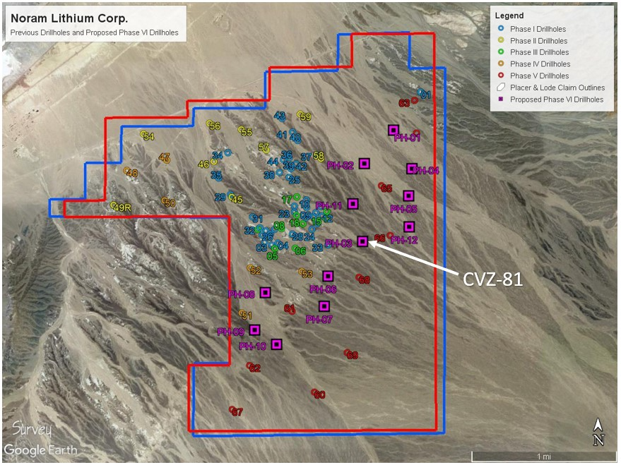
Figure 2 – Location of all past drill holes (Phase I to Phase V) previously completed in addition to the 12 holes completed for Phase VI. Phase VI holes are indicated in purple.

The technical information contained in this news release has been reviewed and approved by Brad Peek., M.Sc., CPG, who is a Qualified Person with respect to Noram’s Clayton Valley Lithium Project as defined under National Instrument 43-101.

About Noram Lithium Corp.

Noram Lithium Corp. (TSXV: NRM | OTCQB: NRVTF | Frankfurt: N7R) is a well-financed Canadian based advanced Lithium development stage company with less than 90 million shares issued and a fully funded treasury. Noram is aggressively advancing its Zeus Lithium Project in Nevada from the development-stage level through the completion of a Pre-Feasibility Study in 2022.

The Company’s flagship asset is the Zeus Lithium Project (“Zeus”), located in Clayton Valley, Nevada. The Zeus Project contains a current 43-101 measured and indicated resource estimate* of 363 million tonnes grading 923 ppm lithium, and an inferred resource of 827 million tonnes grading 884 ppm lithium utilizing a 400 ppm Li cut-off. In December 2021, a robust PEA** indicated an After-Tax NPV(8) of US$1.3 Billion and IRR of 31% using US$9,500/tonne Lithium Carbonate Equivalent (LCE). Using the LCE long term forecast of US$14,000/tonne, the PEA indicates an NPV (8%) of approximately US$2.6 Billion and an IRR of 52% at US$14,000/tonne LCE.

Please visit our web site for further information: www.noramlithiumcorp.com.

ON BEHALF OF THE BOARD OF DIRECTORS

Sandy MacDougall
Chief Executive Officer and Director
C: 778.999.2159

For additional information please contact:
Peter A. Ball
President and Chief Operating Officer
peter@noramlithiumcorp.com
C: 778.344.4653

Neither the TSX Venture Exchange nor its Regulation Services Provider (as that term is defined in the policies of the TSX Venture Exchange) accepts responsibility for the adequacy or accuracy of this release. This news release may contain forward-looking information which is not comprised of historical facts. Forward-looking information involves risks, uncertainties and other factors that could cause actual events, results, performance, prospects and opportunities to differ materially from those expressed or implied by such forward-looking information. Forward-looking information in this news release includes statements regarding, among other things, the completion transactions completed in the Agreement. Factors that could cause actual results to differ materially from such forward-looking information include, but are not limited to, regulatory approval processes. Although Noram believes that the assumptions used in preparing the forward-looking information in this news release are reasonable, including that all necessary regulatory approvals will be obtained in a timely manner, undue reliance should not be placed on such information, which only applies as of the date of this news release, and no assurance can be given that such events will occur in the disclosed time frames or at all. Noram disclaims any intention or obligation to update or revise any forward-looking information, whether as a result of new information, future events or otherwise, other than as required by applicable securities laws. *Updated Lithium Mineral Resource Estimate, Zeus Project, Clayton Valley, Esmeralda County, Nevada, USA (August 2021) **Preliminary Economic Assessment Zeus Project, ABH Engineering (December 2021).

